US HISTORY REGENTS QUESTIONS: WEEK 2-7

- Which of these events related to space exploration occurred first?

(1) Neil Armstrong walking on the Moon
(2) development of the space shuttle
(3) John Glenn orbiting Earth
(4) launching of Sputnik

- The Hungarian uprising of 1956, the U-2 incident, and the Cuban missile crisis led to

(1) military actions by the Southeast Asia Treaty Organization (SEATO)
(2) increased tensions between the United States and the Soviet Union
(3) international efforts to control communist China
(4) creation of the Warsaw Pact

- The United States Supreme Court under Chief Justice Earl Warren (1953–1969) made several landmark decisions that

(1) drew criticism for supporting States rights
(2) weakened the power of the federal government
(3) strengthened the authority of the police
(4) increased the rights of individuals

- The baby boom after World War II led directly to

(1) a decrease in spending for public education
(2) a return to a rural lifestyle
(3) an increased demand for housing
(4) a decrease in consumer spending

- Which action has come to symbolize the end of the Cold War?

(1) establishing the Peace Corps
(2) achieving a truce in the Korean War
(3) tearing down the Berlin Wall
(4) improving United States relations with China

- Which development resulted from the construction of the interstate highway system?

(1) increased suburbanization
(2) reduced air pollution
(3) decreased fuel consumption
(4) growth of long-distance passenger train service

- “… And so, my fellow Americans: ask not what your country can do for you—ask what you can do for your country.…”
— President John F. Kennedy, Inaugural Address, January 20, 1961

Which action by President John F. Kennedy was most consistent with the challenge included
in this statement?

(1) forming the Peace Corps
(2) negotiating the Nuclear Test Ban Treaty
(3) supporting the Bay of Pigs invasion
(4) visiting the Berlin Wall

Base your answers to questions 2 and 3 on the passage below and on your knowledge of social studies.

…You express a great deal of anxiety over our willingness to break laws. This is certainly a legitimate concern. Since we so diligently urge people to obey the Supreme Court’s decision of 1954 outlawing segregation in the public schools, at first glance it may seem rather paradoxical for us consciously to break laws. One may want to ask: “How can you advocate breaking some laws and obeying others?” The answer lies in the fact that there are two types of laws: just and unjust. I would be the first to advocate obeying just laws. One has not only a legal but a moral responsibility to obey just laws. Conversely, one has a moral responsibility to disobey unjust laws. I would agree with St. Augustine that “an unjust law is no law at all.”…
— Dr. Martin Luther King Jr.,
“Letter from Birmingham Jail,” April 16, 1963

- Which type of action against unjust laws is Dr. Martin Luther King Jr. supporting in this passage?

(1) militant resistance
(2) civil disobedience
(3) judicial activism
(4) affirmative action

- Which statement most accurately summarizes the main idea of the passage?

(1) People must obey Supreme Court decisions.
(2) You can never break some laws while obeying others.
(3) Violence brings faster results than peaceful protest.
(4) Following moral principles is sometimes more important than following the law.

- Which development led to the other three?

(1) growth of new home construction
(2) increase in school populations
(3) start of the baby boom
(4) pressure on the Social Security system

Base your answers to questions 11 and 12 on the photograph below and on your knowledge of social studies.
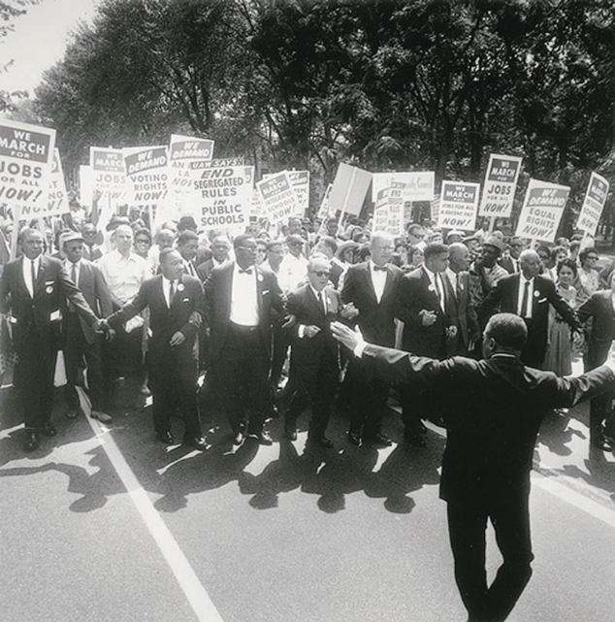
Source: National Archives

- What is a valid generalization that can be drawn from this photograph?

(1) Activists often advocate taking over the government.
(2) Demonstrators use nonviolent means to demand equal rights.
(3) Civil rights leaders supported “separate but equal” education.
(4) Protesters encouraged a nationwide strike by teachers.

- The delay in implementing which Supreme Court decision helped lead to the protest shown in this photograph?

(1) Plessy v. Ferguson
(2) Brown v. Board of Education of Topeka
(3) Tinker v. Des Moines
(4) New Jersey v. T. L. O.

Base your answer to question 13 on the cartoon below and on your knowledge of social studies.
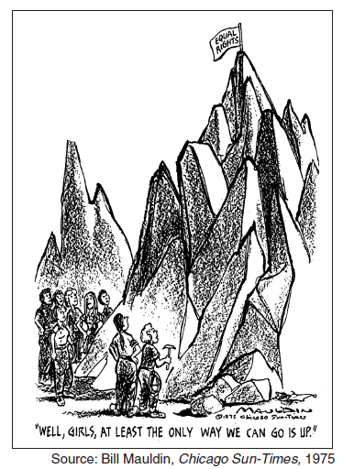

- In the 1970s, many women’s rights advocates reacted to the situation shown in the cartoon by

(1) rejecting the provisions of Title IX
(2) opposing affirmative action programs
(3) demanding the right to vote in all elections
(4) supporting the Equal Rights Amendment to the Constitution

- Lunch counter sit-ins and the actions of freedom riders are examples of

(1) steps taken in support of the Americans with Disabilities Act
(2) programs dealing with affirmative action
(3) violent acts by the Black Panthers
(4) nonviolent attempts to oppose segregation

- The Supreme Court rulings in Roe v. Wade (1973) and Planned Parenthood of Southeastern Pennsylvania, et al. v. Casey (1992) are similar in that both cases dealt with a woman’s right to

(1) privacy
(2) medical insurance
(3) equal pay for equal work
(4) participate in school sports

REVIEW

49 One way in which the New Deal, the Fair Deal, and the Great Society are similar is that these programs

(1) promoted the idea of “rugged individualism”
(2) increased government commitment to the well-being of the people
(3) reduced the amount of money spent on domestic programs
(4) encouraged the states to take a more active role in national defense

50 The policy of Dollar Diplomacy, the Good Neighbor policy, and the Alliance for Progress were designed to

(1) increase United States influence in Latin America
(2) open trade with Southeast Asia
(3) maintain peace with European nations
(4) provide foreign aid to African nations

EXTRA

Base your answer to question 15 on the excerpt below and on your knowledge of social studies.

“. . . With America’s sons in the fields far away, with America’s future under challenge right here at home, with our hopes and the world’s hopes for peace in the balance every day, I do not believe that I should devote an hour or a day of my time to any personal partisan causes or to any duties other than the awesome duties of this office—the Presidency of your country. Accordingly, I shall not seek, and I will not accept, the nomination of my party for another term as your President. . . .”
— President Lyndon B. Johnson, March 31, 1968

- The decision announced in this speech was based primarily on the

(1) assassination of Martin Luther King Jr.
(2) growing violence in urban America
(3) outbreak of terrorist attacks around the world
(4) involvement of the United States in the Vietnam War

36 • In the 1940s, President Franklin D. Roosevelt
made winning World War II a priority over
extending the New Deal.
• In the 1950s, President Harry Truman’s focus
shifted from the Fair Deal to the Korean War.
• In the 1960s, President Lyndon B. Johnson’s
attention to the Great Society gave way to
preoccupation with the Vietnam War.
These presidential actions best support the
conclusion that
(1) presidents prefer their role as commander in
chief to that of chief legislator
(2) domestic programs are often undermined by
the outbreak of war
(3) Presidents Roosevelt, Truman, and Johnson
were not committed to their domestic
initiatives
(4) large domestic reform programs tend to lead
nations toward involvement in foreign wars

- During the 1950s, the main goal of the civil rights movement was to

(1) create separate African American economic and social institutions
(2) eliminate legal segregation from American life
(3) establish affirmative action programs to compensate for past wrongs
(4) form a new nation for African Americans

Base your answer to question 50 on the graphs below and on your knowledge of social studies.

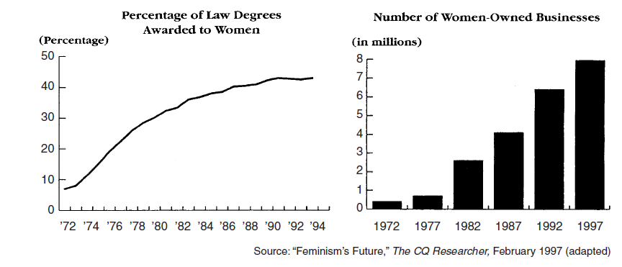

50 Data from the graphs most clearly support the conclusion that by the mid-1990s, American women as a group

(1) surpassed men in the number of businesses owned and law degrees received
(2) had given up marriage in favor of careers outside the home
(3) had gained more opportunities in professional areas
(4) earned more than men in the legal profession

40 Which development is most closely associated with the belief in the domino theory?

(1) military involvement in Vietnam
(2) construction of the Berlin Wall
(3) signing of the nuclear test ban treaty
(4) end of the Korean War

38 One way in which President John F. Kennedy’s Peace Corps and President Lyndon Johnson’s
Volunteers in Service to America (VISTA) are similar is that both programs attempted to

(1) increase domestic security
(2) support United States troops fighting overseas
(3) improve the quality of people’s lives
(4) provide aid to immigrants coming to the United States

- … For the war against poverty will not be won here in Washington. It must be won in the field, in every private home, in every public office, from the courthouse to the White House.…
— President Lyndon B. Johnson,
State of the Union Address, January 8, 1964

This statement expresses President Lyndon B. Johnson’s view that the

(1) federal government is solely responsible for the war on poverty
(2) court system must be held accountable for poverty
(3) problem of poverty is easily solved
(4) entire country must help fight poverty

- A major way in which the Civil Rights Act (1964) and the Americans with Disabilities Act (1990) are similar is that both laws

(1) were intended to lift Americans out of poverty
(2) failed to pass constitutional review by the Supreme Court
(3) gave a minority group the right to vote after years of protest
(4) provided equal protection to groups that had experienced discrimination

Base your answers to questions 34 and 35 on the passage below and on your knowledge of social studies.

“This Government, as promised, has maintained the closest surveillance of the Soviet Military buildup on the island of Cuba. Within the past week, unmistakable evidence has established the fact that a series of offensive missile sites is now in preparation on that imprisoned island. The purpose of these bases can be none other than to provide a nuclear strike capability against the Western Hemisphere. . . .”
— President John F. Kennedy, October 22, 1962

34 Which action did President Kennedy take following this statement?

(1) urging Allied forces to remove Soviet weapons from Cuba
(2) ordering a naval quarantine of Cuba
(3) breaking off diplomatic relations with the Soviet Union
(4) asking the United Nations to stop grain shipments to the Soviet Union

35 The crisis described in this passage was resolved when

(1) Cuba became a capitalist nation
(2) the United States seized control of Cuba
(3) Soviet Premier Nikita Khruschev met with President Kennedy
(4) the Soviet Union withdrew its missiles from Cuba

Base your answer to question 9 on the chart below and on your knowledge of social studies.

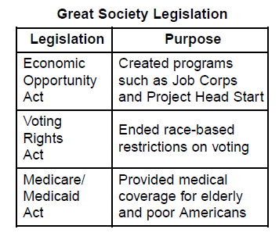
- The legislation identified in this chart was an effort to solve problems related to

(1) illegal immigration and terrorism
(2) poverty and discrimination
(3) illiteracy and domestic abuse
(4) budget deficits and famine

SKILLS

Base your answers to questions 17 and 18 on the map below and on your knowledge of social studies.
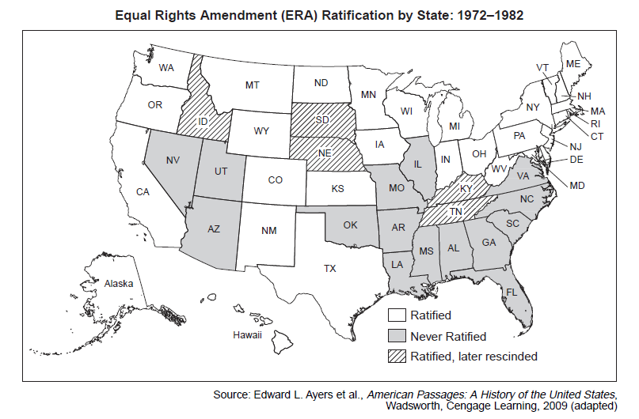

- Based on this map, the Equal Rights Amendment (ERA) received the least support in the

(1) Rocky Mountain states
(2) Pacific Coast states
(3) northeastern states
(4) southeastern states

- Based on this map, the proposed equal rights amendment was not added to the Constitution because

(1) too few New England states supported it
(2) fewer than three-fourths of the states ratified it
(3) the president vetoed the passage of the amendment
(4) Idaho, Nebraska, and Kentucky never held a ratification vote

48 Which list of wars that involved the United States is in the correct chronological order?

(1) Vietnam War → War on Terrorism → Korean War → World War II
(2) Korean War → World War II → Vietnam War → War on Terrorism
(3) World War II → Vietnam War → War on Terrorism → Korean War
(4) World War II → Korean War → Vietnam War → War on Terrorism

KEY:
EXTRA
TEST
REVIEW
SKILL

