US HISTORY: REGENTS QUESTIONS
WEEK 2-4

Base your answers to questions 1 and 2 on the photograph below and on your knowledge of social studies.
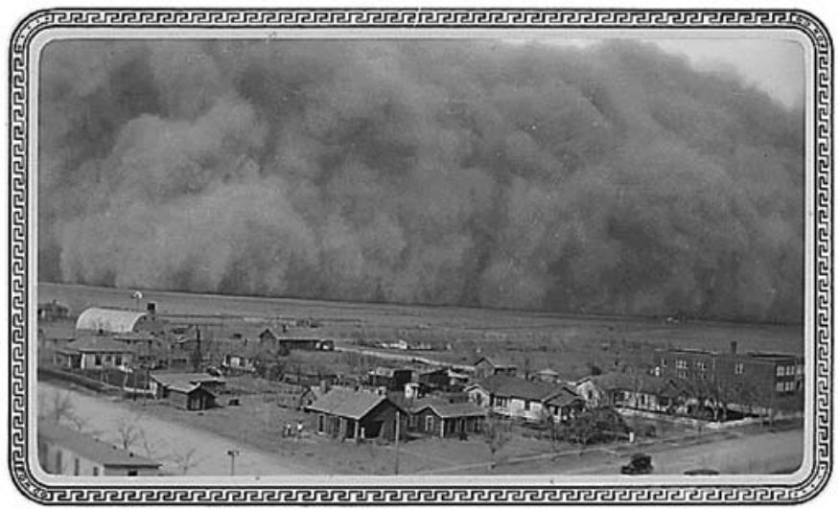

- During the 1930s, the conditions shown in this photograph occurred mainly

(1) on the Atlantic Coast
(2) on the Great Plains
(3) in the Rocky Mountains
(4) in the Pacific Northwest

- Many farmers in the region affected by the conditions shown in this photograph reacted by

(1) migrating to California
(2) accepting aid from the Tennessee Valley Authority
(3) investing in better farm equipment
(4) marching on Washington, D.C.

- What was a major cause of the Great Depression?

(1) overproduction and underconsumption
(2) a decrease in the supply of consumer goods
(3) an increase in demand for imported products
(4) an increase in the price of wheat on the world market

Base your answer to question 4 on the cartoon below and on your knowledge of social studies.
OH, SO THAT’S THE KIND OF A SAILOR HE IS!
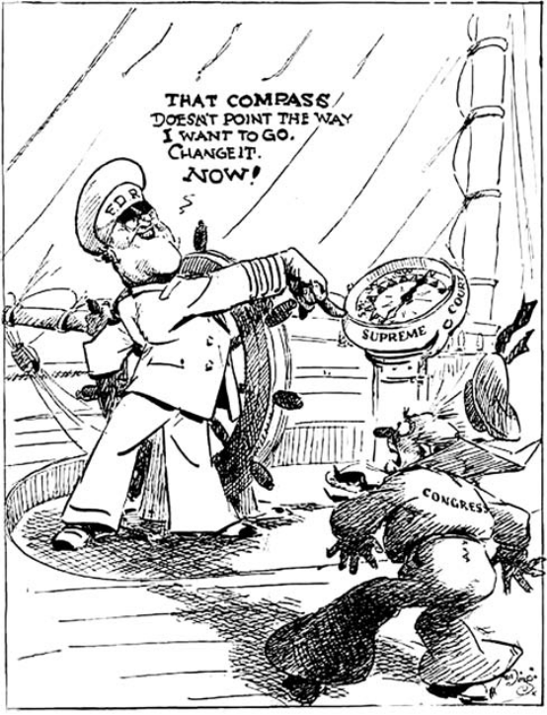
Source: J. N. “Ding” Darling, Des Moines Register, March 29, 1937 (adapted)

- The cartoon illustrates President Franklin D. Roosevelt’s dissatisfaction with

(1) Congress leading the nation into World War II
(2) Congress resisting proposals to strengthen the navy
(3) New Deal programs being declared unconstitutional
(4) Being unable to appoint minorities to the Supreme Court

- The New Deal changed American political thinking because it was based on the principle that the

(1) economy will fix itself if left alone
(2) federal government should attempt to solve social and economic problems
(3) political parties must work together to deal with national problems
(4) states should take a leadership position in solving social issues

- Which action did President Franklin D. Roosevelt take that helped organized labor gain strength during the New Deal?

(1) requiring the American Federation of Labor to admit skilled workers
(2) allowing women to work in government agencies
(3) signing the National Labor Relations Act (Wagner Act)
(4) selecting John L. Lewis as his Secretary of Labor
- Many of the songs, movies, and books of the 1930s are similar in that they

(1) romanticized urban life
(2) relived the bad times of the past
(3) helped people escape from the realities of everyday life
(4) pointed out the mistakes that led to the Great Depression

- The Civilian Conservation Corps (CCC) and the Works Progress Administration (WPA) were both New Deal programs developed to address the problem of

(1) excessive stock market speculation
(2) high unemployment
(3) increased use of credit
(4) limited income of senior citizens

- During the Great Depression, one way New Deal programs tried to stimulate economic recovery was by

(1) raising tariff rates
(2) increasing interest rates
(3) creating public works jobs
(4) lowering the minimum wage

- Which geographic area is most closely associated with the Dust Bowl of the 1930s?

(1) Great Lakes basin
(2) Mississippi River valley
(3) Appalachian Mountains
(4) Great Plains

- President Herbert Hoover’s response to the Great Depression was often criticized because it

(1) wasted money on new social programs
(2) caused widespread rioting and looting in major cities
(3) raised taxes on businesses and the wealthy
(4) failed to provide direct relief for the neediest persons

- A major reason for creating the Tennessee Valley Authority (TVA) in 1933 was to

(1) build and manage a turnpike in the valley
(2) provide health care benefits for southerners
(3) encourage African Americans to settle in the valley
(4) improve economic conditions in a poor rural region
- President Franklin D. Roosevelt believed that declaring a bank holiday and creating the Federal Deposit Insurance Corporation (FDIC) would help the nation’s banking system by

(1) restoring public confidence in the banks
(2) reducing government regulation of banks
(3) restricting foreign investments
(4) granting tax relief to individuals

- The Social Security Act (1935) is considered an important program because it

(1) brought about a quick end to the Great Depression
(2) provided employment for those in need of a job
(3) established a progressive income tax
(4) extended support to elderly citizens

Base your answer to question 15 on the cartoon below and on your knowledge of social studies.

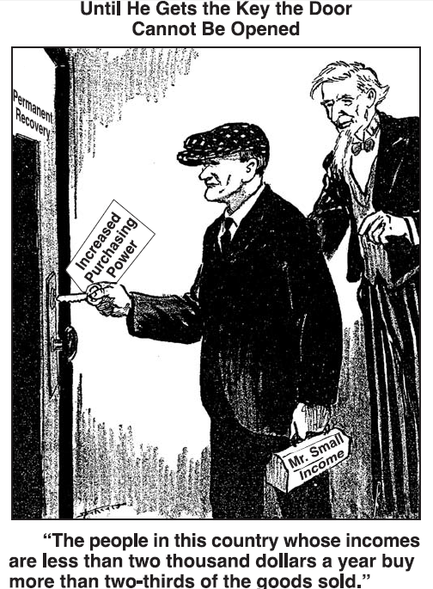
- President Franklin Roosevelt

- Based on this cartoon, economic recovery would require

(1) fewer regulations by the federal government
(2) increased taxes on the working class
(3) more money in the hands of lower-income families
(4) protective tariffs on foreign goods

EXTRA:

Base your answer to question 19 on the cartoon below and on your knowledge of social studies.
All Set!
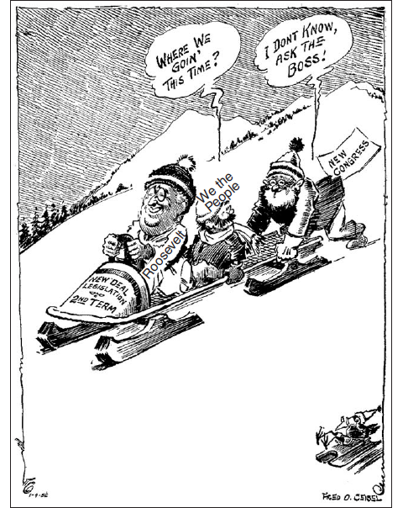
Fred O. Seibel, Richmond Times-Dispatch, January 4, 1936 (adapted)

- Which statement about President Franklin D. Roosevelt’s plans for a second term most accurately expresses the main idea of the cartoon?
(1) Congress will give President Roosevelt a free hand to lead the nation.
(2) The American people will trust Congress to control President Roosevelt.
(3) President Roosevelt will seek direction from the people.
(4) The Great Depression will no longer be a serious concern.

Base your answers to questions 22 and 23 on the song below and on your knowledge of social studies.

Brother, Can You Spare a Dime?
They used to tell me I was building a dream
And so I followed the mob.
When there was earth to plow or guns to bear,
I was always there, right on the job.
They used to tell me I was building a dream
With peace and glory ahead —
Why should I be standing in line, just waiting for bread?
Once I built a railroad, I made it run,
Made it race against time.
Once I built a railroad, now it’s done —
Brother, can you spare a dime? . . .
Once in khaki suits, gee, we looked swell
Full of that Yankee Doodle-de-dum.
Half a million boots went slogging through hell,
And I was the kid with the drum. . . .
— E. Y. Harburg and J. Gorney, 1932

- Which statement most accurately expresses the main idea of this song?

(1) Railroad workers were often overpaid.
(2) The average wage in 1930 was 10 cents an hour.
(3) Soldiers never have difficulty finding jobs when they return from war.
(4) Hard times threaten economic opportunity.

Base your answer to question 14 on the cartoon below and on your knowledge of social studies.

Let’s Harmonize!
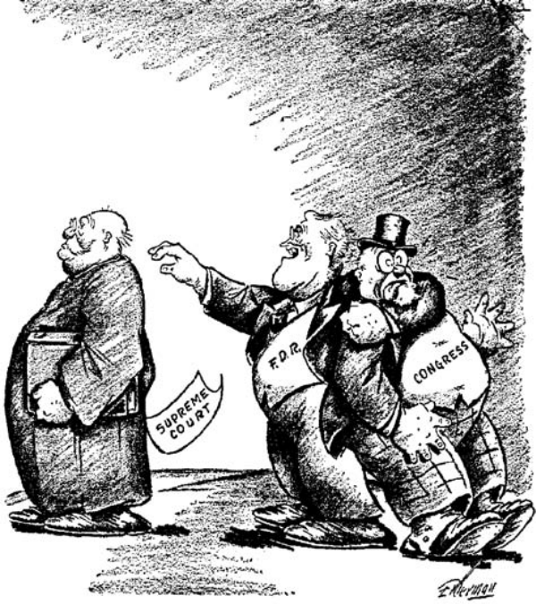
Source: Gene Elderman, Washington Post, January 7, 1937 (adapted)

- The cartoonist is commenting on President Franklin D. Roosevelt’s efforts to

(1) win congressional approval for his Supreme Court nominees
(2) gain Supreme Court support for his legislative program
(3) set up a retirement plan for Supreme Court Justices
(4) keep members of Congress off the Supreme Court

- The economic boom of the 1920s was fueled in part by

(1) government subsidies paid to farmers
(2) tariff reductions on European goods
(3) increased investment in the stock market
(4) construction by the Tennessee Valley Authority (TVA)

- A major reason that President Franklin D. Roosevelt proposed adding Justices to the Supreme Court in 1937 was to

(1) make the Court processes more democratic
(2) end corruption and favoritism in handling cases
(3) influence Court decisions related to New Deal programs
(4) ensure the appointment of members of minority groups

11) Which event led to the other three?

(1) migration of 300,000 people to California to find work
(2) development of Dust Bowl conditions on the Great Plains
(3) passage of New Deal legislation to conserve soil
(4) publication of John Steinbeck’s novel The Grapes of Wrath

- What was a guiding principle of the New Deal economic policies?

(1) Pro-business tax breaks would solve the problems associated with urban poverty.
(2) Antitrust legislation would destroy the free market economy of the United States.
(3) Rugged individualism must be allowed to solve social inequality.
(4) Government must assume more responsibility for helping the poor.

REVIEW:

- What was one cause of the stock market crash of 1929 and the Great Depression that followed?

(1) Costs associated with World War I had bankrupted the economy.
(2) Speculators had purchased shares of stock on margin with borrowed funds.
(3) Federal tax cuts had caused high inflation.
(4) Low farm production had weakened banks.

