US History 2: Midterm
REVIEW SHEET

WEEK 2-1:

- What was the main purpose of the Monroe Doctrine?

- Why did the United States declare war on Spain in 1898?
(CAUSES of the Spanish-American war)

- Yellow journalists created support for the Spanish-American War by writing articles about what ship?

- What was yellow journalism?

- Why did the United States issue the Open Door policy (1899–1900)?

- Which president started building the Panama Canal?

- When a strong country (US) takes over a weak country (Panama), what is that called?

- What type of journalism can be seen in the headlines of this newspaper?
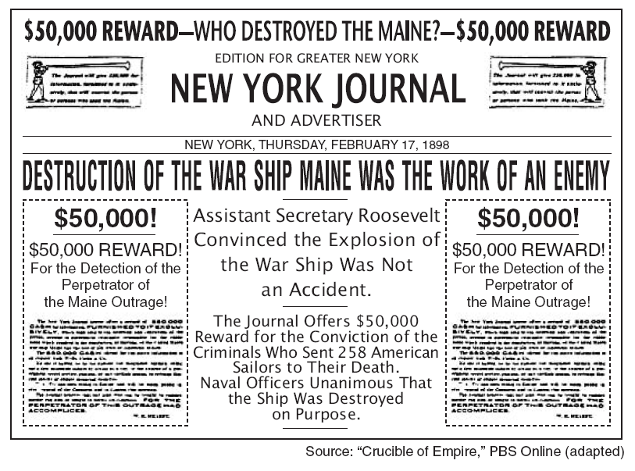

- These types of stories encouraged Congress declare ________________.

WEEK 2-2:

- What’s the vocabulary term that means you don’t take sides?

- Why did the United States enter World War I (1917)?

- Why did the Senate refuse to join the League of Nations?

- What was the purpose of President Woodrow Wilson’s Fourteen Points (1918)?

- What was the Zimmerman telegram?

WEEK 2-3:

- Why did African Americans migrate out of the South after WWI? Where did they go?

- Who were the people involved in the Harlem Renaissance of the 1920s?

- What were the 2 sides of the John Scopes trial?

- Why did the stock market crash in 1929? (How were people paying for stocks?)

- Why did small farmers go out of business in the 1920s? Although the number of farms went down, farm production went __________.

- Did people follow the law during Prohibition in the 1920s?

- What invention is the cause of this chart? (Hint: Ford)

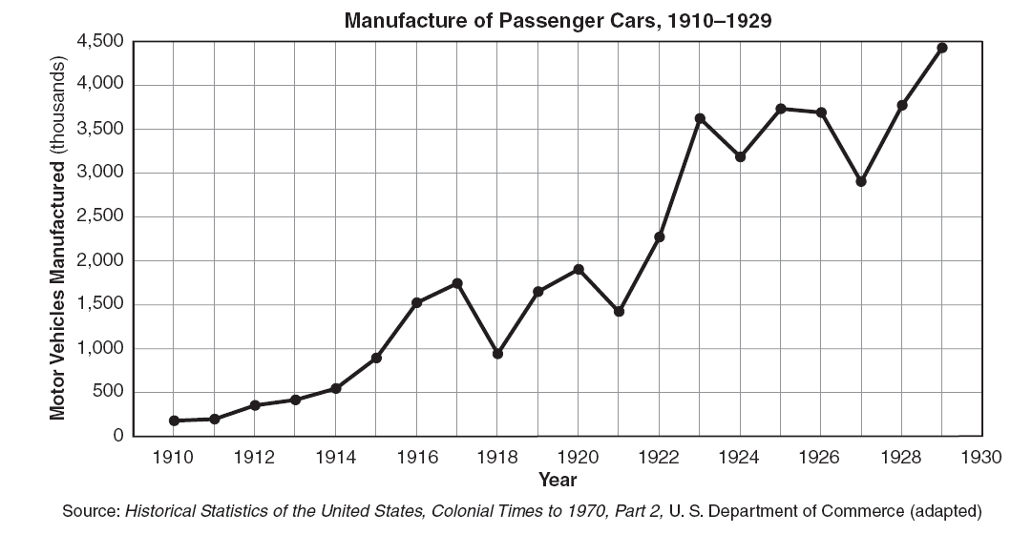

- What type of government appeared in Russia after the Bolshevik Revolution (October 1917)? What did the US think of this? (Hint: Palmer’s raids)

- How did the Harlem Renaissance promote African American culture?

- What was the main idea of Langston Hughes’ “I, Too?”

- Which foreign policy did Warren G. Harding support when he used the phrase “return to normalcy” during his presidential campaign of 1920?

WEEK 2-4:

- How did the New Deal fix unemployment?

- In what region of the US did the Dust Bowl occur?

- Where did farmers move during the Dust Bowl?

- What were the causes of the Great Depression?

Base your answer to question 30 on the cartoon below and on your knowledge of social studies.
OH, SO THAT’S THE KIND OF A SAILOR HE IS!
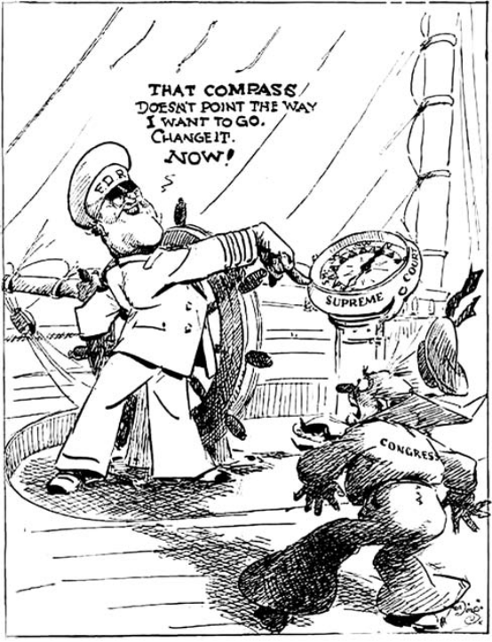
Source: J. N. “Ding” Darling, Des Moines Register, March 29, 1937 (adapted)

- Why is FDR unhappy in this cartoon?

WEEK 2-5:

- Why were consumer goods rationed during World War II?

- What was the Manhattan Project?

Base your answers to questions 33 and 34 on the cartoon below and on your knowledge of social studies.
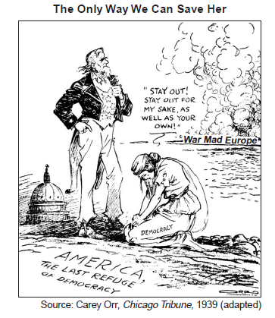

- What is the main idea of this cartoon?

- What were the Neutrality Acts?

- During World War II, how was the federal government involved in the economy?

- How did President Truman change the US military after World War II?

- Why were the Nuremberg Trials important?

WEEK 2-6:

- What was NATO?

- How did NAFTA & the European Union expand trade?

- What is the goal of the United Nations?

Base your answers to questions 41 and 42 on the time line below and on your knowledge of social studies.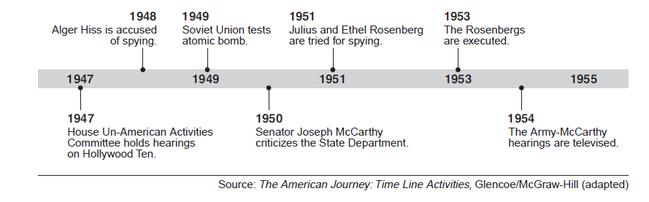

- How are all the events on this timeline related?

- Which civil liberty (human right) was most threatened during this period?

REVIEW FROM MIDTERM 1:

- What did the case of Marbury v. Madison (1803) establish?

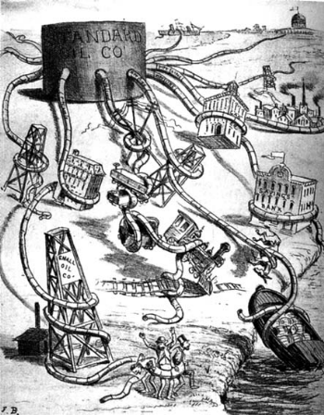
- What economic concept is illustrated by the cartoon?

- What did the Supreme Court decide in Plessy v. Ferguson (1896)?

- What part of the U.S. are the Homestead Act and the transcontinental railroads associated with?

- Schenck v. United States (1919) was about what type of freedom?

- This poster is a response to what law?
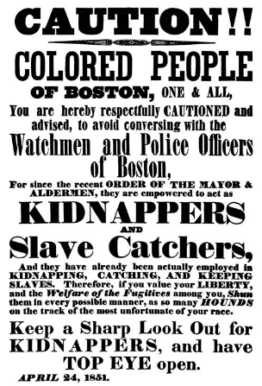

- Why were poll taxes, literacy tests, and grandfather clauses created in the South?

- Define: nativism. Who did nativists want to keep out of the US?

THEMATIC ESSAY
GRAPHIC ORGANIZER

Presidential Action | Background | Effect
FDR’s
“New Deal”
Truman
drops the atomic bomb

