meet the candidates
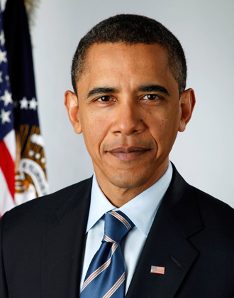  Pete Souza / The White House  The Democratic Contender  Barack Obama  Obama is the current U.S. President and preferred candidate for re-election next fall. He was born in Hawaii. Obama spent time as a community organizer in Chicago, Illinois. He went on to earn a law degree and eventually became a Senator representing Illinois. In 2008, he became the first African-American President of the United States. He will most likely be nominated to run for a second term in office against the Republican nominee in 2012. | 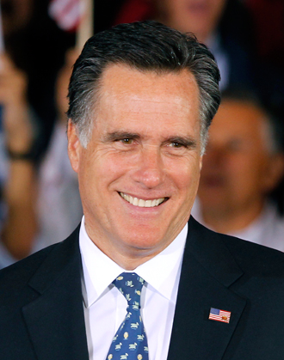  Gerald Herbert / AP Images  The Republican Contender  Mitt Romney  Romney was born in Detroit, Michigan. He was elected Governor of Massachusetts from 2003 to 2007. His campaign has partly focused on his skills as a successful business leader. Romney has founded and headed several companies, and is credited with saving the 2002 Winter Olympics in Salt Lake City, which had been suffering from money difficulties.

Mitt Romney

Born:
March 12, 1947, in Detroit, Michigan

Hometown:
Belmont, Massachusetts

Family:
He has been married to Ann Romney since 1969. They have five grown sons: Tagg, Matt, Josh, Ben, and Craig. The Romneys also have 18 grandchildren.

Career:
He was the Governor of Massachusetts from 2003 to 2007. Before that, he was president of the organizing committee for the 2002 Winter Olympics in Salt Lake City, Utah. He also co-founded Bain Capital, a financial company, and helped run it for 14 years.

Hobbies:
reading, skiing, horseback riding, and waterskiing

Favorite foods:
meat loaf, pretzels, and peanut M&M’s

Name game:
Romney’s first name is Willard. Until first grade, he was known as Billy. But he didn’t like the nickname and started going by his middle name, Mitt, instead.

When he was your age:
As a kid, Mitt Romney went to the Vaughn School in Bloomfield Hills, Michigan. He later wrote that his fourth-grade teacher, Mrs. Clouse, inspired him by “making me believe that I could learn anything.”
Mitt idolized his dad. George Romney was president of the American Motors car company. “Work was never just a way to make a buck to my dad,” Mitt once said. “It was about making life better for people.”
Mitt loved to talk about cars with his dad, and he hoped to run a car company himself someday. Instead, he followed his father into politics. George was the Governor of Michigan for six years.

Barack Obama

Born:
August 4, 1961, in Honolulu, Hawaii

Hometown:
Chicago, Illinois

Family:
He has been married to Michelle Obama since 1992. They have two daughters, Malia (age 14) and Sasha (age 11).

Career:
He has served as President since January 2009. Before that, he was a U.S. Senator from Illinois for four years. He also served in the Illinois State Senate for eight years and worked as a lawyer.

Hobbies:
Watching and playing basketball, reading, writing, and cooking

Favorite foods:
Chili, french fries, and pork chops

Name game:
Obama was named after his father, who was from Kenya, a country in East Africa. Obama went by the nickname Barry until he was in college.

When he was your age:
At age 10, Barack Obama started fifth grade at Punahou (POOH-nahhoe) School in Honolulu, Hawaii. He was a new kid in town. Barack and his family had been living in Indonesia, a nation in Southeast Asia. Barack’s mother was worried that he wasn’t getting a good education. So she sent him back to Hawaii to live with his grandparents.
During that period, Barack learned valuable lessons from his grandmother. “She’s the one who taught me about hard work,” he later said. “She’s the one who put off buying a new car or a new dress for herself so that I could have a better life.”

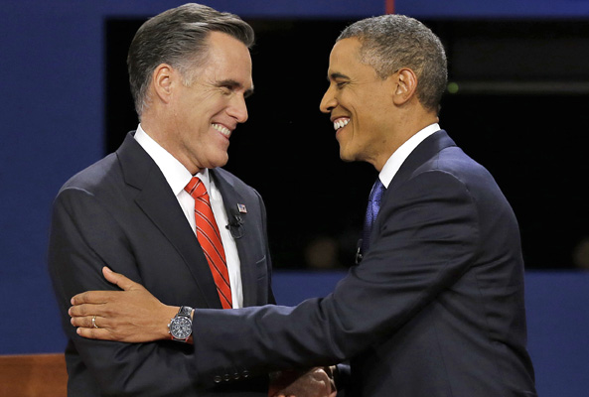
Presidential candidates Mitt Romney and Barack Obama shake hands after the first debate. (Charlie Neibergall / AP Images)

Candidates Face Off at First Debate

Obama and Romney discuss jobs, taxes, and the economy
By Jenna Winocur | October 4 , 2012
This article was written on location by Scholastic News Kid Reporter Jenna Winocur.
Voters got a chance for an up close look at the two major-party candidates for President last night at the first of three presidential debates.
The back-and-forth discussion between President Barack Obama, the Democratic candidate, and former Massachusetts Governor Mitt Romney, the Republican candidate, gave students at the University of Denver a lot to think about. For many, this will be their first chance to vote in a general election for President.
“Most of us don’t have a presidential election the first time we get to vote,” said University of Denver student Mason Seymore. “It’s a lot to put on an 18-year-old. So it’s going to take a lot of thought and consideration before I decide.”
At a debate, candidates try to sway undecided voters to their side by presenting their ideas to the public and discussing those ideas with the other candidate. Questions at last night’s debate were broad and focused on domestic policy—issues that are specifically about what is going on in the United States rather than what is happening in other countries. Most of the conversation centered on the economy, jobs, and taxes.
Candidates were allowed two minutes in each of six segments to answer a question. They then used the additional 11 minutes in each segment to highlight their differences on the issue being debated.

DISCUSSING DETAILS
One of the key issues for voters this election is the economy. So candidates quoted many numbers and listed lots of specifics in their policy proposals.
On the subject of taxes, Obama said Romney was proposing a $5 trillion tax cut that the government could not afford. “He’s been asked over 100 times how he would pay for it,” Obama said.
But Romney said he wouldn’t cut taxes that much and brought up the President’s policy on Medicare and the new health-care law that critics call “Obamacare.”
“I like that term,” Obama said, pointing out that his plan is much like one Romney passed in Massachusetts when he was Governor.
Romney said his plan in Massachusetts worked because it was designed to meet the needs of a specific state. He opposes Obama’s plan because “the federal government should not be telling people” how to handle their health care.
STILL UNDECIDED
So who won the first debate of the season? Students outside the debate hall addressed that question after the candidates gave their closing statements.
“Romney had some really good points,” said Katrine Aucmeiusi, a 19-year-old international business major. “He was good at countering Obama’s arguments.”
“I don’t think there was a winner or a loser,” said engineering major Irene Wilson, 19. “Both got good points across. They did a really good job explaining the topics.”
The next presidential debate will be held on October 16, in Hempstead, New York. But before Obama and Romney meet again, their running mates will get a chance to debate. The vice-presidential debate will be held on October 11, in Danville, Kentucky. The final presidential debate will be held on October 22 in Boca Raton, Florida.

