Global 4: Test 1
REVIEW SHEET

WEEK 2-1:

- Which concept is represented in these World War I recruiting posters? (Hint: these posters want people to have pride in their country)

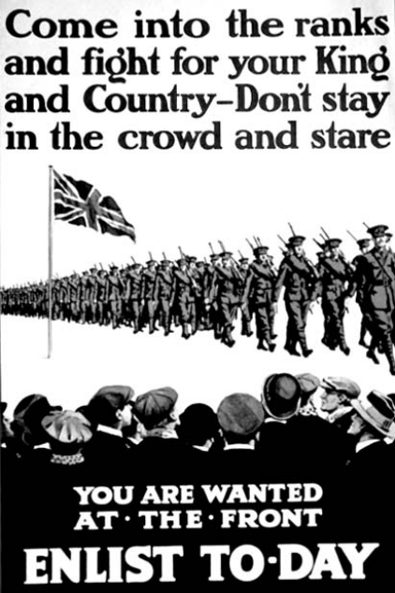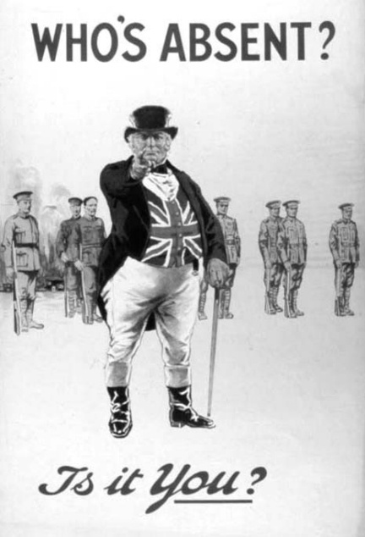

- Which event is considered the immediate cause of World War I?

- Define: militarism

- The assassination of Archduke Franz Ferdinand was the immediate cause of which war?

- Which region was described as “the powder keg of Europe” prior to World War I?

- Which type of warfare was used in World War I?

- What were the underlying long-term causes of World War I? (Hint: MAIN)

- What were the economies doing at home during World War I?

WEEK 2-2:

- What is a command economy?

- Five-year plans and collectivization are most closely associated with which leader?

- The Bolshevik Party in 1917 gained the support of the peasant class because they promised them 3 things. What were they? (Hint: slogan)

- What happened as a result of Joseph Stalin’s policies (collectivization) in Ukraine during the 1930s?

- • Five-year plans
• Collectivization of agriculture
• Great Purge

Which individual is associated with all these policies?

- According to this cartoon, what did Lenin want Russia to get rid of?
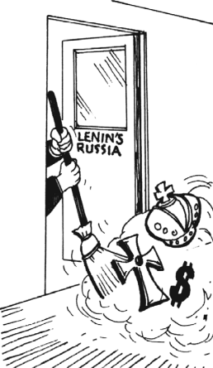

- What was the goal of Joseph Stalin’s five-year plans?

- What is totalitarianism?

- What is communism?

- • Led the Russians in a second revolution (1917)
• Promised “Peace, Land, and Bread”
• Established the New Economic Policy (NEP)

Which leader is being described by these statements?

WEEK 2-3:

- The Amritsar Massacre and the Salt March are both associated with the independence movement in which country?

- Disintegration of the Austro-Hungarian Empire, creation of new nation-states in central Europe, and Germany’s loss of colonies were all consequences of which war?

- Which political leader gained power as a result of the failing economy of the Weimar Republic?

- Between 1923 and 1938, which leader instituted a modernization program in Turkey?

- Mohandas Gandhi’s protests during India’s independence movement were often successful because of what strategy?

- Which leader is most closely associated with the rise of fascism in Italy prior to World War II?

- Which type of government or way of thinking best completes this graphic organizer?

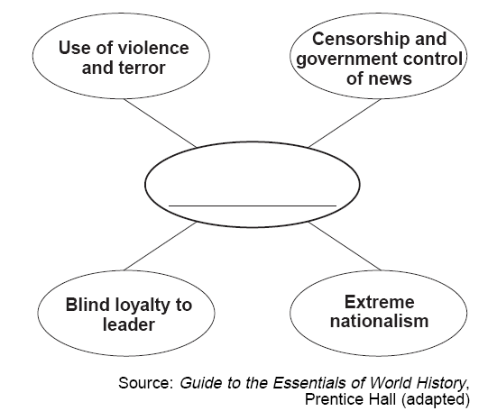

- This cartoonist is referring to the way Germany was affected in 1919 by what document?

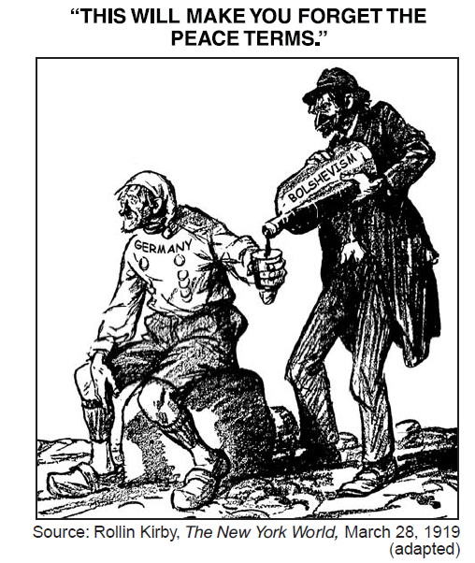

- Why was Mohandas Gandhi protesting against Great Britain in India? Why was Great Britain there?

- One similarity between Adolf Hitler and Benito Mussolini is that both were

_____________________________ leaders.

- Why was the Bolshevik Revolution in Russia and the rise of fascism in Germany and Italy successful?

- Which letter identifies the nation most closely associated with Mohandas Gandhi?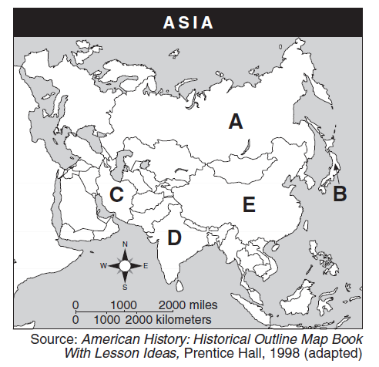

- What was one reason that totalitarian dictatorships gained power in Europe between World War I and World War II?

- Based on the information in this chart, which were the 3 big reasons for the Nazis’ rise to power in Germany?
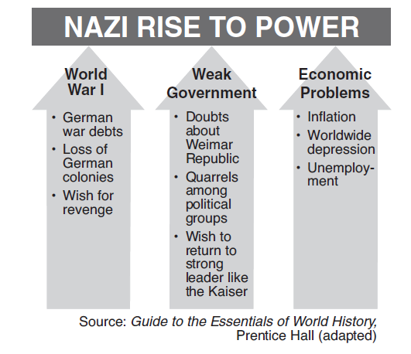

REVIEW FROM GLOBAL 3:

- Why were European countries interested in imperializing Africa?

- Enlightenment thinkers encouraged people to use ________________________________.

- The slogan “Blood and Iron” and a united Germany are most closely associated with which leader?

- What is the Middle Passage?

- What was a result of the Industrial Revolution in Europe? (Hint: social classes)

- According to John Locke, what is the purpose of government?

- How are Toussaint L’Ouverture, Simón Bolívar, and José de San Martín similar?

- Which region was the Berlin Conference of 1884 about?

THEMATIC ESSAY:

Political System | Characteristics | Effects on history/culture of a nation
COMMUNISM
FASCISM

