Regents Q’s: REVIEW – 9

- One way in which Toussaint L’Ouverture, Simón Bolívar, and José de San Martín are similar is that they

(1) supported the Reconquista
(2) led independence movements
(3) fought for Native American suffrage
(4) defended the encomienda system

- What was one effect of the French Revolution?

(1) Differences between ethnic groups were eliminated.
(2) Communism became popular.
(3) Militarism was discouraged.
(4) Nationalistic feelings were stimulated.

- One major effect of Napoleon’s rule of France was that it led to

(1) an increase in the power of the Roman Catholic Church
(2) massive emigration to the Americas
(3) trade agreements with Great Britain
(4) a restoration of political stability

- “Angry Mob Destroys Bastille”
“Robespierre’s Execution Ends Reign of Terror”
“Napoleon Seizes Power”

Which country’s revolution is referred to in these headlines?
(1) Spain
(2) Austria
(3) France
(4) Russia

- Under the Old Regime in France, the burden of taxation fell mostly on the

(1) monarchy
(2) clergy
(3) nobles
(4) commoners

- “The French Revolution is most important for having changed subjects to citizens.”

This statement emphasizes the shift from
(1) religious traditions to secular values
(2) divine right rule to people’s participation in government
(3) rural lifestyles to urban lifestyles
(4) private property ownership to government ownership

- Which geographic condition contributed to the defeat of Napoleon’s troops during the invasion of Russia?

(1) drought
(2) typhoons
(3) severe flooding
(4) harsh winter

- At the Congress of Vienna (1815), the governments of Europe reacted to the French Revolution and the rule of Napoleon by attempting to

(1) restore old regimes to power
(2) spread the idea of democracy
(3) encourage nationalist movements
(4) promote the European free-trade zone

- Which event is most closely associated with the French Revolution?

(1) Council of Trent
(2) Thirty Years’ War
(3) Reign of Terror
(4) Paris Peace Conference

- Porfirio Diaz, Francisco “Pancho” Villa, and Emiliano Zapata are best known for their struggles in the

(1) Haitian independence movement
(2) Mexican Revolution
(3) Nicaraguan War
(4) Cuban Revolution

- The slogan “Blood and Iron” and a united Germany are most closely associated with

(1) Prince Metternich
(2) Simón Bolívar
(3) Camillo Cavour
(4) Otto von Bismarck

- The unification of Germany under Otto von Bismarck demonstrates the

(1) influence of Marxist ideology
(2) impact of nationalism
(3) force of civil disobedience
(4) power of democratic ideals

- One political objective of both Otto von Bismarck and Giuseppe Garibaldi was to

(1) overthrow divine right monarchies
(2) unify their nations
(3) establish communist systems
(4) form an alliance with Great Britain

- • Location — included lands surrounding the eastern Mediterranean Sea
• People — Turks, Arabs, Greeks, Muslims, Christians, and Jews
• Nickname during the 19th and early 20th centuries — “Sick Man of Europe”

Which empire is described by these characteristics?

(1) Gupta
(2) Mongol
(3) Roman
(4) Ottoman

Base your answer to question 15 on the map below and on your knowledge of social studies.

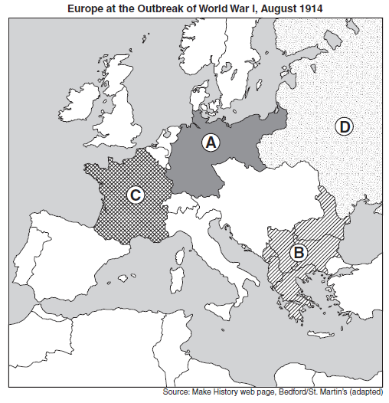
- Which area of Europe was known as the “Powder Keg” of Europe prior to the outbreak of World War I?

(1) A
(2) B
(3) C
(4) D

