Regents Q’s REVIEW-8

- Enlightenment thinkers encouraged the improvement of society through the

(1) teachings of the church
(2) use of reason
(3) development of absolutism
(4) establishment of a rigid social hierarchy

- Which pair of ideas were central to the Scientific Revolution?

(1) social stability and economic self-sufficiency
(2) observation and experimentation
(3) technology and military expansion
(4) scarcity and interdependence

- Which statement about the Scientific Revolution in Europe is accurate?

(1) The existence of natural laws was rejected.
(2) Scientists questioned traditional beliefs about the universe.
(3) New ideas supported the geocentric theory of Ptolemy.
(4) The Bible was used to justify new scientific findings.

Base your answer to question 4 on the chart below and on your knowledge of social studies.
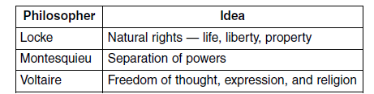

- Which period is most closely associated with the major ideas of these philosophers?

(1) Crusades
(2) Renaissance
(3) Reconquista
(4) Enlightenment

- According to John Locke, the purpose of government is to

(1) protect the natural rights of individuals
(2) serve the monarch
(3) create overseas settlements
(4) stimulate the economy

- Seventeenth-century scholars Galileo Galilei and René Descartes faced serious challenges to their scientific theories because their ideas

(1) were based on the Bible
(2) contradicted traditional medieval European beliefs
(3) relied only on teachings from non-Christian cultures
(4) were not supported by scientific investigations

- One contribution that John Locke made to Enlightenment philosophy was the idea that

(1) absolute monarchies should continue
(2) the punishment should fit the crime
(3) individual rights should be denied
(4) governments should be based on the consent of the people

Base your answer to question 8 on the illustration below and on your knowledge of social studies.
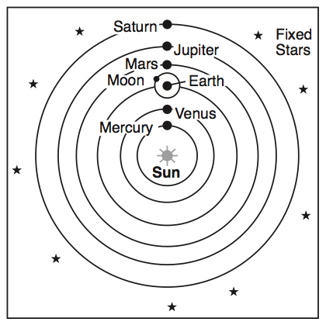

- Which individual supported the theory represented in this illustration?

(1) Socrates
(2) Ptolemy
(3) Dante
(4) Galileo

