Regents Q’s: REVIEW-4

- • In less than 50 years, it was the largest unified land empire in history.
• In 1279, it was the first foreign group to gain complete control of China.
• It made the caravan routes across Asia safe for trade and travel.
• When attempting to conquer Japan in 1274 and 1281, its fleets were destroyed
by storms.

Which empire is most closely associated with these statements?

(1) Persian
(2) Gupta
(3) Ottoman
(4) Mongol

- What was one influence of Mongol rule on the history of Russia?

(1) Contact with kingdoms in western Europe greatly increased.
(2) The Chinese writing system was introduced and adopted.
(3) Most Russians converted from Orthodox Christianity to Islam.
(4) Russian leaders adopted the idea of strong, centralized control of the empire.

- Which situation was a result of Pax Mongolia?

(1) Trade increased between Europe and Asia.
(2) China became isolated from its neighbors.
(3) Warfare between Japan and Vietnam escalated.
(4) Europeans conquered the Aztecs and Incas.

- The leadership of Genghis Khan, the use of the stirrup, and excellent horsemanship skills all contributed directly to the

(1) collapse of Silk Road trade
(2) defeat of Tokugawa Japan
(3) beginning of European exploration
(4) rise of the Mongol Empire

- • Creation of the House of Wisdom in Baghdad
• Development of algebra
• Use of calligraphy as an art form

Which Golden Age is most closely associated with these achievements?

(1) Islamic
(2) Gupta
(3) Tang
(4) Songhai

- Which heading best completes the partial outline below?

I. __________________________________________
A. Development of medical encyclopedias
B. Development of algebra and astronomical tables
C. Production of cotton textiles and woolen carpets
D. Production of literature, calligraphy, and geometric art

(1) Achievements of Feudal Societies
(2) Inventions During the Neolithic Revolution
(3) Issues of the Protestant Reformation
(4) Contributions of the Islamic Civilization

- Which geographic feature had the greatest influence on the development of the Inca Empire?

(1) deserts
(2) irregular coastline
(3) river valleys
(4) mountains

- One way in which the ancient Inca Empire and the Roman Empire are similar is that both

(1) fought rivals for control of the sea
(2) adopted Christianity as the state religion
(3) traded with other civilizations along the Silk Road
(4) built a system of roadways throughout their empires

Base your answer to question 9 on the photographs below and on your knowledge of social studies.
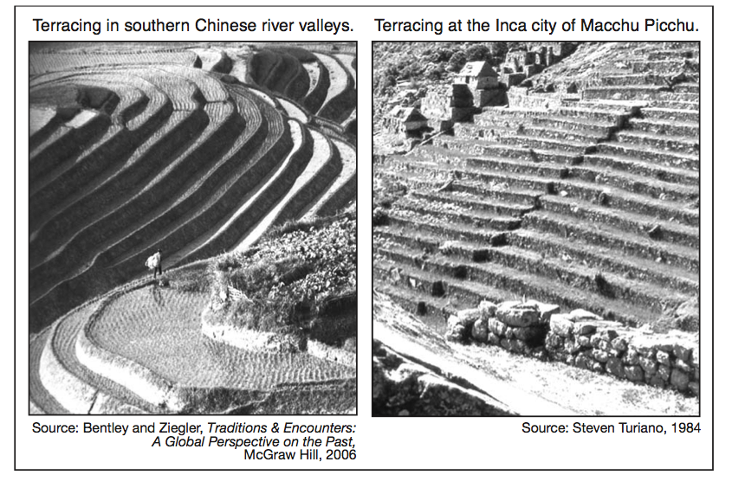
- These photographs indicate the people of China and the people of ancient Peru modified their environment to

(1) create effective trade routes
(2) increase the amount of land available for agriculture
(3) move large quantities of water into cities
(4) provide an effective defense

- The kingdoms of Ghana, Mali, and Songhai prospered primarily due to their

(1) exchanges with Indian ports
(2) direct access to the Arabian Sea
(3) control of trade routes
(4) abundance of diamonds

- Which statement is an opinion rather than a fact?

(1) Mansa Musa made a pilgrimage to Mecca.
(2) Mali would have flourished without Mansa Musa’s influence.
(3) Mali’s economy was based on the gold and salt trade.
(4) Timbuktu became a center for Islamic learning.

- Which river was essential to the survival of the West African kingdoms of Ghana, Mali, and Songhai?

(1) Thames
(2) Niger
(3) Indus
(4) Euphrates

- The trans-Saharan trade carried out by West African civilizations was primarily based on an exchange of

(1) gold and salt
(2) ivory and silk
(3) silver and tea
(4) hardwoods and animal skins

- One way in which the Silk Roads and the West African trade routes are similar is that along both routes

  - (1) the main items exchanged were ivory and tobacco
  - (2) concrete was used to improve the surface of the roads
  - (3) a single currency was used to make transactions easier
  - (4) ideas were exchanged as merchants interacted with each other

- What was a significant effect of Mansa Musa’s pilgrimage to Mecca?

(1) The African written language spread to southwest Asia.
(2) Military leaders eventually controlled Mali.
(3) Islamic learning and culture expanded in Mali.
(4) The trading of gold for salt ended.

