Regents Q’s: REVIEW-18

1. In Africa, a key factor that has led to desertification is the

(1) loss of animal species

(2) burning of fossil fuels

(3) disposal of toxic waste

(4) overgrazing of livestock

1. **“Contaminated Food from China Sold in the United States”**

**“Computer Virus Shuts Down Hundreds of Businesses Worldwide”**

**“Multinational Corporations Relocate Factories”**

These headlines are directly related to

(1) world hunger

(2) overpopulation

(3) global warming

(4) economic interdependence

1. The “one child” policy in China, established during the late 1970s, was an attempt to

(1) gain the support of the upper classes

(2) increase tax revenue for government programs

(3) eliminate Western influence

(4) reduce the population growth rate

Base your answer to question 4 on the cartoon below and on your knowledge of social studies.



Source: Ammer, Weiner Zeitung, Vienna, Austria, www.cartoonweb.com

1. What is the best title for this cartoon?

(1) “Breaking Through the Iron Curtain”

(2) “Globalization Reaches the Wall”

(3) “Separating East from West”

(4) “A Road to Cultural Uniqueness”

1. **“Reliance on Imported Oil Raises Concerns in China, Europe, & the United States”**

**“Coca-Cola Accused of Wasting Precious Water in India”**

**“Competition for Control of Cobalt Mines Causes Violence in Congo”**

These headlines best illustrate the economic concept of

(1) inflation

(2) embargo

(3) boycott of goods

(4) scarcity of resources

Base your answer to question 6 on the cartoon below and on your knowledge of social studies.



1. Which statement best reflects this cartoonist’s point of view?

(1) The development of computer technology is prohibited in China.

(2) Chinese prisoners are denied access to computers.

(3) Foreign software developers have flooded the Chinese market.

(4) Some American firms have assisted the Chinese government in monitoring

citizen computer usage.

1. What is a long-term effect of the Soviet invasion of Afghanistan in 1979?

(1) Communism was strengthened in South Asia.

(2) Hostilities between China and India lessened.

(3) The influence of militant Islamic groups increased in the region.

(4) Tensions along the border between Pakistan and Afghanistan were reduced.

1. The southern edge of the Sahara is expanding in a process called

(1) annexation

(2) conservation

(3) desertification

(4) desalination

1. The destruction of the rain forests in Latin America is primarily due to the

(1) diseases carried by insects

(2) wildfires occurring during dry seasons

(3) devastation caused by high winds during the tropical storm season

(4) demand for timber, farmland, and grazing land

1. Which group of countries earns much of their revenue from the sale of oil?

(1) China, Korea, Jordan

(2) Turkey, Brazil, Lebanon

(3) Argentina, Malaysia, Chile

(4) Saudi Arabia, Nigeria, Venezuela

Base your answer to question 11 on the cartoon below and on your knowledge of social studies.



Source: Auth, The Philadelphia Inquirer, 2002 (adapted)

1. What is the main idea of this 2002 cartoon?

(1) The United States refuses to become involved in another war.

(2) Nuclear proliferation continues to threaten world peace.

(3) The Cold War conflict continues today.

(4) Pakistan is the dominant nuclear force in this region.

1. The term *Green Revolution* refers to

(1) an overthrow of the government by radical parties

(2) increased agricultural production based on technological advancements

(3) a drastic change in the environment based on global warming

(4) decreased food production caused by terrorism

Base your answer to question 13 on the chart below and on your knowledge of social studies.

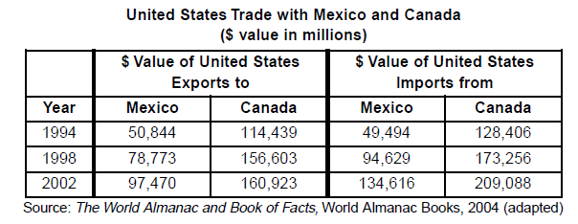

1. The economic trend represented in this chart is most likely an effect of the creation of the

(1) Organization of American States (OAS)

(2) North Atlantic Treaty Organization (NATO)

(3) North American Free Trade Agreement (NAFTA)

(4) Organization of Petroleum Exporting Countries (OPEC)

Base your answer to question 14 on the cartoon below and on your knowledge of social studies.



Source: Brian Barling, Christian Science Monitor, April 25, 2008

1. What is the main idea of this cartoon?

(1) Petroleum is being overproduced.

(2) The demand for petroleum exceeds production.

(3) Fossil fuels are unevenly distributed.

(4) The demands of global environmental groups have increased.

Base your answer to question 15 on the passage below and on your knowledge of social studies.

... The expansion of communications meant that the world got more deeply connected and became “flat,” in Thomas Friedman’s famous formulation. Cheap phone calls and broadband made it possible for people to do jobs for one country in another country—marking the next stage in the ongoing story of capitalism. With the arrival of big ships in the fifteenth century, goods became mobile. With modern banking in the seventeenth century, capital became mobile. In the 1990s, labor became mobile. People could not necessarily go to where the jobs were, but jobs could go to where people were. And they went to programmers in India, telephone operators in the Philippines, and radiologists in Thailand. The cost of transporting goods and services has been falling for centuries. With the advent [coming] of broadband, it has dropped to zero for many services. Not all jobs can be outsourced—not by a long shot—but the effect of outsourcing can be felt everywhere....

* Fareed Zakaria, The Post-American World, W. W. Norton & Company, 2008

1. Which conclusion about the global economy is best supported by this 2008 passage?

(1) The labor market in Asia relies on child labor.

(2) Technology has decreased the cost of doing business.

(3) Capitalism has not met the needs of the working class.

(4) Globalization is creating fewer jobs.

1. By the late 1970s in China, the growing size of its population influenced the government’s decision to

(1) encourage people to migrate to other countries

(2) force families to work on communes

(3) engage in wars to gain territory

(4) institute a one-child policy

1. Which condition, in combination with drought, has most directly forced the migration of people out of the southern regions bordering the Sahara?

(1) urbanization

(2) coastal pollution

(3) wildlife tourism

(4) desertification

Base your answer to question 18 on the passage below and on your knowledge of social studies.

... For Ukraine, however, contamination via river water is still a major problem, since most of the rivers flow southwards. To slow the spread of radiation, protective dams were built along the Dnieper after the accident. “But of course not all riverbanks could be protected in this way,” as the Ukrainian government agency Chernobyl Interinform points out in its summary of the situation. “Particularly during flooding, radiation is still leached into rivers. This is a particular threat for the 30 million people who obtain their drinking water from the Dnieper basin.” ...

* Chernobyl.info

1. The aftermath of which problem is being described in this passage?

(1) volcanic eruption

(2) nuclear disaster

(3) global warming

(4) deforestation

Base your answer to question 19 on the cartoon below and on your knowledge of social studies.

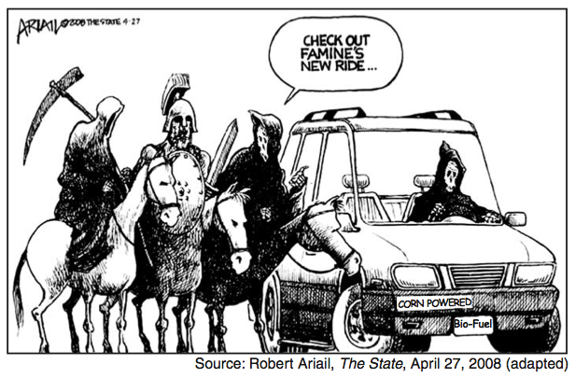

1. What is the main idea of this cartoon?

(1) Riding a horse is more dangerous than riding in an automobile.

(2) The use of bio-fuels made from corn will improve automobile safety.

(3) Using corn to make bio-fuels for automobiles will increase food

shortages.

(4) Feeding corn to horses is less efficient than using it to make fuel for

automobiles.