Regents Q’s: REVIEW-17

1. What was a direct result of the Four Modernizations introduced in China by Deng Xiaoping?

(1) Freedom of speech was guaranteed.

(2) Goods and services were evenly distributed.

(3) Economic opportunities were expanded.

(4) Fewer consumer goods were produced.

1. The gathering at Amritsar (1919), the rallies in Soweto (1976), and the demonstrations in Tiananmen Square (1989) directly resulted in

(1) rejection of Western ideas

(2) promises of economic reform

(3) movements toward democracy

(4) violence against the protestors

Base your answers to question 3 on the cartoon below and on your knowledge of social studies.

**“Filthy Imperialist!”**



Source: Emmwood, Daily Mail, September 23, 1963 (adapted)

1. The tools shown in this cartoon represent traditional symbols of

(1) manorialism

(2) communism

(3) western capitalism

(4) national socialism

1. What was one social change Mao Zedong instituted in China after 1949?

(1) granting legal equality for men and women

(2) requiring arranged marriages

(3) adopting the practice of foot binding

(4) mandating Confucianism as the state philosophy

1. Which of these groups were the major supporters of 20th-century communist revolutions?

(1) priests and artisans

(2) bourgeoisie and nobility

(3) entrepreneurs and capitalists

(4) workers and peasants

1. One way in which Joseph Stalin’s five-year plans and Mao Zedong’s Great Leap Forward are similar is that both plans were

(1) efforts to reduce human rights violations

(2) policies to improve relations with the West

(3) methods used to control population growth

(4) attempts to increase agricultural and industrial production

1. The treatment of untouchables in India, the treatment of Jews during the Holocaust, and the treatment of Chinese student demonstrators in Tiananmen Square are all examples of

(1) fascist policies

(2) extraterritoriality

(3) excommunication

(4) human rights violations

1. Which Chinese leader is most closely associated with leading the Great Leap Forward and the Cultural Revolution?

(1) Sun Yixian (Sun Yat-sen)

(2) Jiang Jieshi (Chiang Kai-shek)

(3) Mao Zedong

(4) Deng Xiaoping

1. Which leader’s policies included *glasnost* and *perestroika*?

(1) Fidel Castro

(2) Nikita Khrushchev

(3) Mikhail Gorbachev

(4) Deng Xiaoping

1. The goal of Mikhail Gorbachev’s policies of perestroika and glasnost was to

(1) expand collectivization and communes

(2) resume development of Soviet nuclear weapons

(3) stimulate economic growth and political discussion

(4) stop expansion of the North Atlantic Treaty Organization (NATO) into

Eastern Europe

1. One way in which Vladimir Lenin’s New Economic Policy and Mikhail Gorbachev’s policy of perestroika are similar is that both

(1) allowed elements of capitalism within a communist economic system

(2) strengthened their country’s military defenses

(3) supported censorship of news and of personal correspondence

(4) increased tensions during the Cold War

1. Which action occurred in the Soviet Union under Mikhail Gorbachev?

(1) Peasants were forced onto collective farms.

(2) Citizens experienced more personal freedoms under glasnost.

(3) The United States and the Soviet Union ended diplomatic relations.

(4) The Soviet government increased its control over the Orthodox Church.

1. Mikhail Gorbachev’s reforms of perestroika and glasnost resulted in

(1) an era of world peace and Soviet prosperity

(2) conditions that helped lead to the breakup of the Soviet Union

(3) a successful transition to a command economy in Russia

(4) censorship of the news media in Russia

Base your answer to question 14 on the cartoon below and on your knowledge of social studies.

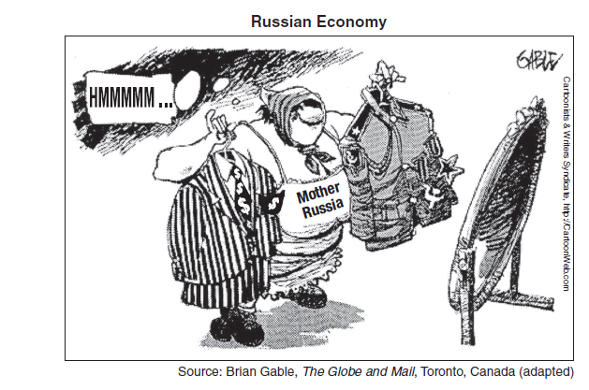

1. The main idea of this 1990s cartoon is that Russia is

(1) deciding between a capitalist or a communist system

(2) attempting to restore military power

(3) expressing concern about how the rest of the world views its government

(4) maintaining a balance between a civilian and a military government

1. During the Cold War, which event occurred *last?*

(1) Cuban missile crisis

(2) destruction of the Berlin Wall

(3) Berlin airlift

(4) launch of *Sputnik* by the Soviet Union

Base your answer to question 16 on the map below and on your knowledge of social studies.

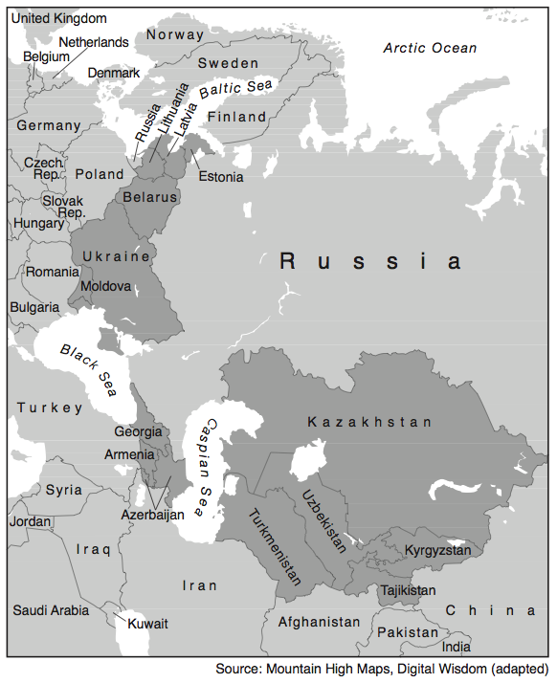

1. What do the darkest areas of this map represent?

(1) former republics of the Soviet Union

(2) current members of the European Union

(3) original member countries of the Warsaw Pact

(4) recent additions to the Organization of Petroleum Exporting Countries

(OPEC)