Regents Q’s: REVIEW-15

- Which country was ruled by Pol Pot and the Khmer Rouge?

(1) Afghanistan
(2) Kazakhstan
(3) Cambodia
(4) Bangladesh

- Which characteristic is most closely associated with both Pol Pot’s government in Cambodia and Slobodan Milosevic’s government in Yugoslavia?

(1) use of terror to achieve political goals
(2) support for freedom of speech
(3) establishment of a theocratic system
(4) respect for ethnic minorities

Base your answer to question 3 on the time line below and on your knowledge of social studies.
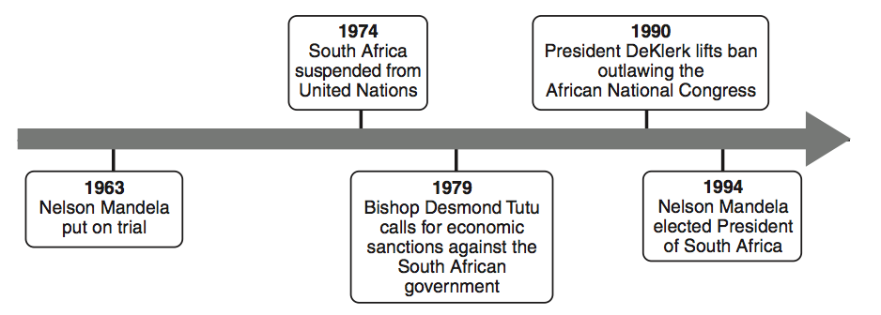
- Which policy is most closely associated with the events on this time line?

(1) nonalignment
(2) détente
(3) containment
(4) apartheid

- Which area was once controlled by Britain, suffered a mass starvation in the 1840s, and became an independent Catholic nation in 1922?

(1) Scotland
(2) India
(3) Ghana
(4) Ireland
- • The Nazi Party controls Germany.
• Khmer Rouge rules in Cambodia.
• The Sandinistas control Nicaragua.
Which statement describes a similarity in these situations?

(1) Civil liberties were promoted.
(2) Voting rights were extended to women.
(3) Leaders won the support of all groups.
(4) One group seized power and limited opposition.

Base your answer to question 6 on the chart below and on your knowledge of social studies.
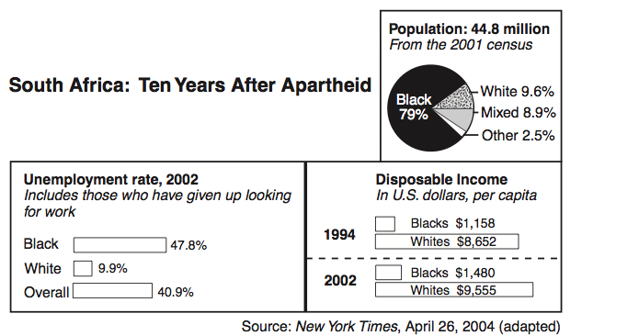

- Which conclusion about South Africa’s economy can be drawn from this chart?

(1) Since the end of apartheid, most blacks have gained economic equality.
(2) In some sectors of the economy, blacks earn more than whites.
(3) Despite the end of apartheid, many blacks continue to struggle
economically.
(4) Economic opportunity for blacks is directly related to education reform.

- Which statement about the Balkan Peninsula since 1995 is most accurate?

(1) Bosnia-Herzegovina and Croatia are now both controlled by Yugoslavia.
(2) Ethnic tensions and conflict continue to be a problem in much of the region.
(3) Slobodan Milosevic of Serbia became the first democratically elected leader
of the region.
(4) The Balkan Peninsula has become one of the most prosperous regions in
Europe.

Base your answers to question 8 on the map below and on your knowledge of social studies.
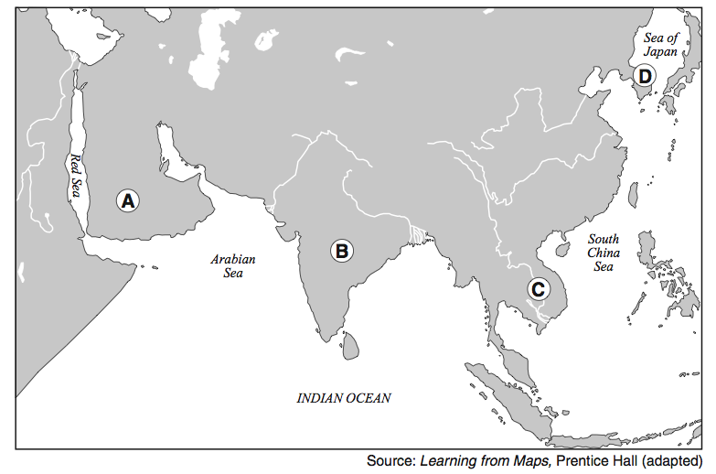
- Which letter identifies the peninsula that was the site of the Vietnam conflict and the atrocities of Pol Pot?

(1) A
(2) B
(3) C
(4) D

- During the 20th century, global attention was drawn to the Armenians of the Ottoman Empire, the Tutsis of Rwanda, and the Muslims of Kosovo because these groups were all victims of

(1) nuclear power accidents
(2) human rights violations
(3) environmental disasters
(4) the AIDS epidemic

Base your answer to question 10 on the cartoon below and on your knowledge of social studies.
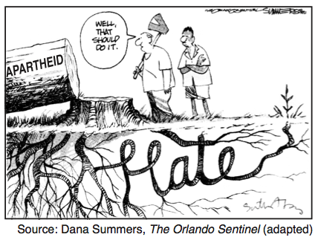
- What is the main idea of this cartoon?

(1) The original causes of apartheid have not been eliminated.
(2) Apartheid improved race relations in South Africa.
(3) Peace can be achieved by nonviolence.
(4) Hate is caused by poverty.
Base your answer to question 11 on the cartoon below and on your knowledge of social studies.

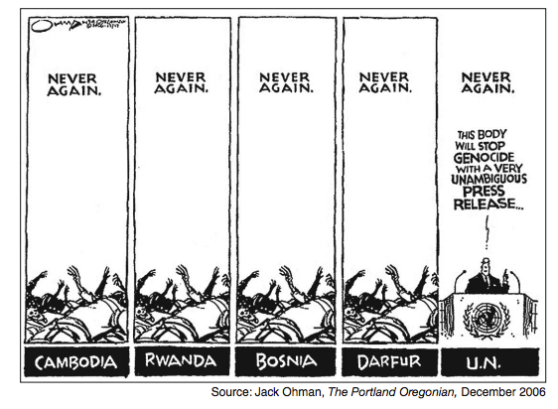
- What is the key idea of this cartoon?

(1) Genocide in Cambodia, Rwanda, Bosnia, and Darfur has been stopped.
(2) Human rights issues are best dealt with by the United Nations.
(3) The United Nations has not been effective in ending genocide.
(4) Fear of war crimes trials has brought peace to troubled regions.

