Regents Q’s: REVIEW-13

1) Which statement describes one major aspect of a command economy?

(1) Supply and demand determines what will be produced.

(2) Most economic decisions are made by the government.

(3) The means of production are controlled by labor unions.

(4) The economy is mainly agricultural.

2) Five-year plans and collectivization are most closely associated with

(1) Joseph Stalin

(2) Mikhail Gorbachev

(3) Adolf Hitler

(4) Deng Xiaoping

3) The Bolshevik Party in 1917 gained the support of the peasant class because they promised them

(1) “Peace, Land, and Bread”

(2) “Liberty, Equality, Fraternity”

(3) abolition of the secret police

(4) democratic reforms in all levels of government

4) Joseph Stalin’s policies in Ukraine during the 1930s directly resulted in

(1) widespread starvation

(2) agricultural self-sufficiency

(3) the development of cottage industries

(4) the use of subsistence farming techniques

5) • Five-year plans

• Collectivization of agriculture

• Great Purge

Which individual is associated with all these policies?

(1) Adolf Hitler

(2) Joseph Stalin

(3) Deng Xiaoping

(4) Jawaharlal Nehru

Base your answer to question 6 on the cartoon below and on your knowledge of social studies.



6) In the view of this cartoonist, Russia under Lenin’s rule was characterized by

(1) a continuation of traditional life

(2) the introduction of capitalism

(3) support for a constitutional monarchy

(4) rejection of the czarist system

7) Which aspect of the economy was emphasized in Joseph Stalin’s five-year plans?

(1) heavy industry

(2) consumer goods

(3) famine relief

(4) private landownership

8) Totalitarian countries are characterized by

(1) free and open discussions of ideas

(2) a multiparty system with several candidates for each office

(3) government control of newspapers, radio, and television

(4) government protection of people’s civil liberties

Base your answers to questions 9 and 10 on the chart below and on your knowledge of social studies.

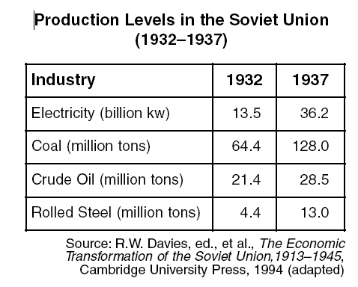

9) Which policy is illustrated in this chart?

(1) pogroms

(2) five-year plans

(3) Russification

(4) nuclear arms

10) The data in this chart illustrate the

(1) benefits of foreign trade

(2) successful development of heavy industry

(3) availability of consumer goods

(4) effects of inflation on the economy

11) Under communism in the former Soviet Union, people were required to

(1) reject modern technology

(2) limit the size of their families

(3) honor their ancestors and religious traditions

(4) put the interests of the state before individual gain

1. The Amritsar Massacre and the Salt March are both associated with the independence movement in

(1) Iraq

(2) India

(3) China

(4) Kenya

1. Which political leader gained power as a result of the failing economy of the Weimar Republic?

(1) Adolf Hitler

(2) Francisco Franco

(3) Benito Mussolini

(4) Charles de Gaulle

1. Between 1923 and 1938, which leader instituted a modernization program in Turkey?

(1) Shah Reza Pahlavi

(2) Jawaharlal Nehru

(3) Kemal Atatürk

(4) Ho Chi Minh

1. Mohandas Gandhi’s protests during India’s independence movement were often successful because of his application of

(1) an appeasement policy

(2) civil disobedience

(3) traditional caste beliefs

(4) divide-and-conquer principles

1. Which leader is most closely associated with the rise of fascism in Italy prior to World War II?

(1) Ho Chi Minh

(2) Winston Churchill

(3) Mao Zedong

(4) Benito Mussolini

1. One similarity between Adolf Hitler and Benito Mussolini is that both

(1) led fascist states

(2) supported communism

(3) rejected militarism

(4) remained in power after World War II

Base your answer to question 18 on the graphic organizer below and on your knowledge of social studies.

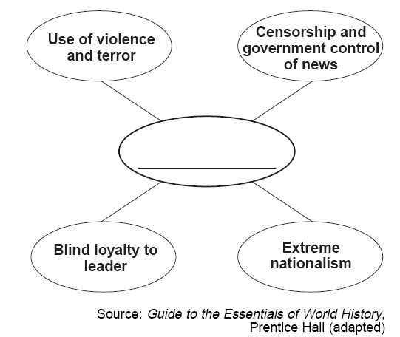

1. Which ideology best completes this graphic organizer?

(1) socialism

(2) democracy

(3) capitalism

(4) fascism

1. Which statement about both the Bolshevik Revolution in Russia and the rise of fascism in Germany and Italy is accurate?

(1) Economic conditions led to political change.

(2) Industrialization hindered national development.

(3) Goals were achieved by peaceful means.

(4) Communist ideals fueled both movements.

Base your answer to question 20 on the map below and on your knowledge of social studies.

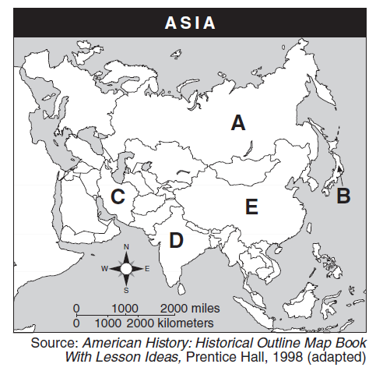

1. Which letter identifies the nation most closely associated with Mohandas Gandhi?

(1) *A*

(2) *B*

(3) *C*

(4) *D*

Base your answers to question 21 on the cartoon below and on your knowledge of social studies.

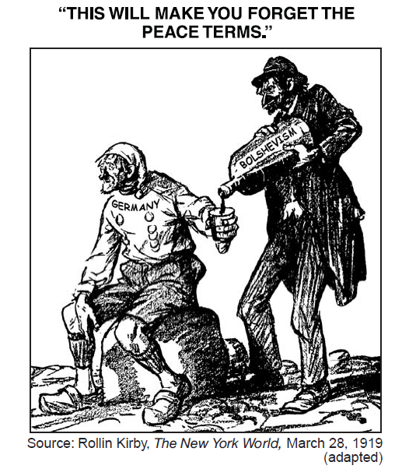

1. This cartoonist is referring to the way Germany was affected in 1919 by

(1) the Congress of Vienna

(2) its defeat of Napoleon

(3) the Treaty of Versailles

(4) its defeat in World War II