Regents Q’s 2-5

- Which leader’s policies included glasnost and perestroika?

(1) Fidel Castro
(2) Nikita Khrushchev
(3) Mikhail Gorbachev
(4) Deng Xiaoping

- The goal of Mikhail Gorbachev’s policies of perestroika and glasnost was to

(1) expand collectivization and communes
(2) resume development of Soviet nuclear weapons
(3) stimulate economic growth and political discussion
(4) stop expansion of the North Atlantic Treaty Organization (NATO) into
Eastern Europe

- One way in which Vladimir Lenin’s New Economic Policy and Mikhail Gorbachev’s policy of perestroika are similar is that both

(1) allowed elements of capitalism within a communist economic system
(2) strengthened their country’s military defenses
(3) supported censorship of news and of personal correspondence
(4) increased tensions during the Cold War

- Which action occurred in the Soviet Union under Mikhail Gorbachev?

(1) Peasants were forced onto collective farms.
(2) Citizens experienced more personal freedoms under glasnost.
(3) The United States and the Soviet Union ended diplomatic relations.
(4) The Soviet government increased its control over the Orthodox Church.

- Mikhail Gorbachev’s reforms of perestroika and glasnost resulted in

(1) an era of world peace and Soviet prosperity
(2) conditions that helped lead to the breakup of the Soviet Union
(3) a successful transition to a command economy in Russia
(4) censorship of the news media in Russia

Base your answer to question 6 on the cartoon below and on your knowledge of social studies.
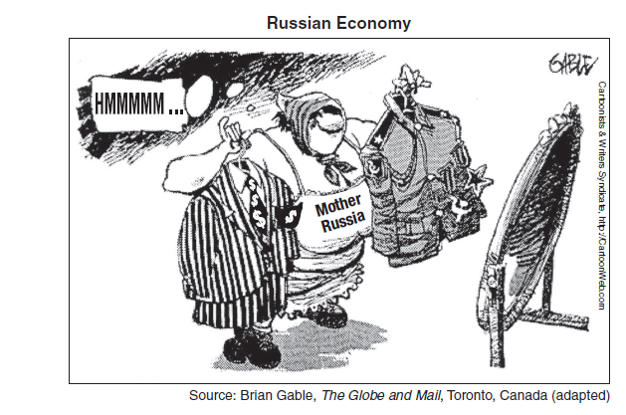

- The main idea of this 1990s cartoon is that Russia is

(1) deciding between a capitalist or a communist system
(2) attempting to restore military power
(3) expressing concern about how the rest of the world views its government
(4) maintaining a balance between a civilian and a military government

- During the Cold War, which event occurred last?

(1) Cuban missile crisis
(2) destruction of the Berlin Wall
(3) Berlin airlift
(4) launch of Sputnik by the Soviet Union

Base your answer to question 8 on the map below and on your knowledge of social studies.

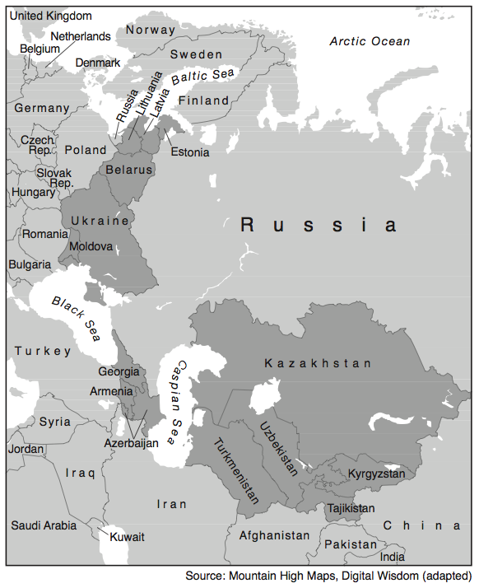

- What do the darkest areas of this map represent?

(1) former republics of the Soviet Union
(2) current members of the European Union
(3) original member countries of the Warsaw Pact
(4) recent additions to the Organization of Petroleum Exporting Countries
(OPEC)

