Global 4: Test 1
REVIEW SHEET

WEEK 2-1:

- Which concept is represented in these World War I recruiting posters? (Hint: these posters want people to have pride in their country)

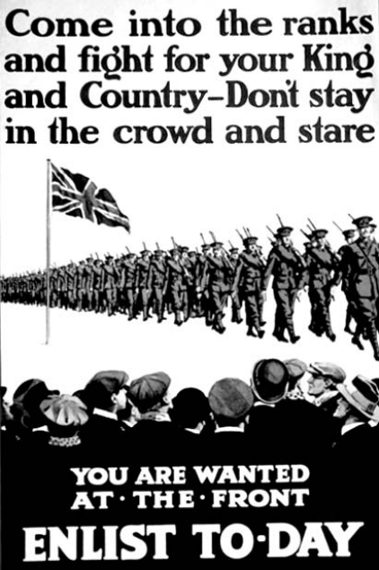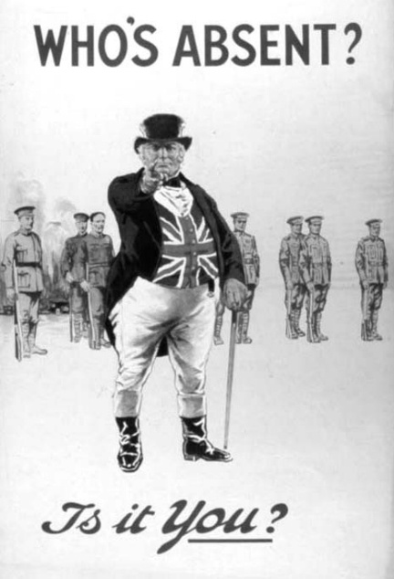

- Which event is considered the immediate cause of World War I?

- Define: militarism

- The assassination of Archduke Franz Ferdinand was the immediate cause of which war?

- Which region was described as “the powder keg of Europe” prior to World War I?

- Which type of warfare was used in World War I?

- What were the underlying long-term causes of World War I? (Hint: MAIN)

- What were the economies doing at home during World War I?

WEEK 2-2:

- What is a command economy?

- Five-year plans and collectivization are most closely associated with which leader?

- The Bolshevik Party in 1917 gained the support of the peasant class because they promised them 3 things. What were they? (Hint: slogan)

- What happened as a result of Joseph Stalin’s policies (collectivization) in Ukraine during the 1930s?

- • Five-year plans
• Collectivization of agriculture
• Great Purge

Which individual is associated with all these policies?

- According to this cartoon, what did Lenin want Russia to get rid of?
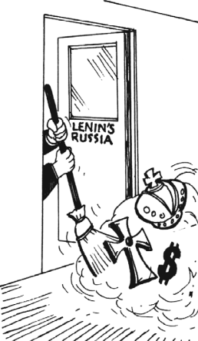

- What was the goal of Joseph Stalin’s five-year plans?

- What is totalitarianism?

- What is communism?

- • Led the Russians in a second revolution (1917)
• Promised “Peace, Land, and Bread”
• Established the New Economic Policy (NEP)

Which leader is being described by these statements?

WEEK 2-3:

- The Amritsar Massacre and the Salt March are both associated with the independence movement in which country?

- Disintegration of the Austro-Hungarian Empire, creation of new nation-states in central Europe, and Germany’s loss of colonies were all consequences of which war?

- Which political leader gained power as a result of the failing economy of the Weimar Republic?

- Between 1923 and 1938, which leader instituted a modernization program in Turkey?

- Mohandas Gandhi’s protests during India’s independence movement were often successful because of what strategy?

- Which leader is most closely associated with the rise of fascism in Italy prior to World War II?

- Which type of government or way of thinking best completes this graphic organizer?

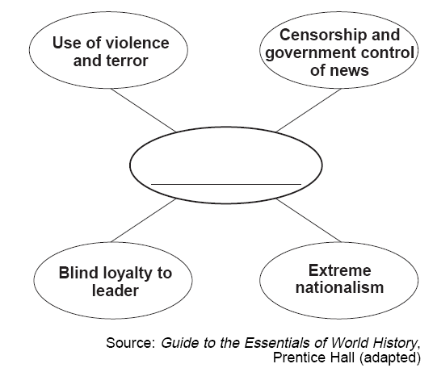

- This cartoonist is referring to the way Germany was affected in 1919 by what document?

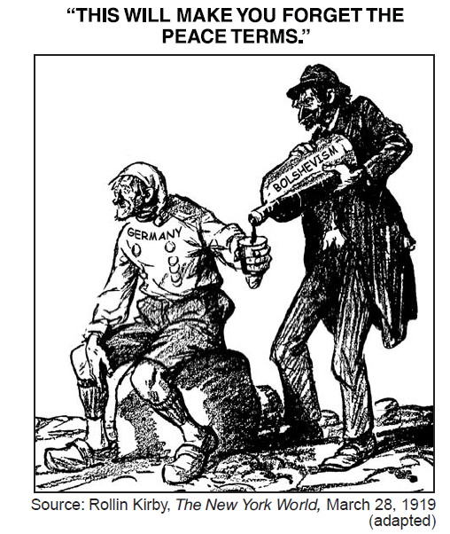

- Why was Mohandas Gandhi protesting against Great Britain in India? Why was Great Britain there?

- One similarity between Adolf Hitler and Benito Mussolini is that both were

_____________________________ leaders.

- Why was the Bolshevik Revolution in Russia and the rise of fascism in Germany and Italy successful?

- Which letter identifies the nation most closely associated with Mohandas Gandhi?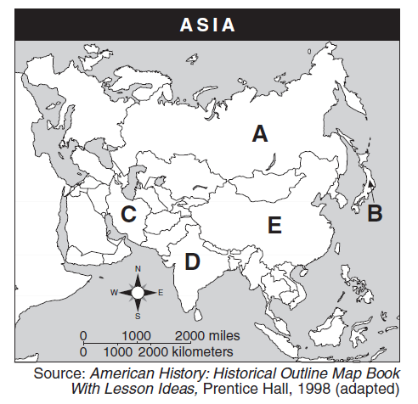

- What was one reason that totalitarian dictatorships gained power in Europe between World War I and World War II?

- Based on the information in this chart, which were the 3 big reasons for the Nazis’ rise to power in Germany?
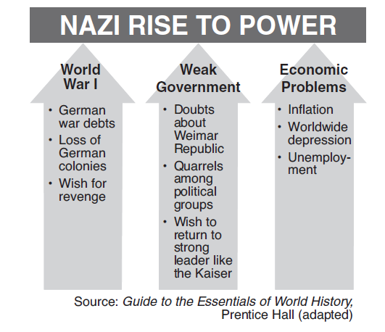

WEEK 2-4:

- Why were the Nuremberg Trials important?

- What is the goal of the United Nations?

Base your answers to questions 35 & 36 on the cartoon below & on your knowledge of social studies.
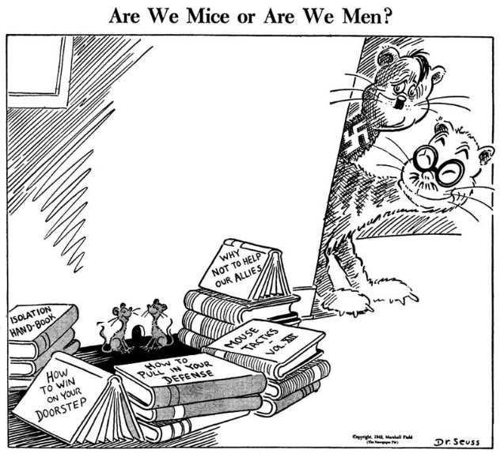

- Which war is this cartoon about?

- What foreign policy is shown in this cartoon?

- Which country attacked Nanjing?

Base your answer to question 38 on the cartoon below and on your knowledge of social studies.
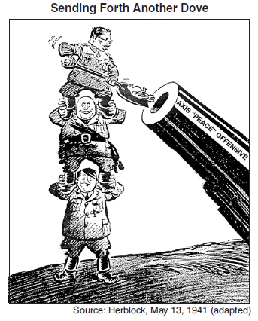
- How would you describe the actions of Japan, Italy, & Germany in this cartoon?

- Define: appeasement

Base your answer to question 40 on the cartoon below and on your knowledge of social studies.
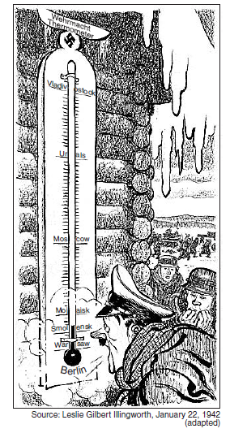
- In this cartoon, who is looking at the temperature & where are they?

WEEK 2-5:

- What is the name of the imaginary line that divided Europe (West vs. East) after WWII?

- Which side were the “nonaligned” countries on?

- What was the Marshall Plan?

- Which countries served as surrogate fighters during the Cold War?

WEEK 2-6:

- How were Stalin’s five-year plans similar to Mao’s Great Leap Forward?

- How did Deng Xiaoping’s “Four Modernizations” affect the economy of China?

- Why do we see religious & ethnic tensions within the same country, all over Africa?

Base your answer to question 48 on the time line below and on your knowledge of social studies.
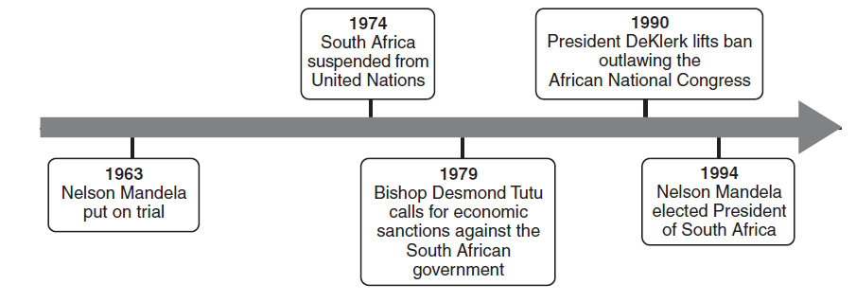
- Which vocab word best describes the events in the timeline?

- How did the government react to protestors in Tiananmen Square?

- What class of people often supported communist revolutions? (Hint: what do the hammer & sickle represent)

THEMATIC ESSAY: Background Info…

Person | Idea | Historical Background | Effect on Nation
Nelson Mandela
Deng Xiaoping

