What were the costs of transforming the USSR from communism to a democratic/capitalist Russia?

- Poverty

As far as the transformation countries are concerned, a leading role in the international debate has been played by the World Bank, and its income distribution specialist, Milanovic. His data have the advantage of being – in principle - internationally comparable and of not being produced by a researcher or organization that might be considered to have an interest in painting an alarmist picture. Milanovic has presented the following data, which are based on an absolute poverty line of four dollars (at 1990 international prices) per capita per day

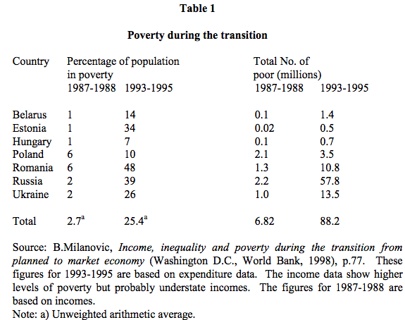

One result of impoverishment has been a worsening of the diet of many people. In Russia a significant problem of undernourishment seems to have developed, in particular among children in poor households. It seems that stunting in Russian children under two increased from 9.4 per cent in 1992 to 15.2 per cent in 1994.
Poverty among children has affected not only their diet, but also their schooling, extra-school activities, and social integration.

- Decline of employment

Officially registered employment in the central and east European countries (excluding the former GDR) fell from about 193 million in 1989 to less than 170 million in 1996, i.e. by about 12 per cent.
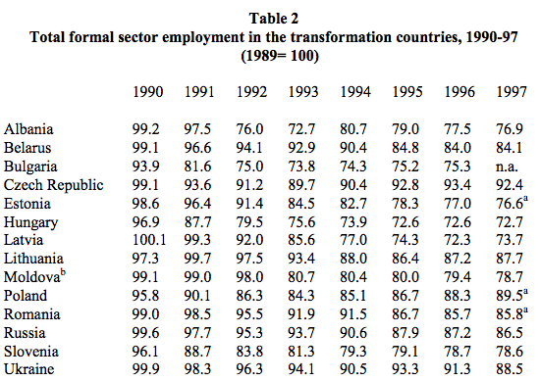

Table 2 shows both the general fall in formal sector employment as well as the particularly sharp falls in some countries, e.g. Hungary and Latvia, which have lost more than a quarter of their formal employment during transformation.

The fall in formal sector employment has had important – usually negative – consequences for the people concerned. It has frequently led to a decline in individual and family income, social exclusion, and a worsening of the life chances of their children. Those ejected from the formal sector currently work abroad (as temporary or permanent – and often illegal – gastarbeiters), in the household or informal sectors, have retired, or have become unemployed.

The decline in employment has disproportionately affected women. In general, the decline in female employment has been larger – in some cases very much larger - than the decline in male employment.

- Increased inequality

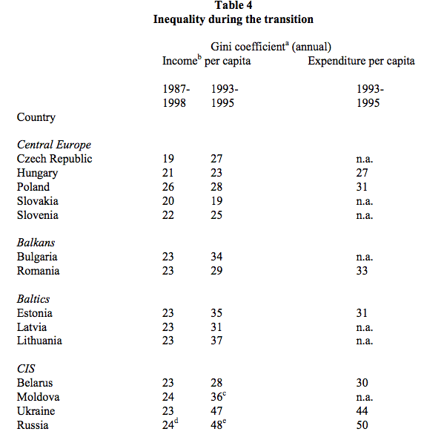

The big increase in inequality in Russia is an important part of the explanation of how it was possible that there was a large growth in consumer durable ownership in that country despite the decline in average real incomes.

- Deterioration of public services

During the transformation, many public social provisions have deteriorated or ceased to be public facilities. For example, there has been neglect of the maintenance of school buildings in many countries. In some countries, such as Bulgaria, Moldova and FYR Macedonia, the heating of schools in winter has become a serious problem. In many countries the provision of school meals has significantly declined.

The costs of education for children and their parents (both direct costs such as textbooks and shoes, and opportunity costs such as the cut in family income resulting from loss of work done on the family farm), migration, the decline in the quality of education (in some countries), and the decline in public administration, have led to a fall in the proportion of certain age groups attending schools (see Table 5).

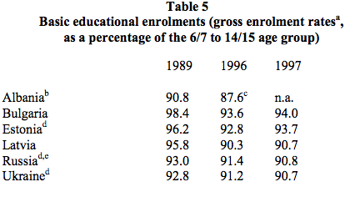
Educational inequality has, in many cases, increased both in provision and achievement. For example in Hungary there has been an increase in the disparity in learning achievements between children in the main cities and in the villages.

In Russia too, educational inequalities have increased. According to a recent study, there are diminishing educational opportunities for many children, especially those who are rural, less affluent, or less well-connected – regardless of their individual merit… As Russian society becomes increasingly stratified in terms of wealth, Russian education is increasingly stratified in terms of opportunity.”

Another example of educational inequality, concerns ethnic minorities. One such case is the situation of Roma children. A 1992 study showed that in Romania only 51 per cent of Roma children of 10 years old regularly attended school, 14 per cent had stopped school, 16 per cent went to school occasionally, and 19 per cent had never been to school.

- Growth of corruption

If one ranks countries by their perceived level of corruption according to Transparency International’s 1999 Corruption Perception Index, then three transformation countries – Slovenia, Estonia & Hungary – are less corrupt than Italy, and one transformation country – Czech Republic – is only just more corrupt than Italy. However, a number of CIS countries – Moldova, Ukraine, Armenia, Russia, Georgia, Kazakhstan, Kyrgystan, Uzbekistan, Azerbaijan– are exceptionally corrupt (significantly more so than even China or Ghana.)

As far as distribution is concerned, corruption reallocates resources to the rich and powerful and is ultimately paid for by the general public.

As far as incentives are concerned, corruption distorts the energies of officials and citizens towards socially unproductive rent seeking. Corruption creates risks, generates the need for unproductive preventive measures, and distorts investment away from areas with high corruption.

As far as politics is concerned, corruption breeds popular alienation and cynicism and ultimately regime instability.

Conclusions

(1) The transformation was a change of system that had serious adverse social consequences for much of the population. These consequences, however, were in general less than the costs of previous change of system in the region.

(2) These consequences included widespread impoverishment, a decline in employment, growth in unemployment, increased inequality, decline in publicly provided services, social exclusion, and in some countries a worsening of the health of the population.

(3) The transformation has led to the growth of a variety of socio-economic pathologies, such as corruption, criminalization, informalization, alcoholism, and tobacco and drug addiction.

(4) There are sharp differences between transformation countries. Whereas some are already (with respect to such indicators as health and corruption levels) Europeanized, others lag a long way behind EU levels. In place of the former homogenous socialist camp, a sharp polarization has developed between countries. Unfortunately, the majority of the population of the region live in the relatively unsuccessful countries

(5) The transformation has brought not only social costs but also many social benefits (such as easier access to modern contraception, increased foreign travel, more interesting media, greater possibilities for legal self-employment and entrepreneurship, in some cases a reduction in national oppression, etc).

Taken from:

Michael Ellman’s Paper: THE SOCIAL COSTS AND CONSEQUENCES OF THE TRANSFORMATION PROCESS

http://www.unece.org/fileadmin/DAM/ead/sem/sem2000/ellman.pdf

