World War I DBQ Documents

Document 1
This chart provides information on the increasing amounts of money spent on armaments rom 1870-1914.
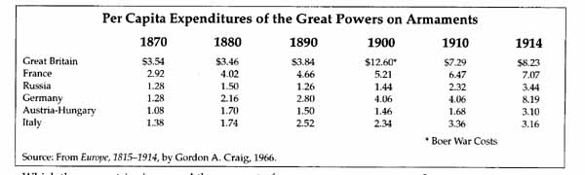
Which three countries increased the amount of money spent on weapons?
1. __________________________________________________________________
2. __________________________________________________________________
3. __________________________________________________________________

How did this increase the chance for war?

__________________________________________________________________
__________________________________________________________________
__________________________________________________________________
__________________________________________________________________

Document 2
.This map of Europe on the eve of World War I shows the alliance systems.
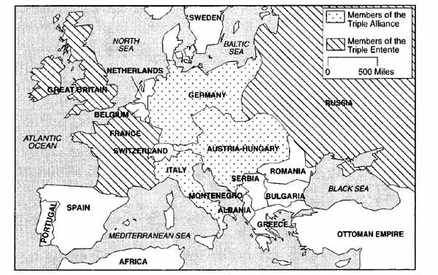
Who were the members of each alliance system?

1. __________________________________________________________________
____________________________________________________________________
____________________________________________________________________

2. __________________________________________________________________
____________________________________________________________________
____________________________________________________________________

How did alliance systems contribute to the outbreak of World War I?

__________________________________________________________________
__________________________________________________________________
__________________________________________________________________
__________________________________________________________________

Document 3
This is an excerpt from the Austro-Hungarian Red Book Number 7. It is the ultimatum that Austria-Hungary sent to Serbia on July 23, 1914.
.....the Royal Serbian Government has done nothing to repress these movement. It has permitted the criminal machinations of various societies and associations directed against the Monarchy, and has tolerated unrestrained language on the part of the press, the glorification of the perpetrators of outrages and the participation of officers and functionaries in subversive agitation.
....[The] Royal Government see themselves compelled to demand from the Royal Serbian Government a formal assurance that they condemn this dangerous propaganda against the Monarchy..
....To accept the collaboration in Serbia of representative so the Austro-Hungarian Government for the suppressions of subversive movement.

What were the accusations made by Austria-Hungary to Serbia?

__________________________________________________________________
__________________________________________________________________
__________________________________________________________________
__________________________________________________________________
What two demands did Austria-Hungary make on Serbia?
- __________________________________________________________________
__________________________________________________________________

- __________________________________________________________________
__________________________________________________________________

Document 4
This excerpt is from Article 231 of Versailles Treaty, which Germany signed, thereby ending World War I.
....The Allied and Associate Governments affirm and Germany accepts the responsibility of Germany and her allies for causing all the loss and damage.....

According to the Versailles Treaty, who was responsible for World War I? Why?

__________________________________________________________________
__________________________________________________________________
__________________________________________________________________
__________________________________________________________________

Document 5
In this excerpt from May 7, 1919, Count Brockdorff-Rantzau, leader of the German delegation to the Versailles Peace Conference, protested.
It is demanded of us that we shall confe3ss ourselves to be alone guilty of the war. Such a confession from my lips would be a lie. We are far from declining all responsibility for the fact that this great World War took place of that it was fought in the way that it was.....But fact that this great World War took place of that it was fought in the way that it was....But we energetically deny that Germany and its people, who were convinced that they fought a war of defense, were alone guilty. No one would want to assert that the disaster began only at the disastrous moment when the successor of Austria-Hungary fell a victim to murderous hands. In the last fifty years, the imperialism of all European states has chronically poisoned international relations. Polices of retaliation, polices of expansion, and disregard for the right of peoples to determine their own destiny, have contributed to the European malady which came to a crisis in the World War. The mobilization of Russia deprived statesmen of the opportunity of curing the disease, and placed the issue in the hands of the military powers.....

What position did the German delegation leader present?
__________________________________________________________________
__________________________________________________________________
__________________________________________________________________
__________________________________________________________________

What did he say caused the war?
__________________________________________________________________
__________________________________________________________________
__________________________________________________________________
__________________________________________________________________

Document 6
In his book, Origins of the World War, Sidney Bradshaw Fay stated his position on the causes of World War I
Nevertheless, a European war broke out. Why? Because in each country [of Europe] political and military leaders did certain things which lead to the mobilization [of their armies for war] and finally to the declarations of war or [these leaders] failed to do certain things which might have prevented [the war]. In this sense, all the European countries in greater or lesser degree were responsible [of the outbreak of World War I].

According to this author, who was responsible for the outbreak of World War I?

__________________________________________________________________
__________________________________________________________________
__________________________________________________________________
__________________________________________________________________

What did he cite as evidence to support this claim?

__________________________________________________________________
__________________________________________________________________
__________________________________________________________________
__________________________________________________________________

Document 7
This is an excerpt from The Century of Total War by Raymond Aron (Doubleday and Company, 1954)
...The rise of Germany, whose supremacy France dreaded and who navy menaced [or threatened] England, had created among [ England and France] an alliance which claimed it was defensive in nature but was denounced by German propaganda as an attempt at [the] encirclement [of Germany]. The two armed camps alarmed each other, and each grew heavy with multiplied incidents, which spread East [with the assassination of the Archduke Ferdinand], where Russia and Austria were advancing contradictory claims....

What role did the assassination and the ultimatum play in the outbreak of the war?

__________________________________________________________________
__________________________________________________________________
__________________________________________________________________
__________________________________________________________________

What responsibility did the alliance systems play in the outbreak of the war?

__________________________________________________________________
__________________________________________________________________
__________________________________________________________________
__________________________________________________________________

