World War 1 NOTES

- The Ottoman Empire was nicknamed: “The ____________________ Man of Europe.”

- Color in the “Powder Keg” on the map. Label the area.
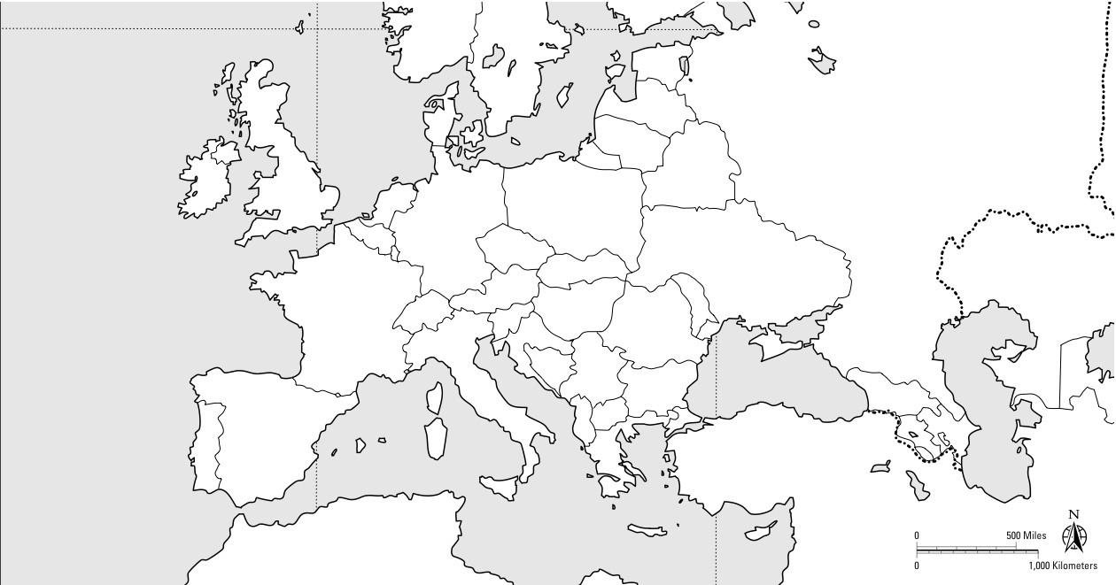

- What were the MAIN long-term causes of World War I?

M _______________________________________________
A _______________________________________________
I _______________________________________________
N _______________________________________________

- What was an immediate (short-term) cause of World War I?

- Fill in the map of the two teams below
Central Powers | Allies
1. | 1.
2. | 2.
3. | 3.
 | *LATER:

- During World War I, both sides fought using ____________________________ warfare.

- Define total war: __________________________________________________________________________________________________________________________________________________________________________________

- What role did government play in the economy during the war?

- What were 2 major turning points of the war?

- Russia…. _____________________________________________________________________________
- The U.S…. ____________________________________________________________________________

- The war ended in _________________________. The ______________________________ won.

- Three effects of World War I were:

- __________________________________________________________________________________
- __________________________________________________________________________________
- __________________________________________________________________________________

