VOCAB SENTENCES 1-5

ALLIANCE

The two nations formed an alliance to defend each other in case of attack.

I recently joined the Gay-Straight Alliance club.

People Nation is an alliance of street gangs generally associated with the Chicago area. They are rivals to the Folk Nation.

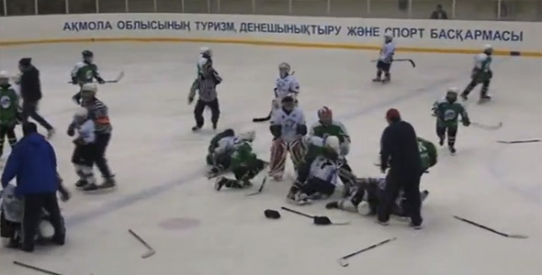

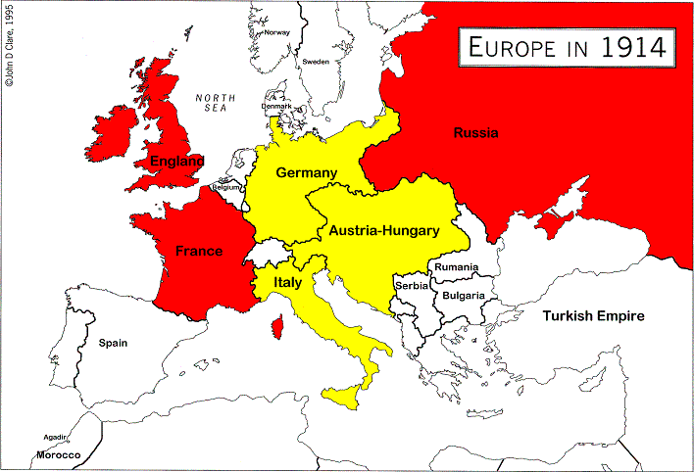

CIVILIANS

Could Saddam Hussein have been removed from power without bombing innocent, Iraqi civilians?

On the soldier’s day off, he was able to wear civilian clothes.

Military prison is much worse than civilian prison.

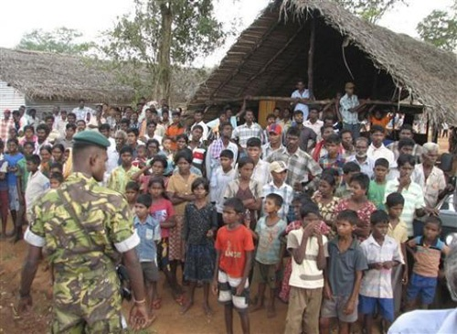

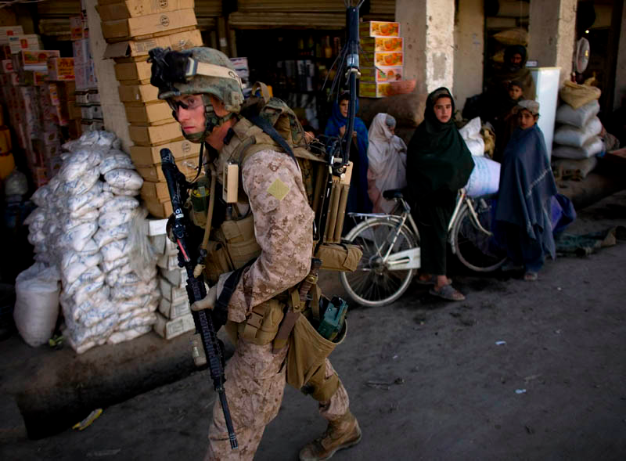

ASSASSINATE

John F. Kennedy was assassinated at 12:30PM on Friday, November 22, 1963 while traveling with his wife.

There have many assassination attempts on Fidel Castro, but he’s still living.

Lincoln was the first American president to be assassinated.

