Russian Revolution NOTES

- Label Russia on the map.
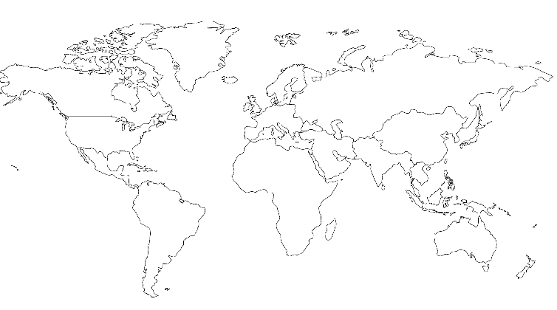

- What type of government did the government have before the revolution?

- What war made Russia lose a lot of power in 1904-5?

- What was “Bloody Sunday” in 1905?

- How did Rasputin, “the evil monk” become so powerful?

- What type of government did the Bolsheviks support?

- Lenin won the support of the people with the slogan:

“_______________________________________________________________________________________”

- CIRCLE: Who did the US support? Lenin OR Czar Nicholas II

- Russia changes its name to ____________________________________________________.

- Which type of economy did Lenin use to make the economy better?

- _________________________________________________ came to power after Lenin died. He was a ____________________________________________________ ruler.

- Fill in the chart below showing Stalin’s changes to the USSR.

CHANGE | EXPLANATION
Stalin killed/imprisoned 1,000’s of people
for plotting against him.

Command Economy | _______________________________________ controlled all parts of the economy.
 | To make everything look great!
 | For everything that made him look bad.

- What was the goal of Stalin’s five-year plans?

- How did collectivization affect the people of the USSR?

