Regents Questions: 1-8

Base your answers to questions 1 and 2 on the cartoon below and on your knowledge of social studies.



1. Which war is most closely associated with this cartoon?

(1) Boer War

(2) Russo-Japanese War

(3) World War II

(4) Cold War

1. Which policy is being questioned in this cartoon?

(1) nonalignment

(2) détente

(3) militarism

(4) isolationism

1. One reason the League of Nations failed as a world organization was that it

(1) supported the rise of fascist states

(2) lacked a military force to settle conflicts

(3) dealt with conflict by establishing naval blockades

(4) encouraged the annexation of territory by force

1. . . . “You should take steps now to cease military resistance. Otherwise, we shall resolutely employ this bomb and all our other superior weapons to promptly and forcefully end the war.” . . .

This paragraph from a 1945 Allied leaflet warned the

(1) Czechs of a German invasion

(2) Americans in Hawaii of a Japanese attack

(3) Koreans of a Russian invasion

(4) Japanese civilians of a United States attack

Base your answer to question 5 on the cartoon below and on your knowledge of social studies.

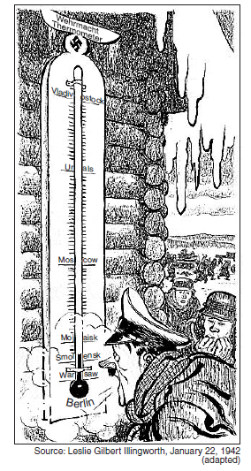

1. This World War II cartoon is showing the relationship between climate and the

(1) inability of Nazi forces to defeat the Soviet Union

(2) success of Allied troops after D-day

(3) efforts by Allied troops to control Berlin

(4) casualties suffered by the Soviet Union

1. The Nuremberg Trials are considered an important event in the 20th century because they

(1) brought an end to genocide

(2) condemned the use of nuclear weapons

(3) ruled on provisions for the postwar occupation of Germany

(4) established principles of responsibility for human rights violations

1. The primary purpose of the United Nations is to

(1) control world grain prices

(2) promote democratic governments

(3) resolve conflicts between nations peacefully

(4) unite all nations militarily through alliances

1. Japan’s invasion of Manchuria, Italy’s attack on Ethiopia, and Germany’s blitzkrieg in Poland are examples of

(1) military aggression

(2) appeasement

(3) containment

(4) the domino theory

1. “. . . Seventy thousand people were killed instantly, and many more would die — 60,000 by November and another 70,000 by 1950. Most of them would be victims of a new method of killing — radiation. . . .”

— Ronald Takai

The situation described in this passage was the direct result of which World War

II event?

(1) blitz of London

(2) attack on Pearl Harbor

(3) D-Day invasion of Normandy

(4) bombing of Hiroshima

Base your answer to question 10 on the cartoon below and on your knowledge of social studies.

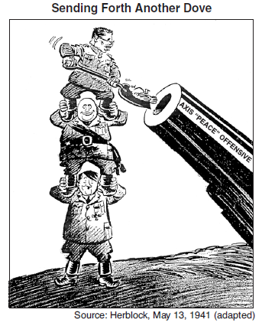

1. The main idea of this 1941 cartoon is that Japan, Italy, and Germany

(1) had formed an alliance for peace

(2) were determined to defeat communism

(3) had supported a peaceful international solution

(4) were committed to aggression

1. The term *appeasement* is best defined as

(1) an attempt to avoid conflict by meeting the demands of an aggressor

(2) a period of peace and prosperity, resulting in cultural achievement

(3) a declaration of war between two or more nations

(4) an agreement removing economic barriers between nations