Regents Questions: 1-6

- The Amritsar Massacre and the Salt March are both associated with the independence movement in

(1) Iraq
(2) India
(3) China
(4) Kenya

- Which political leader gained power as a result of the failing economy of the Weimar Republic?

(1) Adolf Hitler
(2) Francisco Franco
(3) Benito Mussolini
(4) Charles de Gaulle

- Between 1923 and 1938, which leader instituted a modernization program in Turkey?

(1) Shah Reza Pahlavi
(2) Jawaharlal Nehru
(3) Kemal Atatürk
(4) Ho Chi Minh

- Mohandas Gandhi’s protests during India’s independence movement were often successful because of his application of

(1) an appeasement policy
(2) civil disobedience
(3) traditional caste beliefs
(4) divide-and-conquer principles

- Which leader is most closely associated with the rise of fascism in Italy prior to World War II?

(1) Ho Chi Minh
(2) Winston Churchill
(3) Mao Zedong
(4) Benito Mussolini

Base your answer to question 6 on the graphic organizer below and on your knowledge of social studies.
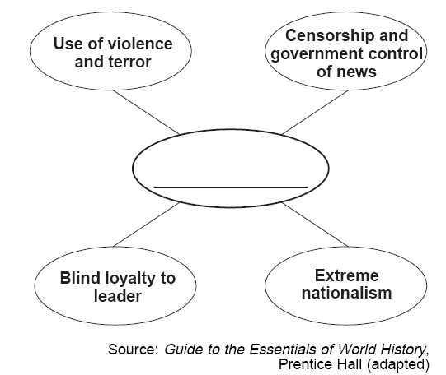
- Which ideology best completes this graphic organizer?

(1) socialism
(2) democracy
(3) capitalism
(4) fascism

- One similarity between Adolf Hitler and Benito Mussolini is that both

(1) led fascist states
(2) supported communism
(3) rejected militarism
(4) remained in power after World War II

- Which statement about both the Bolshevik Revolution in Russia and the rise of fascism in Germany and Italy is accurate?

(1) Economic conditions led to political change.
(2) Industrialization hindered national development.
(3) Goals were achieved by peaceful means.
(4) Communist ideals fueled both movements.

Base your answers to question 9 on the cartoon below and on your knowledge of social studies.
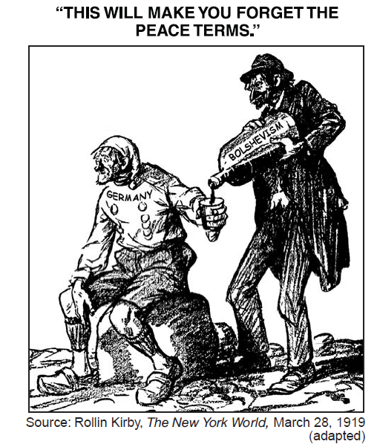
- This cartoonist is referring to the way Germany was affected in 1919 by

(1) the Congress of Vienna
(2) its defeat of Napoleon
(3) the Treaty of Versailles
(4) its defeat in World War II

Base your answer to question 10 on the map below and on your knowledge of social studies.
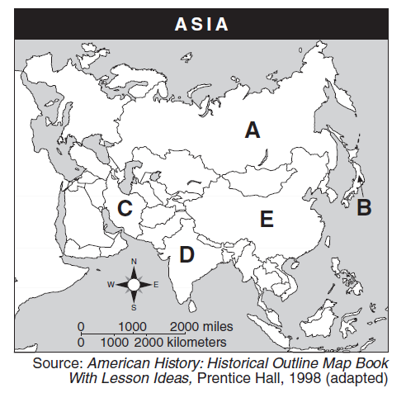
- Which letter identifies the nation most closely associated with Mohandas Gandhi?

(1) A
(2) B
(3) C
(4) D

