Regents Questions: 1-6

1) Which statement describes one major aspect of a command economy?

(1) Supply and demand determines what will be produced.

(2) Most economic decisions are made by the government.

(3) The means of production are controlled by labor unions.

(4) The economy is mainly agricultural.

2) Five-year plans and collectivization are most closely associated with

(1) Joseph Stalin

(2) Mikhail Gorbachev

(3) Adolf Hitler

(4) Deng Xiaoping

3) The Bolshevik Party in 1917 gained the support of the peasant class because they promised them

(1) “Peace, Land, and Bread”

(2) “Liberty, Equality, Fraternity”

(3) abolition of the secret police

(4) democratic reforms in all levels of government

4) Joseph Stalin’s policies in Ukraine during the 1930s directly resulted in

(1) widespread starvation

(2) agricultural self-sufficiency

(3) the development of cottage industries

(4) the use of subsistence farming techniques

5) • Five-year plans

• Collectivization of agriculture

• Great Purge

Which individual is associated with all these policies?

(1) Adolf Hitler

(2) Joseph Stalin

(3) Deng Xiaoping

(4) Jawaharlal Nehru

Base your answer to question 6 on the cartoon below and on your knowledge of social studies.



6) In the view of this cartoonist, Russia under Lenin’s rule was characterized by

(1) a continuation of traditional life

(2) the introduction of capitalism

(3) support for a constitutional monarchy

(4) rejection of the czarist system

7) Which aspect of the economy was emphasized in Joseph Stalin’s five-year plans?

(1) heavy industry

(2) consumer goods

(3) famine relief

(4) private landownership

8) Totalitarian countries are characterized by

(1) free and open discussions of ideas

(2) a multiparty system with several candidates for each office

(3) government control of newspapers, radio, and television

(4) government protection of people’s civil liberties

Base your answers to questions 9 and 10 on the chart below and on your knowledge of social studies.

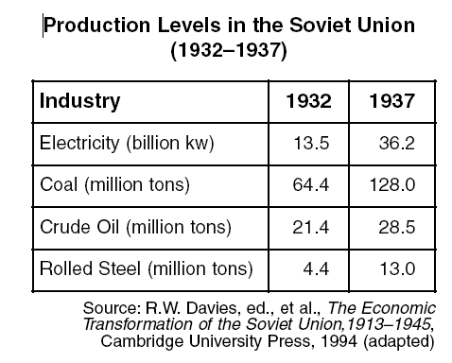

9) Which policy is illustrated in this chart?

(1) pogroms

(2) five-year plans

(3) Russification

(4) nuclear arms

10) The data in this chart illustrate the

(1) benefits of foreign trade

(2) successful development of heavy industry

(3) availability of consumer goods

(4) effects of inflation on the economy

11) Under communism in the former Soviet Union, people were required to

(1) reject modern technology

(2) limit the size of their families

(3) honor their ancestors and religious traditions

(4) put the interests of the state before individual gain