Regents Questions 1-5

Base your answer to question 1 on the posters below and on your knowledge of social studies.

 

1. Which concept is represented in these World War I recruiting posters?

(1) justice

(2) diversity

(3) nationalism

(4) humanism

1. Which event is considered the immediate cause of World War I?

(1) signing of the Treaty of Versailles

(2) invasion of Poland by Germany

(3) assassination of Archduke Francis Ferdinand

(4) use of unrestricted submarine warfare by Germany

1. The term *militarism* can best be defined as

(1) loyalty to a nation or ethnic group

(2) buildup of armaments in preparation for war

(3) avoidance of military involvement in civil wars

(4) control of territories for economic and political gain

Base your answer to question 4 on the map below and on your knowledge of social studies.

**Europe at the Outbreak of World War I, August 1914**

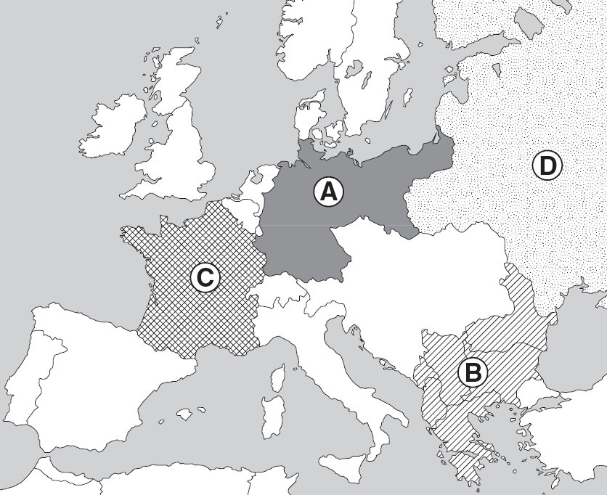

1. Which area of Europe was known as the “Powder Keg” of Europe prior to the outbreak of World War I?

(1) *A*

(2) *B*

(3) *C*

(4) *D*

1. The assassination of Archduke Franz Ferdinand was the immediate cause of

(1) the Franco-Prussian War

(2) the Russo-Japanese War

(3) World War I

(4) World War II

1. Which region was described as “the powder keg of Europe” prior to World War I?

(1) Iberian Peninsula

(2) British Isles

(3) Balkan Peninsula

(4) Scandinavia

1. What was a major cause of World War I?

(1) rebellions in colonial lands in Africa and Asia

(2) expansion of communism into western Europe

(3) militarism in the nations of Europe

(4) inability of the League of Nations to keep the peace

Base your answer to question 8 on the passage below and on your knowledge of social studies.

. . . A weary, exhausted, nerve-racked group of men it was indeed that, about noon November 1, assembled in a gully north of Sommerance [France] to rest and dig in for the night. The artillery was still firing furiously, but the enemy’s barrage [bombardment] had ceased very suddenly about 10:00 a.m. and now only occasional shells from long-range rifles would explode in the vicinity. The weather was gloomy and the moist air chilled one to the bones. Yet it was with that meticulous [methodical] care that is characteristic of worn-out men, that we prepared our foxholes, carrying boards and iron sheeting from abandoned machine-gunners’ dugouts in order to make our “houses” as comfortable as possible, even though only for one night. . . .

Source: William L. Langer, Gas and Flame in World War I, Knopf/Borzoi

1. Which means of warfare is described in this passage?

(1) guerilla

(2) nuclear

(3) biological

(4) trench

1. One action that many governments took during World War I was to

(1) encourage political dissent and freedom of the press

(2) regulate their economic systems to increase production

(3) prevent women from seeking employment in factories

(4) raise tariffs to encourage trade

1. What was the immediate cause of World War I in Europe?

(1) start of the civil war in Russia

(2) sinking of the British liner, *Lusitania*

(3) assassination of the heir to the throne of the Austro-Hungarian Empire

(4) attack on Poland by the German army

EXTRA!

Base your answer to question 5 on the passage below and on your knowledge of social studies.

**Observation of a Soldier in World War I**

Private Archie Surfleet, February 8th, 1918 — We have been in camp near the wood at Écurie for some days now and a more miserable existence it would be hard to imagine. There is nothing but unrest and uncertainty and everyone here is absolutely fed up to the teeth.

— Malcolm Brown, Tommy Goes to War

5) Which hypothesis can best be supported by this passage?

(1) Allied forces were on the verge of winning the war.

(2) Technology had created a military stalemate.

(3) Revolution in Russia hastened the end of the war.

(4) Conditions contributed to low troop morale.

7) The Triple Alliance and the Triple Entente contributed to the start of World War I by

(1) failing to include Germany and France as members

(2) threatening countries in the Western Hemisphere

(3) allowing Japanese aggression in Korea

(4) increasing tensions between European Countries