Regents Q’s 1-10

- Which country was ruled by Pol Pot and the Khmer Rouge?

(1) Afghanistan
(2) Kazakhstan
(3) Cambodia
(4) Bangladesh

- Which characteristic is most closely associated with both Pol Pot’s government in Cambodia and Slobodan Milosevic’s government in Yugoslavia?

(1) use of terror to achieve political goals
(2) support for freedom of speech
(3) establishment of a theocratic system
(4) respect for ethnic minorities

Base your answer to question 3 on the time line below and on your knowledge of social studies.
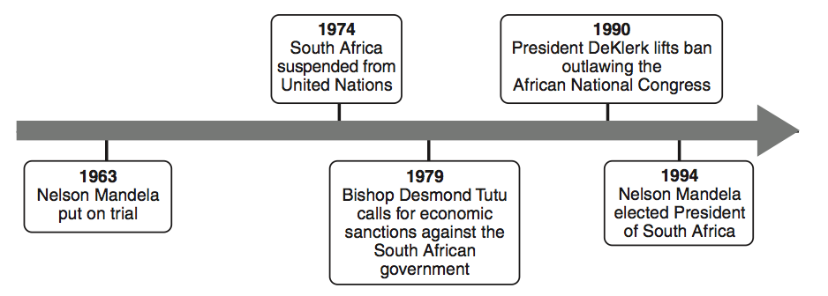
- Which policy is most closely associated with the events on this time line?

(1) nonalignment
(2) détente
(3) containment
(4) apartheid

- Which area was once controlled by Britain, suffered a mass starvation in the 1840s, and became an independent Catholic nation in 1922?

(1) Scotland
(2) India
(3) Ghana
(4) Ireland

- • The Nazi Party controls Germany.
• Khmer Rouge rules in Cambodia.
• The Sandinistas control Nicaragua.
Which statement describes a similarity in these situations?

(1) Civil liberties were promoted.
(2) Voting rights were extended to women.
(3) Leaders won the support of all groups.
(4) One group seized power and limited opposition.

Base your answer to question 6 on the chart below and on your knowledge of social studies.
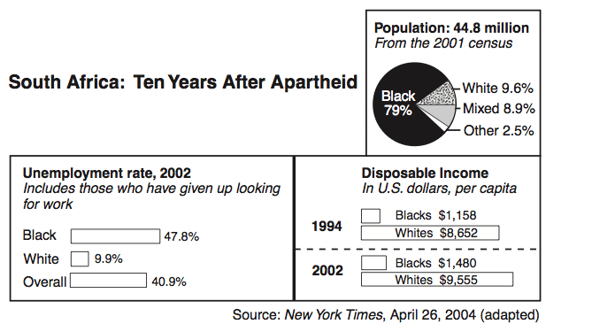

- Which conclusion about South Africa’s economy can be drawn from this chart?

(1) Since the end of apartheid, most blacks have gained economic equality.
(2) In some sectors of the economy, blacks earn more than whites.
(3) Despite the end of apartheid, many blacks continue to struggle
economically.
(4) Economic opportunity for blacks is directly related to education reform.

- Which statement about the Balkan Peninsula since 1995 is most accurate?

(1) Bosnia-Herzegovina and Croatia are now both controlled by Yugoslavia.
(2) Ethnic tensions and conflict continue to be a problem in much of the region.
(3) Slobodan Milosevic of Serbia became the first democratically elected leader
of the region.
(4) The Balkan Peninsula has become one of the most prosperous regions in
Europe.

Base your answers to question 8 on the map below and on your knowledge of social studies.
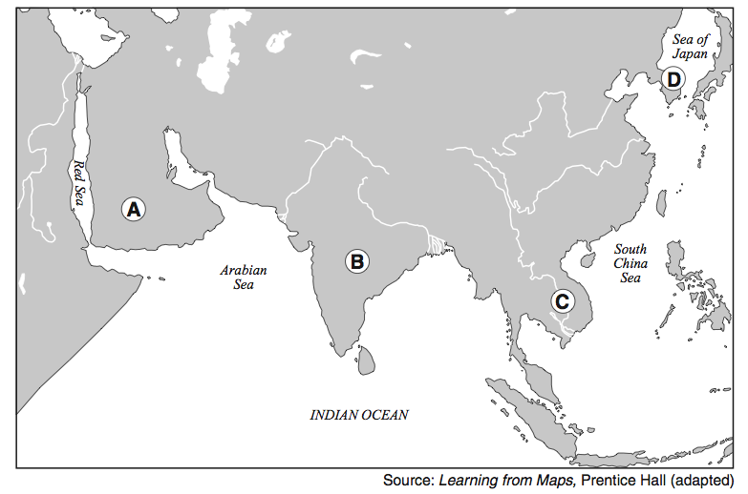
- Which letter identifies the peninsula that was the site of the Vietnam conflict and the atrocities of Pol Pot?

(1) A
(2) B
(3) C
(4) D

- During the 20th century, global attention was drawn to the Armenians of the Ottoman Empire, the Tutsis of Rwanda, and the Muslims of Kosovo because these groups were all victims of

(1) nuclear power accidents
(2) human rights violations
(3) environmental disasters
(4) the AIDS epidemic

Base your answer to question 10 on the cartoon below and on your knowledge of social studies.
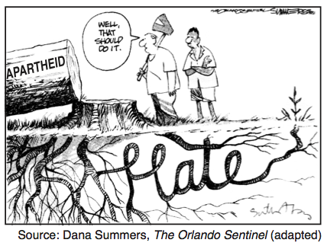
- What is the main idea of this cartoon?

(1) The original causes of apartheid have not been eliminated.
(2) Apartheid improved race relations in South Africa.
(3) Peace can be achieved by nonviolence.
(4) Hate is caused by poverty.

EXTRA:

Base your answer to question 1 on the passage below and on your knowledge of social studies.

...We have triumphed in the effort to implant hope in the breasts of the millions of our people. We enter into a covenant [agreement] that we shall build the society in which all South Africans, both black and white, will be able to walk tall, without any fear in their hearts, assured of their inalienable right to human dignity—a rainbow nation at peace with itself and the world....
- Nelson Mandela, excerpt from Inaugural Address

- These words were delivered in 1994 by the newly elected president of South Africa to praise his countrymen’s rejection of

(1) nationalism
(2) Pan-Africanism
(3) apartheid
(4) democracy

- Which leader is most closely associated with Desmond Tutu and F. W. de Klerk?

(1) Jomo Kenyatta
(2) Kwame Nkruhmah
(3) Nelson Mandela
(4) Jawaharlal Nehru

- In the second half of the 20th century, what was one action taken by both Nelson Mandela and Desmond Tutu?

  - (1) protesting against apartheid in South Africa
  - (2) supporting the white government of Rhodesia
  - (3) sending troops to liberate captives in Sudan
  - (4) leading the independence movement in Ghana

- Armenians under Ottoman rule and Cambodians under the Khmer Rouge both experienced

(1) an outbreak of the plague
(2) human rights violations
(3) economic sanctions
(4) an agricultural revolution

- The Armenian massacre, the Holocaust, and the Rape of Nanking are examples of

(1) appeasement policies
(2) resistance movements
(3) Russification efforts
(4) human rights violations

Base your answer to question 18 on the cartoon below and on your knowledge of social studies.

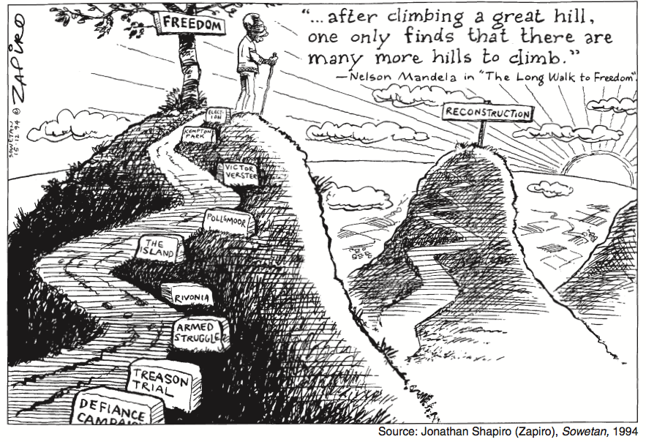

- What is the main idea of this cartoon?

(1) Nelson Mandela has completed South Africa’s reconstruction.
(2) Although black South Africans have overcome many obstacles to achieve
freedom, many struggles lie ahead.
(3) The mountains of South Africa have hindered black South African
participation in national elections.
(4) The reconstruction of South Africa can only be achieved through violence,
treason, and defiance.

- The governments of Augusto Pinochet, Saddam Hussein, and Slobodan Milosevic are examples of

(1) absolute monarchies
(2) oppressive regimes
(3) democratic republics
(4) Islamic theocracies

Base your answers to questions 22 and 23 on the passage below and on your knowledge of social studies.

. . . Above all, we want equal political rights, because without them our disabilities will be permanent. I know this sounds revolutionary to the Whites in this country, because the majority of voters will be Africans. This makes the White man fear democracy.
But this fear cannot be allowed to stand in the way of the only solution which will guarantee racial harmony and freedom for all. It is not true that the enfranchisement [right to vote] of all will result in racial domination. Political division, based on colour, is entirely artificial and, when it disappears, so will the domination of one colour group by another. The ANC [African National Congress] has spent half a century fighting against racialism. When it triumphs it will not change that policy. . . .
- Nelson Mandela, Speech at Rivonia Trial, 1964

- This passage describes the opposition of the African National Congress to the

(1) revival of colonialism
(2) rivalries between tribes
(3) practice of apartheid
(4) introduction of a coalition government

- Which generalization can be supported by this passage?

(1) Racism has disappeared in South Africa.
(2) The African National Congress has changed its social goals.
(3) Giving the vote to black Africans will result in racial domination.
(4) Nelson Mandela opposed political division based on color.

- The primary purpose of the United Nations is to

(1) control world grain prices
(2) promote democratic governments
(3) resolve conflicts between nations peacefully
(4) unite all nations militarily through alliances

- The South African government’s policy of racial separation between 1948 and 1994 was called

(1) Pan-Africanism
(2) democratization
(3) apartheid
(4) suffrage

- Many critics believe that the policy of the British government during the Irish Famine

(1) contributed to food shortages
(2) ignored military concerns
(3) discouraged emigration
(4) led directly to civil war

- Totalitarian governments are characterized by the

(1) elimination of heavy industry
(2) use of censorship, secret police, and repression
(3) lack of a written constitution
(4) support of the people for parliamentary decisions

- Ethnic cleansing in Bosnia, the killing fields of Cambodia (Kampuchea), and the dirty war in Argentina are all examples of

(1) nationalist revolts
(2) human rights violations
(3) international terrorism
(4) religious conflicts

