Regents Questions: Week 1-1.5

- The slogan “Blood and Iron” and a united Germany are most closely associated with

(1) Prince Metternich
(2) Simón Bolívar
(3) Camillo Cavour
(4) Otto von Bismarck

- The unification of Germany under Otto von Bismarck demonstrates the

(1) influence of Marxist ideology
(2) impact of nationalism
(3) force of civil disobedience
(4) power of democratic ideals

- One political objective of both Otto von Bismarck and Giuseppe Garibaldi was to

(1) overthrow divine right monarchies
(2) unify their nations
(3) establish communist systems
(4) form an alliance with Great Britain

- • Location — included lands surrounding the eastern Mediterranean Sea
• People — Turks, Arabs, Greeks, Muslims, Christians, and Jews
• Nickname during the 19th and early 20th centuries — “Sick Man of Europe”

Which empire is described by these characteristics?

(1) Gupta
(2) Mongol
(3) Roman
(4) Ottoman

Base your answer to question 5 on the map below and on your knowledge of social studies.

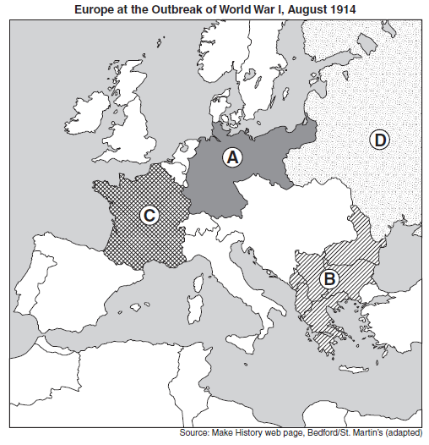
- Which area of Europe was known as the “Powder Keg” of Europe prior to the outbreak of World War I?

(1) A
(2) B
(3) C
(4) D

