Human Rights Violation: NOTES
WORLD MAP: Label each country on this map.
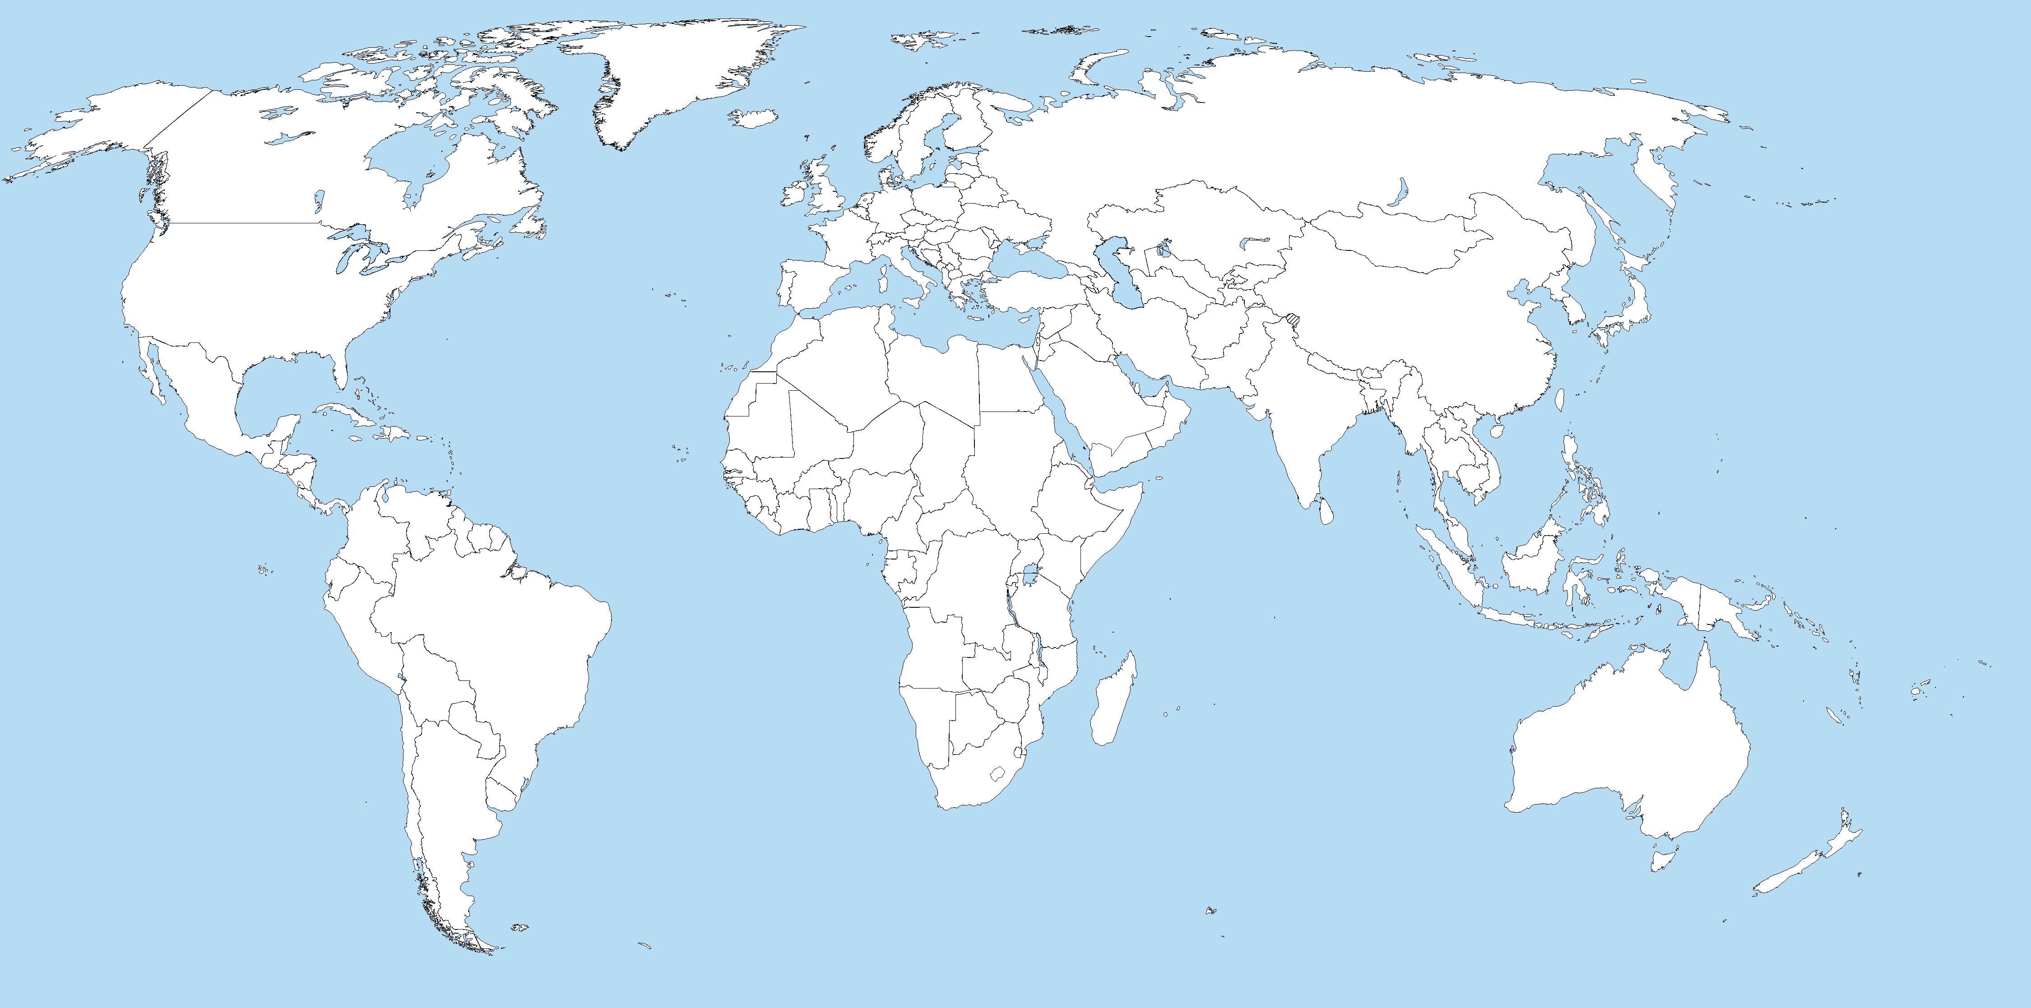

1. Cambodia: Khmer Rouge

Background | Rights Violated | Actions Taken

2. Yugoslavia (Balkans): “Ethnic Cleansing”

Background | Rights Violated | Actions Taken

3. South Africa: Apartheid

Background | Rights Violated | Actions Taken

4. Ireland: “The Troubles”

Background | Rights Violated | Actions Taken

5. Rwanda: Hutu & Tutsi

Background | Rights Violated | Actions Taken

Choose which human rights violation you want to write your 2nd paragraph on: ________________________________________

