Between the Wars NOTES

- Atatürk brought ________________________________________________________ & ________________________________________________________________ to Turkey.

- In which country did the Amritsar Massacre occur?

- Which letter represents India on the map below? _________

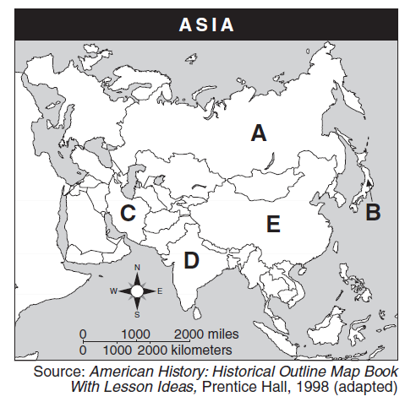

- What strategy did Gandhi use to resist British imperialism?

- Fill in the chart below.
The Great Depression

Causes | Effects
1. | 1.
2. | 2.
3. | 3.
 | 4.

- List 4 features of fascism:
  - ________________________________________________________________________
  - ________________________________________________________________________
  - ________________________________________________________________________
  - ________________________________________________________________________

- ___________________________________ was the fascist leader in Italy.

- ___________________________________ was the leader of the Nazi party in Germany.

- Hitler blamed the _______________ for Germany’s problems. This way of thinking was called: ________________________________________________________.

- If fascism seems so bad, why did the people let fascist leaders gain power?

- Were Mussolini & Hitler good or bad leaders? Why?

