Regents Q’s 2-2

Base your answer to question 1 on the chart below and on your knowledge of social studies.
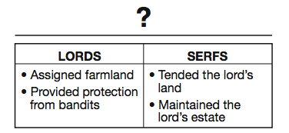

- What is the best title for this chart?

(1) Role of the Church
(2) Feudal Obligations
(3) Knights’ Code of Chivalry
(4) Rules for Guild Membership

- An economic reason for the institution of serfdom was to maintain

(1) an educated citizenry
(2) a stable workforce
(3) overseas trade
(4) religious uniformity

- What is a primary characteristic of a feudal society?

(1) a representative government
(2) economic equality for all
(3) protection of individual rights
(4) an exchange of land for services

- Which political system is best described in the outline below?
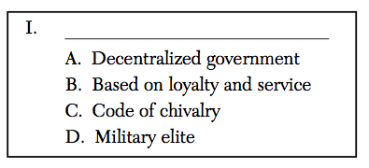

(1) Oligarchy
(2) Absolutism
(3) Feudalism
(4) Democracy
- In western Europe, feudalism developed after the

(1) Roman Empire collapsed
(2) Renaissance began
(3) city of Constantinople fell
(4) Mongols invaded

- Which heading best fits the partial outline below?
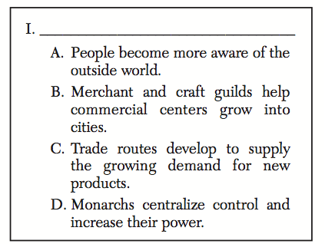

(1) Seljuk Turks Dominate Europe
(2) Democracy Ends in Eastern Europe
(3) Feudalism Declines in Western Europe
(4) Religion Becomes Powerful Force in Europe

Base your answers to questions 7 on the artwork below and on your knowledge of social studies.
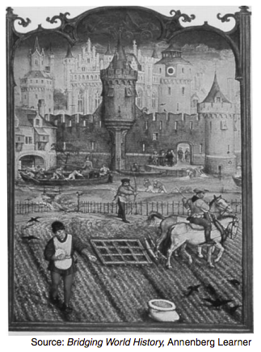
- Which economic system is most closely associated with the activities shown in this art work?

(1) manorialism
(2) capitalism
(3) communism
(4) socialism

