Regents Q’s 2-1

- In the late 1400s and early 1500s, what was a major reason for the European voyages of exploration?

(1) introduction of Enlightenment ideas
(2) desire to control Constantinople
(3) rapid industrialization
(4) need for alternate trade routes

- Which idea is most closely associated with the economic concept of mercantilism?

(1) Colonies exist to provide raw materials and markets for a colonial power.
(2) Wealth and power are based on land exchanged between nobles.
(3) Goods and services are traded without government interference.
(4) Property is owned collectively and administered by the state.

- The encomienda system in colonial Latin America led to the

(1) use of forced labor
(2) establishment of trade unions
(3) increase in landownership by Native Americans
(4) weakening of the power of peninsulares

- The use of the terms Encounter and Columbian exchange represents attempts to describe the

(1) nature of cultural interactions
(2) establishment of land grants
(3) results of scientific innovations
(4) origins of divine right theory

- The Middle Passage is best defined as

(1) a route through the Swiss Alps
(2) a narrow body of water connecting two larger bodies of water
(3) the forced journey of enslaved Africans to the Americas
(4) the expulsion of Muslims from Spain

- “. . . (It) brought the potato, the pineapple, the turkey, dahlias, sunflowers, magnolias, maize, chillies and chocolate across the Atlantic. On the other hand, tens of millions died in the pandemics of the 16th century, victims of smallpox, measles and the other diseases brought by Europeans (and don’t forget that the African slave trade was begun by the Europeans, to replace the work force they had decimated).”. . .
— Michael Wood, BBC History (adapted)

Which historical development is being described in this quotation?

(1) establishment of the line of Demarcation
(2) creation of the Hanseatic League
(3) Columbian exchange
(4) Glorious Revolution

- The journeys of Vasco da Gama, Bartholomeu Dias, and Christopher Columbus became possible in the late 1400s because of the

(1) support of exploration by the English government
(2) trade connections established by Ibn Battuta
(3) effects of the Atlantic slave trade
(4) development of new navigational instruments and technology

Base your answers to questions 8 and 9 on the passage below and on your knowledge of social studies.

... In addition, after the last battle they were afraid of the horses and guns, of our swords and crossbows and our good fighting. Above all was the great mercy of God, Who gave us the strength to keep on....
- Bernal Díaz del Castillo, The Bernal Díaz Chronicles, Doubleday & Company

- In this passage about a conflict in Mexico, whose perspective is being expressed?

(1) Aztec warrior
(2) Spanish conquistador
(3) Portuguese explorer
(4) Inca emperor

- According to this author, which factors were influencing the outcome of the conflict?

(1) efficiency and education
(2) climate and disease
(3) tribute and tradition
(4) technology and fear

EXTRA:

- What was the primary economic policy used by the Spanish with their Latin American colonies?

(1) embargoes
(2) tariffs
(3) boycotts
(4) mercantilism

Base your answer to question 2 on the diagram below and on your knowledge of social studies.

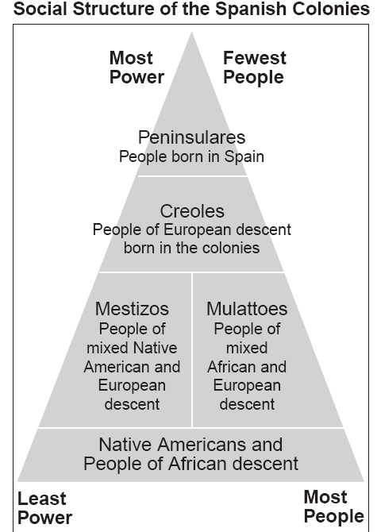

- Which conclusion about Spanish colonialism in the Americas can be drawn from this diagram?

(1) The fewest people in the population had the greatest power.
(2) Africans and Native Americans were politically powerful.
(3) The peninsulares made up the majority of the population.
(4) Mestizos and mulattoes controlled the most land in the colonies.

Base your answer to question 3 on the map below and on your knowledge of social studies.
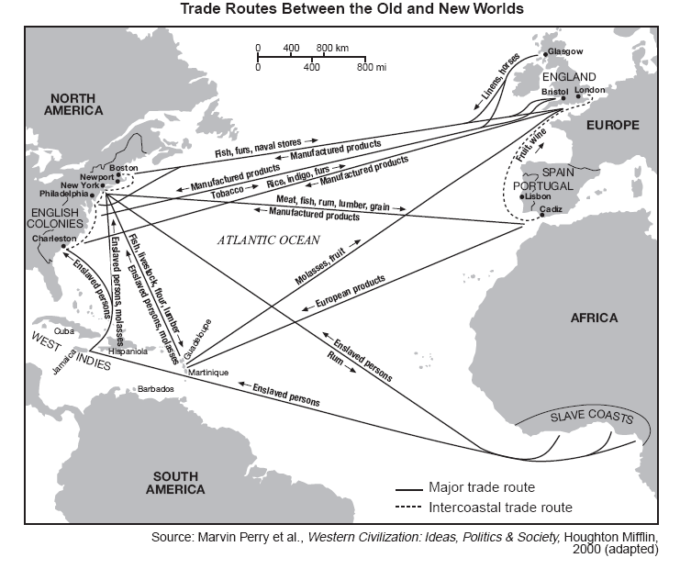
- Based on the information shown on this map, most manufactured goods were produced in

(1) the West Indies
(2) Europe
(3) English colonies
(4) Africa

- Which region’s colonial class structure included peninsulares, creoles, and mestizos?

(1) western Europe
(2) sub-Saharan Africa
(3) East Asia
(4) Latin America

- Which statement demonstrates a major characteristic of mercantilism in colonial Latin America?

(1) Colonies developed local industries to compete with Spain.
(2) Spanish colonies traded freely with English colonies.
(3) Spain instituted democratic governments in its colonies.
(4) Colonies were a source of raw materials for Spain.

