Name: _______________________________ Date: _______________________

Medieval Problems, Medieval Solutions

Problem 1: Since the Crusades (during the 1200s and 1300s) Northern Europe had a hard time trading. The following city-states in Germany, Poland, Belgium, Denmark, Sweden, Norway, and Russia were all competing with each other. These cities are:

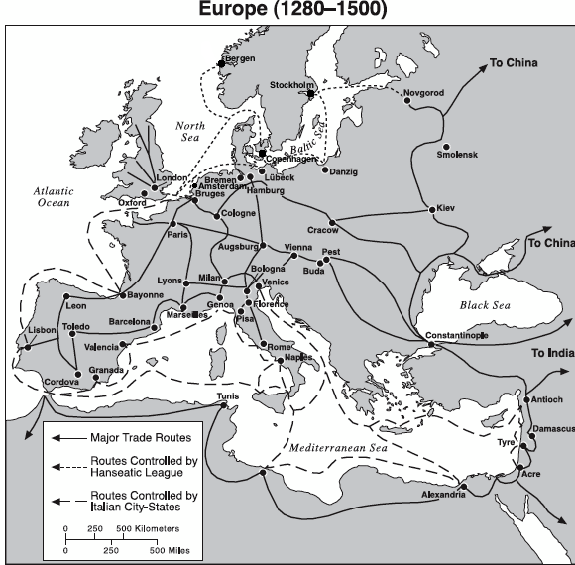
Germany: Bremen, Hamburg, Lubeck Poland: Danzig Russia: Novgorod
England: London Belgium: Bruges Norway: Bergen
Sweden: Stockholm Denmark: Copenhagen

But the problem is that they all have similar supplies and demands, but each city’s craftsmen make the same products differently – for example, Stokholm’s cloth makers are using similar techniques as Bruges, but the cloth feels different and the sheep have slightly different hair, the fur traders from Novgorod make fur pelts and coats differently than the fur traders in Copenhagen. So the people in these cities demand goods from other places, but the merchants who control the cities don’t want to lose business. The merchants have armies that they use to force foreign merchants to pay tolls for trading in their cities. So people in a city-state have to pay higher prices for the goods from other places. But there is another problem – Viking pirates keep attacking the merchants’ ships and other vessels that are trying to come into the North Sea from Portugal, France, and Castille/Aragon (Spain). So all of the merchants in these cities have a hard time trading for goods from the Middle East, North Africa, and West Africa. Some cities have advantages, like:

1) Novgorod is near Mongol trade routes and produced huge amounts of timber (for shipbuilding) and furs
2) Bruges and Hamburg have a direct trade route south to Italy while also making the best beer for export
3) London is the closest sea route to Portugal and also made some of the finest cloth in Europe
4) Copenhagen has access to many fish and mammal species that only live in the islands of Denmark
5) Stokholm has easy access to Novgorod AND Danzig while producing both iron and copper
6) Danzig was a primary source for grain from the rest of Poland
7) Bergen was the best source for dried cod (a type of fish)
8) Lubeck had access to salt mines and was in the center of all of these city-states
9) Bremen had direct access to the North Sea while also connecting to Hamburg, Lubeck, and Amsterdam

How should all these city-states cooperate to make sure that trade flourishes instead of competing so that trade declines?

Problem 2: Because of the Black Death, many people have abandoned their manors and come to towns. The towns are getting bigger, and this requires master craftsmen and artisans (people who make stuff) like blacksmiths (people who work with metal), weavers (people who make cloth), potters (people who make pots and jars out of clay), carpenters (people who build things out of wood), etc. Masters with these skills are coming to the towns, but they are using different types of tools, different measurements (some people are using a “foot” as measurement, but everyone’s feet are different sizes!), different replaceable pieces like nails and staples.

This is causing problems because when consumers want to buy products from different master craftsmen, the products don’t fit with each other – a master carpenter building walls for a house might not work when a different master roofer comes to make the roof, or chairs might not fit well for a table if a different master makes the table and chairs. If a master carpenter runs out of nails from one master blacksmith and needs to go to another, the nails the other one makes might be different. Different master weavers might make clothes that don’t fit the same way, or that are different thicknesses, so a person will end up with a tight fitting shirt that keeps him warm, but pants that are too thin, or shoe heels with different thickness.

Another issue was that these master craftsmen were competing against each other, which meant that they would lower their prices constantly so they could sell their products successfully – but that also meant that masters were often making so little money that if they needed to pay for a funeral or doctors bills, they could not. Or if one of them died, their wives and children would not have any savings to live off.

Besides that, many of the master craftsmen would hire assistants, or use apprentices (people who studied to do that skill) but pay them differently, so people doing the same job would receive different wages. Because the masters were charging low prices, they would often pay their apprentices less money, so these apprentices would not care as much about their job and the products were not built well.

How can we fix this system so that all the master craftsmen work together to make the best products for their customers without hurting themselves or their workers instead of working against each other, producing different products, and hurting both themselves and their customers?

