Regents Q’s 2-1.5

Base your answer to question 1 on the chart below and on your knowledge of social studies.
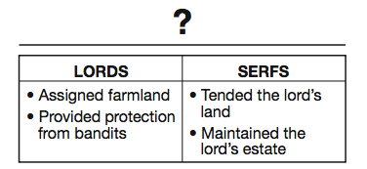

- What is the best title for this chart?

(1) Role of the Church
(2) Feudal Obligations
(3) Knights’ Code of Chivalry
(4) Rules for Guild Membership

- An economic reason for the institution of serfdom was to maintain

(1) an educated citizenry
(2) a stable workforce
(3) overseas trade
(4) religious uniformity

- One way Japanese feudalism during the Tokugawa shogunate was different from European feudalism is that during this period of Japanese feudalism

(1) political power was more centralized
(2) foreign missionaries were welcomed
(3) emperors were overthrown in coups d’état
(4) most wealthy merchants were able to attain high social status

- What is a primary characteristic of a feudal society?

(1) a representative government
(2) economic equality for all
(3) protection of individual rights
(4) an exchange of land for services

- Which political system is best described in the outline below?
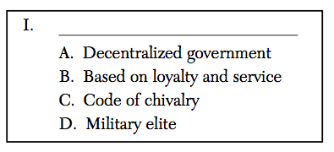

(1) Oligarchy
(2) Absolutism
(3) Feudalism
(4) Democracy

- Which statement about government during the Tokugawa period in Japan is most accurate?

(1) The power of the emperor was absolute and supreme.
  - (2) The real power was held by foreign countries.
  - (3) Actual power was held by the shogun.
  - (4) Political power was in the hands of the merchant class.

- In western Europe, feudalism developed after the

(1) Roman Empire collapsed
(2) Renaissance began
(3) city of Constantinople fell
(4) Mongols invaded

- Which heading best fits the partial outline below?
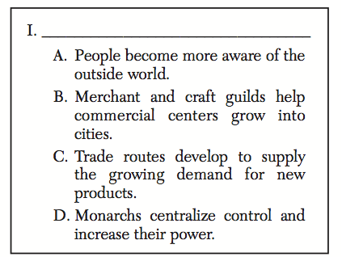

(1) Seljuk Turks Dominate Europe
(2) Democracy Ends in Eastern Europe
(3) Feudalism Declines in Western Europe
(4) Religion Becomes Powerful Force in Europe

