Exploration: Part 1 NOTES

- Why did European countries want to explore more of the world?

- Which 2 countries explored first? Why?

- Shade in Spain & circle Portugal on the map of Europe below.

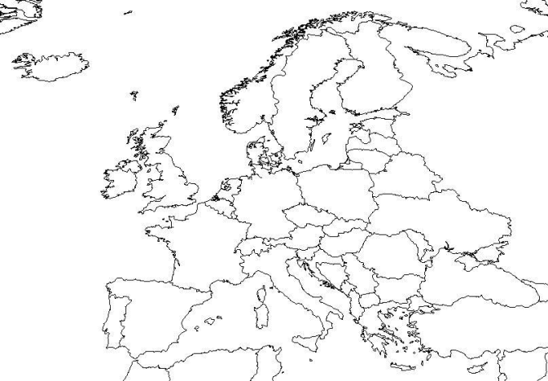

- What part of the world did Spain & Portugal take over?

- What actions are the following explorers best known for?
- Christopher Columbus: _________________________________________________________
- Hernan Cortes: ___________________________________________________________________
- Francisco Pizarro: _______________________________________________________________

- How were Europeans able to conquer the natives (even though they were outnumbered?)

- ____________________________________________________________________________
- ____________________________________________________________________________
- ____________________________________________________________________________
- ____________________________________________________________________________

TERMS TO KNOW:
- Conquistador

- Conquer

- Allies

- Cortes & Pizarro

