Age of Exploration Notes: PART ONE

- What were the first two countries to explore?

- Label Spain & Portugal on the map.

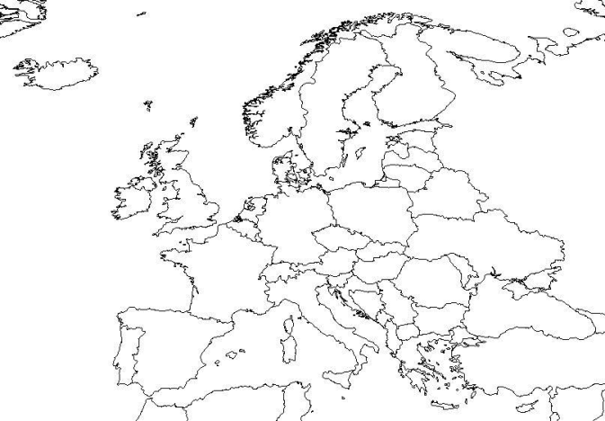

- Why were they able to explore?

- Which country were Ferdinand & Isabella from?

- What new technology helped explorers?

- Who were the famous explorers?

- What were the Dutch in Cape Town called?

- Who was the first explorer to circumnavigate the globe?

- Who controlled India (& the Sepoys)?

