America en el idioma de la memoria (excerpt)
By Gioconda Belli
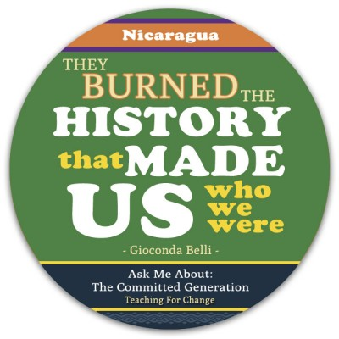

Who are we?
Who are these men, these women without language, scorned for their color
for their skins, their feathers, and their adornments?
So we would not read other than their sacred writings
They burned ours in bonfires
Our history, our poetry, the records of our people
They filled the sockets of our eyes with smoke
They filled our intestines with tears
They burned our writings, carefully painted by the scribes
They burned the history that made us who we were
Oh, how the old wailed in the plazas
seeing the names of their ancestors burn in the flames
Ah long night sad night of the ashes
A night in that we were left without hands, without language,
without memory
converted into slaves, sleepwalkers.

Excerpts from Textbooks about Columbus

We are now in February 1495. Time was short for sending back a good “dividend” on the supply ships getting ready for the return to Spain. Columbus therefore turned to a massive slave raid as a means for filling up these ships. The [Columbus] brothers rounded up 1,500 Arawaks [Taínos]—men, women, and children—and imprisoned them in pens in Isabela, guarded by men and dogs. The ships had room for no more than 500, and thus only the best specimens were loaded aboard. The Admiral then told the Spaniards they could help themselves from the remainder to as many slaves as they wanted. Those whom no one chose were simply kicked out of their pens. Such had been the terror of these prisoners that (in the description by Michele de Cuneo, one of the colonists) “they rushed in all directions like lunatics, women dropping and abandoning infants in the rush, running for miles without stopping, fleeing across mountains and rivers.”
Of the 500 slaves, 300 arrived alive in Spain, where they were put up for sale in Seville by Don Juan de Fonseca, the archdeacon of the town. “As naked as the day they were born,” the report of this excellent churchman says, “but with no more embarrassment than animals ...” The slave trade immediately turned out to be “unprofitable, for the slaves mostly died.” Columbus decided to concentrate on gold, although he writes, “Let us in the name of the Holy Trinity go on sending all the slaves that can be sold.”

Every man and woman, every boy or girl of fourteen or older, in the province of Cibao ... had to collect gold for the Spaniards. As their measure, the Spaniards used ... hawks’ bells. ... Every three months, every [Taíno] had to bring to one of the forts a hawks’ bell filled with gold dust. The chiefs had to bring in about ten times that amount. In the other provinces of Hispaniola, twenty-five pounds of spun cotton took the place of gold.Copper tokens were manufactured, and when a [Taíno] had brought his or her tribute to an armed post, he or she received such a token, stamped with the month, to be hung around the neck. With that they were safe for another three months while collecting more gold. Whoever was caught without a token was killed by having his or her hands cut off ...There were no gold fields, and thus, once the [Taínos] had handed in whatever they still had in gold ornaments, their only hope was to work all day in the streams, washing out gold dust from the pebbles. It was an impossible task, but those Taínos who tried to flee into the mountains were systematically hunted down with dogs and killed, to set an example for the others to keep trying. ...
During those two years of the administration of the brothers Columbus, an estimated one half of the entire population of Hispaniola was killed or killed themselves. The estimates run from one hundred and twenty-five thousand to one-half million.

Compare these passages to what you have heard before about Columbus. Think of the textbook passages that usually describe Columbus.

QUESTIONS FOR DISCUSSION:

• How factually accurate was the account?

• What was omitted—left out—that in your judgment would be important for a full understanding of Columbus (for example, his treatment of the Taínos; slave-taking; his method of getting gold; the overall effect on the Taínos)?

• What motives does the book give to Columbus? Compare those with his real motives.

• Who does the book get you to root for, and how is that accomplished? (For example, are the books horrified at the treatment of Taínos or thrilled that Columbus makes it to the so-called New World?)

• How do the publishers use illustrations? What do these communicate about Columbus and his “enterprise”?

• In your opinion, why does the book portray the Columbus/Taíno encounter the way it does?

• Can you think of any groups in our society who might have an interest in people having an inaccurate view of history?

EXAMPLE STUDENT’S RESPONSE:

It seemed to me as if the publishers had just printed up some “glory story” that was supposed to make us feel more patriotic about our country. In our group, we talked about the possibility of the government trying to protect young students from such violence. We soon decided that that was probably one of the farthest things from their minds. They want us to look at our country as great, and powerful, and forever right. They want us to believe Columbus was a real hero. We’re being fed lies. We don’t question the facts, we just absorb information that is handed to us because we trust the role models that are handing it out.

