2. A Horrible End or a New Beginning?

During the Middle Ages, Muslim trade routes in the Mediterranean, North Africa, and the Middle East connected with the Silk Route and Indian Ocean. The Tang and Song Dynasties in China increased trade on the Silk Route, which motivated the Mongols to conquer Asia to benefit from these trade networks. By the 1300s, even Medieval Europeans demanded goods from the Middle East, India, and China, but needed gold to obtain them. Port cities like Constantinople in the Byzantine Empire, London in England, Genoa, Venice, Florence, Naples, and Messina in Italy, Barcelona in Spain, Lisbon in Portugal, and Danzig and Hamburg in Germany were increasingly trading with these trade networks. But in the 1330s, a plague (a disease that spreads quickly and kills large numbers of people) emerged in China. It spread along these same trade routes that were helping to bring Europeans out of the Dark Ages.

Spread of the Plague 1333-1351
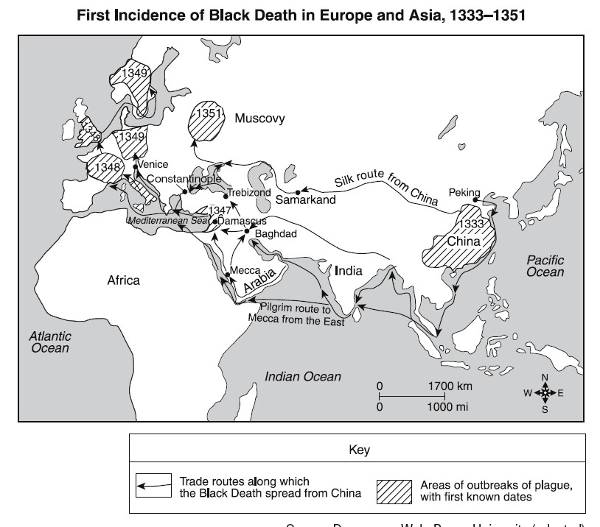

Spread of the Plague In Europe
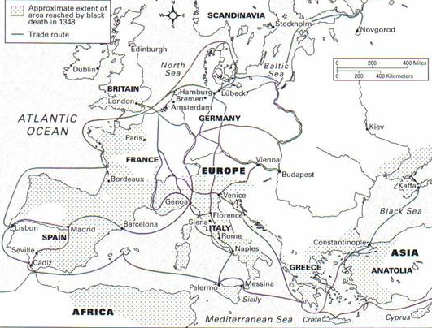

There were two forms of the plague: pneumonic (a disease that enters through the lungs and infects the respiratory system) and bubonic (a disease that enters through the skin and affects the lymphatic system). The pneumonic plague was more common. It started with a fever and within 12 to 20 hours, a person would begin coughing up blood. Pneumonic plague would kill a person within 2 days. The bubonic plague took longer to kill. After being infected, a person would not see symptoms for 2 to 5 days. Early symptoms would be swelling of the lymph nodes in the armpits, groin, and neck. The swelling grew into buboes (big boils filled with pus). Then came a fever, chills, nausea, vomiting, bloody diarrhea, rapid heart rate, and finally death within 2 to 4 days of seeing the first symptoms.

Because the plague could take up to 5 days to be noticed and another 4 days to kill, anyone suspected of having the plague would be quarantined (locked in a room) for ten days. The following are two diary entries by Antonio, a boy living in Florence who survived the plague.
Florence July 1348
Dear Diary,

A cloud has settled over our house. Just a few weeks ago, on a warm summer morning, father and I tended to the cows together.

“Papa,” I asked him, “the townspeople are all ill. I have been hearing dreadful things. Piles of bodies, and the stench is suffocating. What if it spreads to our home? I fear our hard work, our farm, all that there is to be proud of will fall victim to this horrid illness if we all are infected and die.”

Papa said nothing, but his glare made me feel foolish for my concerns. I imagine our lord is watching over us during this nightmare. Or maybe we are being punished for some wrongdoing?

-Antonio

Florence December 1348

Dear Diary,

The warmth of July is a distant memory now. Our crops have overgrown and died in the fields because most of the townspeople, including my mama, papa, two of my brothers, and 5 cousins have perished from the disease. My prayers remain, but seem to drift further from the lord’s ears.

It began with a cough. While preparing supper, Mama nearly fell over. Within hours, she was in bed, and the next day she withered and died. Papa was the next to fall ill. He did not give up easily, talked often about returning to the farm just as soon as the illness passed through him. But he was feverish and hard to understand. Yesterday he had fevered so high during the night that his mattress was soaked with sweat. Large boils appeared in his armpits and groin, and he coughed up blood every minute until he died.

My only living brother Paul and I spend our days in the field, trying to recoup what we can of the crops. So far neither of us has begun to cough or shown signs of the plague.

Just a few days ago, as I turned to walk down the field, I saw a wandering cow. He seemed to have walked from a farm far away, and looked tired as he approached me. I wondered if he came from a farm lost to the plague, owned by the dead.

When I arrived back at our home, Anna was bent over the table, her short frame bouncing violently up and down from coughing. She turned to me, showing her apron covered in blood. I spent the evening nursing her with warm cloths and gently rubbing her back as she wretched over and over again.

-Antonio

Postscript
Because of the Plague, several changes occurred in Europe. Wages increased, as many lords had to begin paying their workers more or they would leave to look for work in towns. The population did not recover the lost people for at least a hundred years. Several towns were abandoned in favor of the cities. Many people became even less religious during this time – they turned to the Church and God for help, but received none. Many towns blamed Jews for the plague, and several towns exterminated their Jewish populations by burning them alive.

But there were positive developments – the inadequate medicines of the time caused many survivors to seek new medicines from the Middle East. In addition, many farmers turned to pastoralism (herding of sheep, goats, cows, and horses) because it took fewer workers than growing crops. This benefitted Europe in the long run, as Muslim merchants started buying more wool and cloth from Europeans. Because of the decreased population and increased wealth, many kings were able to control lords and knights more easily, and the nations of England, Scotland, Portugal, and France emerged as independent kingdoms.

