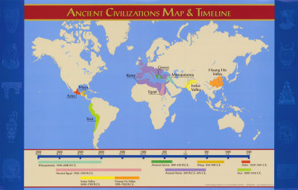

EVENTS/CIVS:

Neolithic Revolution | 10,000 BCE
Mesopotamia (Sumer) | 3500 BCE
Egypt | 3100 BCE
Indus Valley | 2700 BCE
Ancient China | 1900 BCE
Greece | 1750 BCE
Rome | 509 BCE

http://www.timemaps.com/history

