Vocab Sentences 1-5

REPUBLIC

In 1983, a monarch no longer headed the country; they became an independent republic.

"I pledge allegiance to the Flag of the United States of America, and to the Republic for which it stands…”

I just visited the Democratic Republic of the Congo.

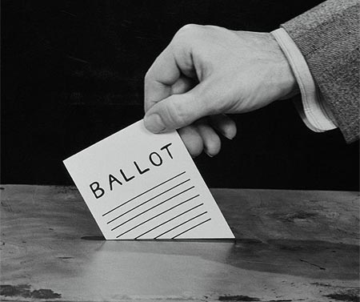

DICTATOR

The man was a brutal dictator who committed terrible crimes against his people.

Dictator for life.

Adolf Hitler is arguably one of the most infamous dictators of all history.

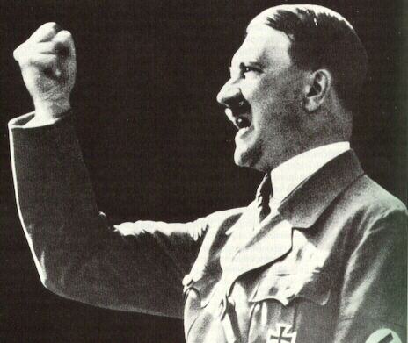

ASSASSINATE

John F. Kennedy was assassinated at 12:30PM on Friday, November 22, 1963 while traveling with his wife.

There have many assassination attempts on Fidel Castro, but he’s still living.

Lincoln was the first American president to be assassinated.

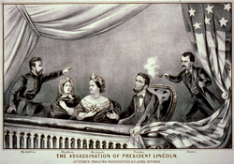

UNITED

Unite to support a diversity of lifestyles.

United together to fight in such large numbers.

The United States of America is a powerful country.

