Regents Questions: 1-9

Base your answer to question 1 on the map below and on your knowledge of social studies.
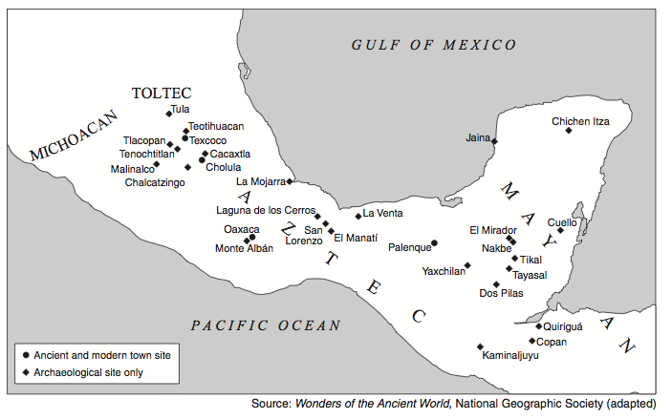

- Which title best describes this map?

(1) Mesoamerican Cultural Areas
(2) South American Urban Areas
(3) Creation of the Spanish Viceroyalties
(4) Outposts of the Inca Empire

- The Gupta civilization (4th–6th centuries) and the Maya civilization (4th–10th centuries) were similar in that both

(1) built temple complexes and developed the concept of zero
(2) eliminated standing armies and introduced an aristocracy
(3) developed early democratic systems
(4) were conquered by European imperialists

- The Aztec use of the calendar and the Maya writing system both illustrate that pre-Columbian cultures in the Americas

(1) traded extensively with Africa
(2) flourished prior to European contact
(3) declined because of invasion and disease
(4) converted others to Islam

Base your answer to question 4 on the diagram below and on your knowledge of social studies.
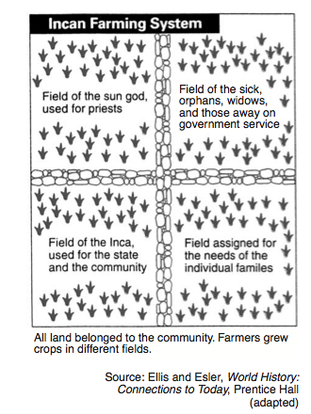
- This diagram shows the Incas had a farming system that

  - (1) provided crops for the entire society
  - (2) left much of the land unfarmed
  - (3) set aside fifty percent of the crops for those who farmed the fields
  - (4) grew crops only for priests and government officials

Base your answers to question 5 on the map below and on your knowledge of social studies.
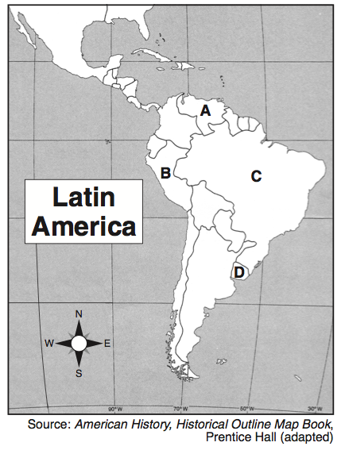

- Which letter identifies the region in the Andes Mountains where many Inca settlements were located?

(1) A (3) C
(2) B (4) D

- Which geographic feature had the greatest influence on the development of the Inca Empire?

(1) deserts
(2) irregular coastline
(3) river valleys
(4) mountains

- One way in which the ancient Inca Empire and the Roman Empire are similar is that both

(1) fought rivals for control of the sea
(2) adopted Christianity as the state religion
(3) traded with other civilizations along the Silk Road
(4) built a system of roadways throughout their empires

Base your answer to question 8 on the photographs below and on your knowledge of social studies.

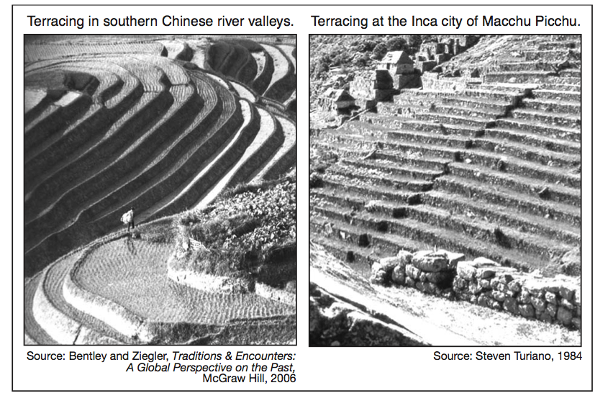
- These photographs indicate the people of China and the people of ancient Peru modified their environment to

(1) create effective trade routes
(2) increase the amount of land available for agriculture
(3) move large quantities of water into cities
(4) provide an effective defense

EXTRA:

Base your answer to question 4 on the map below and on your knowledge of social studies.

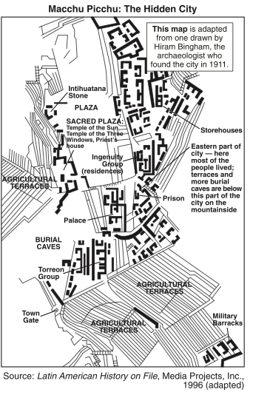

- Which conclusion about the Inca city of Macchu Picchu can be drawn from the map?

(1) Religious activities were prohibited in this city.
(2) The city was a ceremonial site, not a place of permanent settlement.
(3) Community planning and an organized way of life are not evident in
this city.
(4) The city had a government with laws, leadership, and a military force.

- The archaeological evidence found at the Mesoamerican sites of Tenochtitlan and Machu Picchu suggests that these societies

(1) consisted of hunters and gatherers
(2) were highly developed and organized cultures
(3) practiced a monotheistic religion
(4) followed a democratic system

- A major agricultural advancement of the Incas was the

(1) domestication of cattle
(2) use of a steel plow
(3) terracing of mountains for farming
(4) development of floating gardens

Base your answer to question 5 on the illustration below and on your knowledge of social studies.

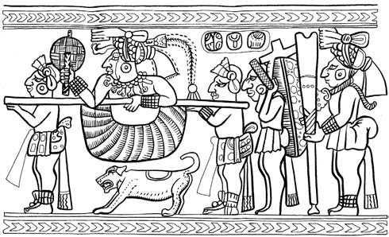
Source: Wilson G. Turner, Maya Designs, Dover Publications

- Which element of civilization is most clearly shown in this Maya artwork?

(1) urbanization
(2) a system of education
(3) a code of laws
(4) social classes

- One way the Incas adapted their environment was by

(1) building a network of roads through the mountains
(2) growing rice as a major agricultural product
(3) establishing an encomienda system
(4) creating floating gardens

Base your answer to question 12 on the drawing below and on your knowledge of social studies.
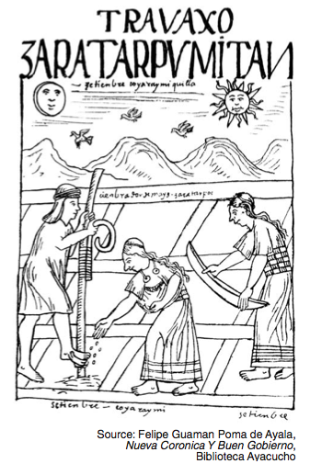
- What does this drawing indicate about the Inca civilization?

(1) religious influence on architecture
(2) cooperation and planning in agriculture
(3) superior military technology used for defense
(4) role of government during a natural disaster

Base your answer to question 4 on the illustrations below and on your knowledge of social studies.

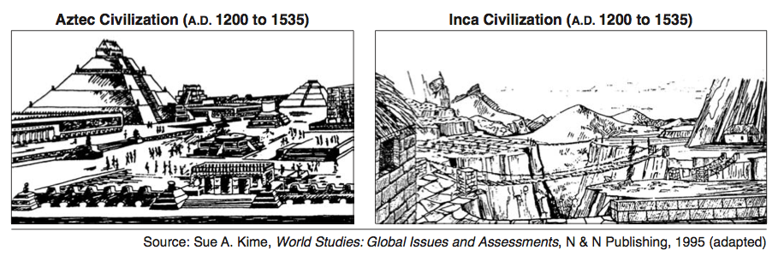

- These illustrations suggest that early Latin American civilizations

(1) were based on European societies
(2) used advanced technology to build complex structures
(3) incorporated early Roman architectural design
(4) were strongly influenced by Renaissance humanism

- A study of Aztec, Maya, and Inca agricultural systems would show that these civilizations

  - (1) relied on mechanized agricultural techniques
  - (2) carried on extensive food trade with each other
  - (3) adapted to their environments with creative farming techniques
  - (4) relied on a single-crop economy

- One way in which the Aztec and Inca civilizations are similar is that they both

(1) defeated the Spanish conquistadors
(2) developed advanced architectural techniques
(3) lacked strong central governments
(4) settled primarily in river valleys

- Which geographic factor had the most influence on the development of Inca society and Japanese society?

(1) frequent monsoons
(2) large deserts
(3) mountainous topography
(4) tropical climate

Base your answer to question 6 on the map below and on your knowledge of social studies.

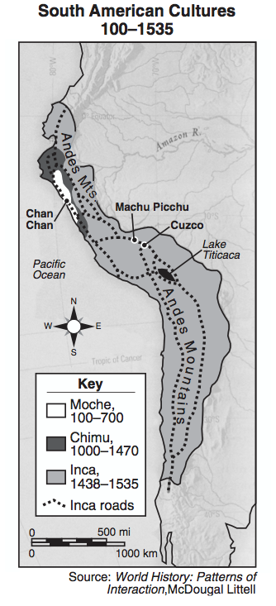
- Which conclusion about Incan society could be drawn from the map?

(1) An extensive road system connected all parts of the Empire for trade.
(2) Their trade depended on many seaports.
(3) Tropical climatic conditions existed through- out the empire.
(4) A similar language unified the Inca civilization.

22) Which phrase best completes the partial outline below?
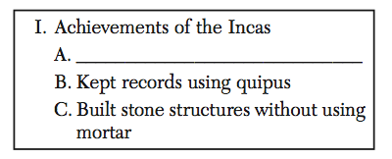

(1) Cast bronze statues
(2) Created a system of terrace farming
(3) Invented a foot stirrup
(4) Developed chariots

- One similarity between the Mongols of Central Asia and the Incas of South America was that both societies

(1) developed cash-crop farming
(2) based their wealth on the slave trade
(3) adapted to difficult physical environments
(4) practiced monotheistic religions

- How did the Inca adapt to their physical environment?

(1) They built large fishing fleets to feed their populations.
(2) They built footbridges that connected their roads across the Andes.
(3) They established extensive trade agreements with Europe.
(4) They raised cattle and horses on the pampas.

Base your answer to question 25 on the graphic organizer below and on your knowledge of social studies.
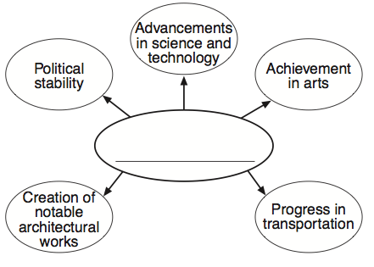

- Which title best completes this graphic organizer?

(1) Characteristics of the Inca Golden Age
(2) Reasons for the Reconquista
(3) Results of Lenin’s New Economic Plan
(4) Features of the Marshall Plan

- The ancient cultures of both the Incas and the Chinese adapted to the physical geography of their region by

  - (1) developing terrace farming on hillsides
  - (2) building chariots to protect their open plains against invaders
  - (3) becoming maritime traders
  - (4) constructing harbors to encourage exploration

Base your answer to question 26 on the passage below and on your knowledge of social studies.

...The girl and two other children were left on a mountaintop to succumb [fall victim] to the cold as offerings to the gods, according to the archaeologists who found the mummified remains in Argentina in 1999....
- “Frozen Inca Mummy Goes On Display,” National Geographic News, September 11, 2007

- This passage best illustrates the role of archaeologists in

(1) interpreting evidence
(2) challenging customs
(3) classifying artifacts
(4) planning expeditions

- “Greek Statues Unearthed in Pompeii”
      - “Chinese Porcelain Found at Zimbabwe Dig”
      - “Mixtec Textiles Found Near Aztec Ruins”
        - Which concept is illustrated by these headlines?

                - (1) colonialism
                - (2) isolationism
                - (3) ethnocentrism
                - (4) cultural diffusion

- Both Inca farmers and Japanese farmers adapted a geographic feature of their countries by

(1) engaging in overseas expansion
(2) growing crops suited to desert climates
(3) building terraces into the mountainsides
(4) reclaiming land from the sea by building dikes

- Which technological advancement helped unify both the Roman and the Inca Empires?

(1) astrolabe
(2) road system
(3) gunpowder
(4) wheeled carts

EXTRA – CONQUISTADORS:

- 16 AdirectresultoftheconquestofTenochtitlánby Hernán Cortés in 1521 was the
  - (1) expulsion of Jews and Muslims from Spain
  - (2) establishment of Portuguese trade routes around Africa
  - (3) fall of the Aztec Empire
  - (4) conquest of the Kush Kingdom

- 17 The expeditions of Hernán Cortés and Francisco Pizarro resulted in the
- (1) destruction of the Aztec and Inca empires (2) capture of Brazil by Portugal (3) colonization of North America by Portugal (4) exploration of the Philippines and East Indies

- 18 What was one reason the Spanish conquistadors were able to conquer the Aztec Empire?
  - (1) The Spanish soldiers made effective use of their military technology against the Aztecs.
  - (2) Aztec religious beliefs promoted nonviolence.
  - (3) Spain joined the Incas in their fight against the Aztecs.
  - (4) The Spanish cavalry outnumbered the Aztec
warriors.

