Regents Questions: 1-6
DAY 2

- Which belief is most closely associated with the philosophy of Confucianism?

(1) nirvana
(2) reincarnation
(3) prayer
(4) filial piety

- Which belief system is considered monotheistic?

(1) Jainism
(2) Daoism
(3) Judaism
(4) Shinto

- Judaism, Islam, and Christianity share a belief in

(1) papal supremacy
(2) teachings of the Koran (Quran)
(3) reincarnation and the Four Noble Truths
(4) an ethical code of conduct and monotheism

- A similarity between Shinto in Japan and animism in African societies is that both

(1) use the Torah to establish law codes
(2) stress the importance of the Eightfold Path
(3) believe that spirits exist in nature
(4) base social rank on a caste system

- • Showing respect for parents
• Maintaining family honor
• Honoring all elders

Which term is most closely related to these three actions?

(1) nirvana
(2) animism
(3) filial piety
(4) hadj (hajj)

- One way in which the Five Relationships, the Ten Commandments, and the Eightfold Path are similar is that they

(1) promote polytheism
(2) establish gender equality
(3) provide codes of behavior
(4) describe secularism

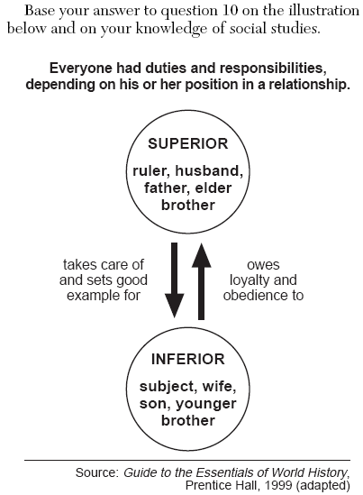

- The illustration shows the relationship between individuals in a society according to the ideas of

(1) Confucius
(2) Moses
(3) Mohammad
(4) Siddhartha Gautama

