Regents Questions: 1-5

- Hammurabi’s Code, the Ten Commandments, and the Twelve Tables were all significant to their societies because they established

(1) democratic governments
(2) official religions
(3) rules of behavior
(4) economic systems

- Which ancient civilization is associated with the Twelve Tables, an extensive road system, and the poets Horace and Virgil?

(1) Babylonian
(2) Greek
(3) Phoenician
(4) Roman

- A geographic similarity between Italy and India is that both of these countries are located

(1) on peninsulas
(2) on archipelagos
(3) between two oceans
(4) south of the equator

- China under the Han dynasty and the Roman Empire were similar in that both grew wealthy because they

(1) developed extensive trade networks
(2) created classless societies
(3) encouraged democratic ideals
(4) established free-market economies

- One contribution of ancient Roman culture was the development of

(1) the concept of zero
(2) the process of making silk
(3) a republican form of government
(4) the printing press

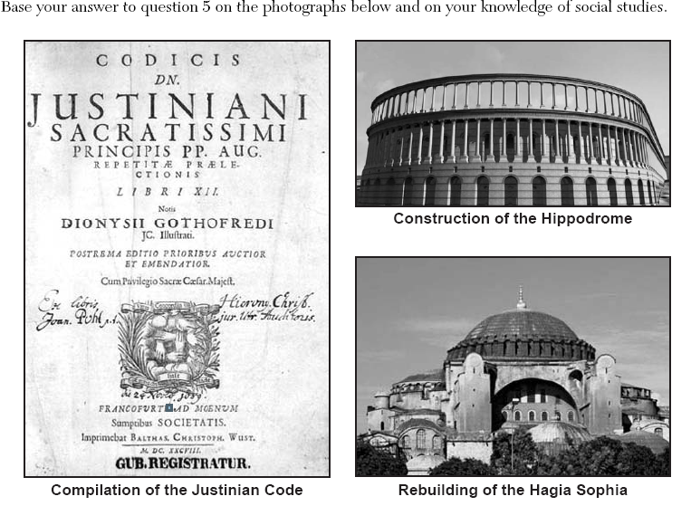

- The cultural contributions shown in these photographs were developed during the

(1) Mesopotamian civilizations
(2) Pax Romana
(3) Tang dynasty
(4) Byzantine Empire

- How did the geography of the Italian peninsula influence the development of the Roman Empire?

- The unnavigable rivers in the northern part of the peninsula protected the Romans from their neighbors.
- The harsh climate prevented agricultural production on the Italian peninsula.
- The lengthy, rugged seacoast encouraged frequent invasions of the Italian peninsula.
- The location of the peninsula contributed to Roman control of the Mediterranean region.

