Regents Questions 1-2

- Which geographic feature was common to the development of civilizations in ancient Egypt, China, India, and Mesopotamia?

(1) river valleys
(2) deserts
(3) rain forests
(4) mountains

- Which action is most closely associated with polytheism?

(1) praying in a synagogue
(2) accepting the Eightfold Path
(3) worshipping many gods
(4) reading the Koran

- One similarity found in both Egyptian and Sumerian civilizations is that each developed a

(1) monotheistic religion
(2) compass
(3) ziggurat
(4) written language

- A geographic similarity between Italy and India is that both of these countries are located

(1) on peninsulas
(2) on archipelagos
(3) between two oceans
(4) south of the equator

- The geographic isolation of a society most often leads to the

(1) development of trade
(2) strengthening of traditional culture & ethnocentrism
(3) promotion of cultural diffusion
(4) growth of international alliances

- One reason the Euphrates, Indus, Nile, and Tigris valleys became centers of early civilization is that these valleys had

(1) borders and elevations that were easy to defend
(2) rich deposits of coal and iron ores
(3) the means for irrigation and transportation
(4) locations in regions of moderate climate and abundant rainfall

- The Code of Hammurabi was a major contribution to the development of civilization because it

(1) treated citizens and slaves equally
(2) ended all physical punishment
(3) recorded existing laws for all to see
(4) rejected the principle of filial piety

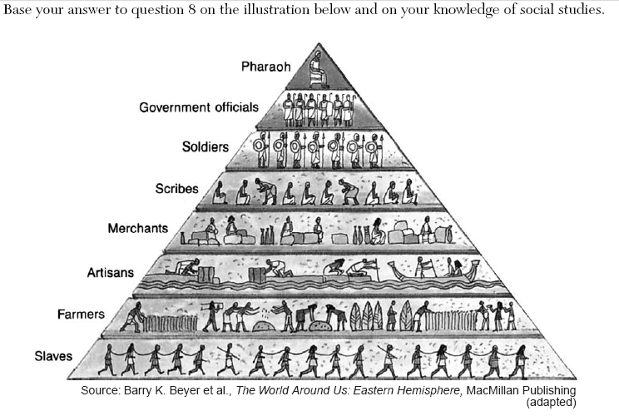

- Based on the information in this illustration, which statement about the society of ancient Egypt is accurate?

(1) The women had equal status to the men.
(2) The social structure was hierarchical.
(3) Social mobility was unrestricted.
(4) Soldiers outnumbered farmers.

