Regents Q’s 1-10

- Many achievements made during the Golden Ages of both Islam and the West African Kingdoms reached European societies by way of

(1) trade networks in the Mediterranean Sea region
(2) trade expeditions between China and Africa
(3) the voyages of Ferdinand Magellan
(4) the travels of Commodore Matthew Perry

- The kingdoms of Ghana, Mali, and Songhai prospered primarily due to their

(1) exchanges with Indian ports
(2) direct access to the Arabian Sea
(3) control of trade routes
(4) abundance of diamonds

- Which statement about the Sahara is most closely associated with the West African civilizations of Ghana and Mali?

(1) Irrigation systems made it possible to farm in the Sahara.
(2) Salt mined in the Sahara was exchanged for gold.
(3) Oases in the Sahara served as their capital cities.
(4) The Sahara prevented the spread of Islam to the region.

- Both Ibn Battuta and Mansa Musa demonstrated their religious values by

(1) meditating along the banks of the Ganges River
  - (2) converting Africans to Christianity
  - (3) making a pilgrimage to Mecca
  - (4) visiting the wailing wall in Jerusalem

- Which statement is an opinion rather than a fact?

(1) Mansa Musa made a pilgrimage to Mecca.
(2) Mali would have flourished without Mansa Musa’s influence.
(3) Mali’s economy was based on the gold and salt trade.
(4) Timbuktu became a center for Islamic learning.

- Which river was essential to the survival of the West African kingdoms of Ghana, Mali, and Songhai?

(1) Thames
(2) Niger
(3) Indus
(4) Euphrates

- The trans-Saharan trade carried out by West African civilizations was primarily based on an exchange of

(1) gold and salt
(2) ivory and silk
(3) silver and tea
(4) hardwoods and animal skins

- One way in which the Silk Roads and the West African trade routes are similar is that along both routes

  - (1) the main items exchanged were ivory and tobacco
  - (2) concrete was used to improve the surface of the roads
  - (3) a single currency was used to make transactions easier
  - (4) ideas were exchanged as merchants interacted with each other

- What was a significant effect of Mansa Musa’s pilgrimage to Mecca?

(1) The African written language spread to southwest Asia.
(2) Military leaders eventually controlled Mali.
(3) Islamic learning and culture expanded in Mali.
(4) The trading of gold for salt ended.

Base your answers to questions 10 and 11 on the map below and on your knowledge of social studies.
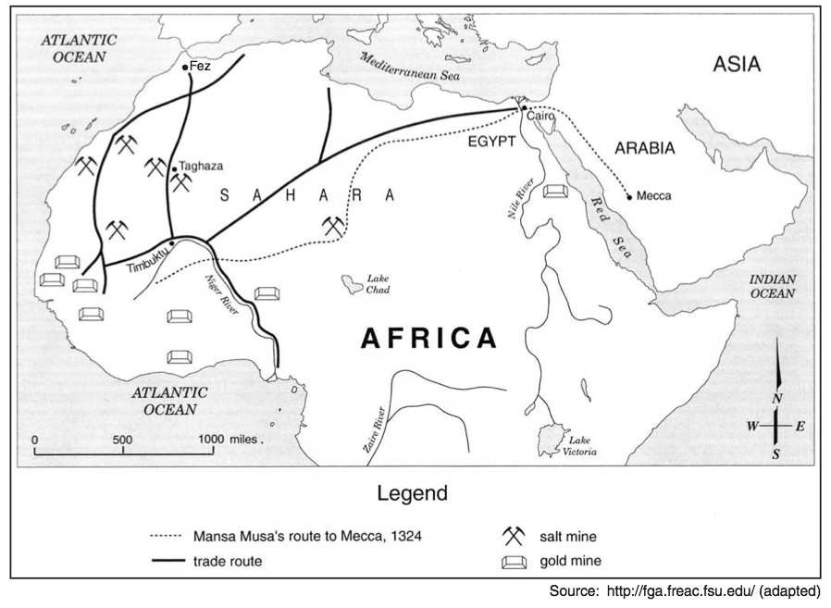

- Which statement about the trip taken by Emperor Mansa Musa is accurate?

(1) The trip extended beyond North African trade routes.
(2) Mansa Musa used the Mediterranean Sea to reach Mecca.
(3) The route primarily followed major rivers.
(4) Mansa Musa traveled to Fez on his way to Mecca.

- Which conclusion about trade is best supported by the information on this map?

(1) Timbuktu was a center of trade in West Africa.
(2) The Sahara Desert prevented trade.
(3) Cairo and Mecca were trading partners.
(4) West African gold and salt were traded along the Zaire River.

EXTRA:

- One way in which the African kingdoms of Ghana and Mali are similar is that they

(1) established their wealth through trade
(2) improved their military strength with the use of gunpowder
(3) opened trade routes to the Americas
(4) adopted Christianity as their major religion

- The economies of the western African civilizations of Ghana, Mali, and Songhai relied on

(1) industrial growth
(2) shipbuilding
(3) textile production
(4) trans-Saharan trade routes

- One way in which Asoka, Mansa Musa, and Suleiman the Magnificent are similar is that they

(1) established republics
(2) led nationalist movements
(3) ruled during times of prosperity
(4) discouraged scientific advancements

- Much of the wealth of the West African kingdoms of Ghana and Mali was gained from the

(1) sale of slaves to Europeans
(2) creation of colonies on the Mediterranean coast
(3) taxation on goods brought by Indian merchants
(4) control of the trans-Saharan trade in gold and salt

- Which economic activity was the basis for most of the wealth and power of the West African empires of Ghana and Mali?

(1) hunting and gathering
(2) farming and cattle ranching
(3) trading in salt and gold
(4) working in bronze and brass

Base your answer to question 17 on the map below and on your knowledge of social studies.
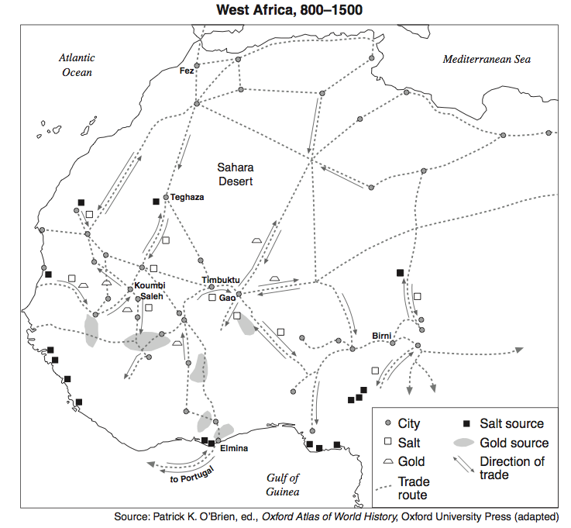

- Based on the map, which conclusion can best be drawn about this region?

(1) The Sahara Desert acted as a barrier to trade.
(2) Rivers served as the primary trade routes for the entire region.
(3) The economy of the region was influenced by extensive trade connections.
(4) Goods from the Gulf of Guinea were exchanged directly with English cities.

- One way in which 14th-century Mali in Africa and 14th-century Venice in Italy are similar is that both

(1) were land-locked city-states
(2) developed economies based primarily on agriculture
(3) became wealthy and powerful as a result of trade
(4) were centers for Islamic learning

- •Timbuktu is known as a great center of learning and trade.
- Walls of Great Zimbabwe reveal a powerful and rich society.
- Complex culture produces brass sculptures in Benin.
What generalization can be made on the basis of these statements?

- Religious beliefs were the most important element in many African
societies.
(2) Some African societies achieved a high level of economic and cultural
development.
(3) North African societies were more advanced than South African societies.
(4) Most African societies were hundreds of years behind Asian societies in
using technology.

