COMMONLY MISSED QUESTIONS: Test #1

**WEEK 1-1:**

1. How did the introduction of **agriculture** affect early peoples?

(1) Societies became nomadic.

(2) Food production declined.

(3) Civilizations developed.

(4) Birthrates decreased rapidly.

**WEEK 1-1.5:**

1. Which name identifies the region located between the **Tigris and Euphrates** rivers?

(1) Cape of Good Hope

(2) Sinai Peninsula

(3) Mesopotamia

(4) Horn of Africa

1. Which factor led to the **development of civilizations** in ancient Mesopotamia?

(1) political harmony

(2) favorable geography

(3) religious differences

(4) universal education

1. The growth of maritime and overland **trading** routes led to

(1) decreased interest in inventions and technology

(2) the limited migration of peoples

(3) increased cultural diffusion

(4) the development of subsistence agriculture

**WEEK 1-2:**

1. Which geographic feature was common to the development of civilizations in ancient **Egypt, China, India, and Mesopotamia**?

(1) river valleys

(2) deserts

(3) rain forests

(4) mountains

1. A geographic similarity between Italy and India is that both of these countries are located

(1) on **peninsulas**

(2) on archipelagos

(3) between two oceans

(4) south of the equator

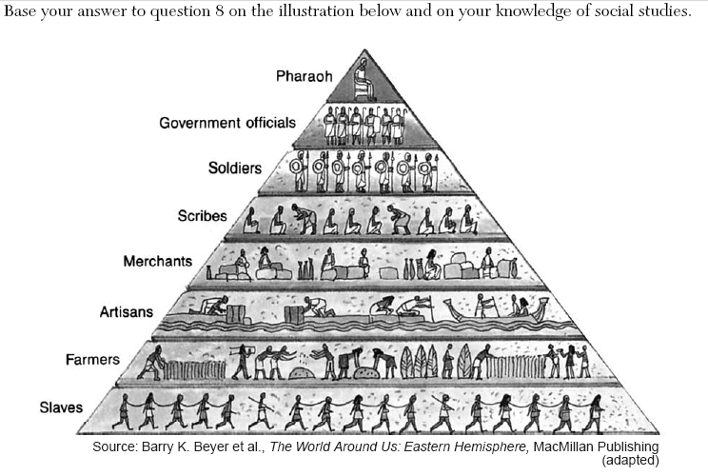

1. Based on the information in this illustration, which statement about the society of ancient Egypt is accurate?

(1) The women had equal status to the men.

(2) The social structure was **hierarchical.**

(3) Social mobility was unrestricted.

(4) Soldiers outnumbered farmers.

**WEEK 1-3:**

1. Before the use of the **Silk Road**, how did geography affect early China?
2. The mountains and deserts in western and southwestern China slowed the

exchange of ideas.

(2) The northwestern region provided many fertile areas suitable for farming.

(3) The three major river systems provided barriers against invasion.

(4) The lack of deep-water ports on the eastern coast prevented China from

developing trade with other nations.

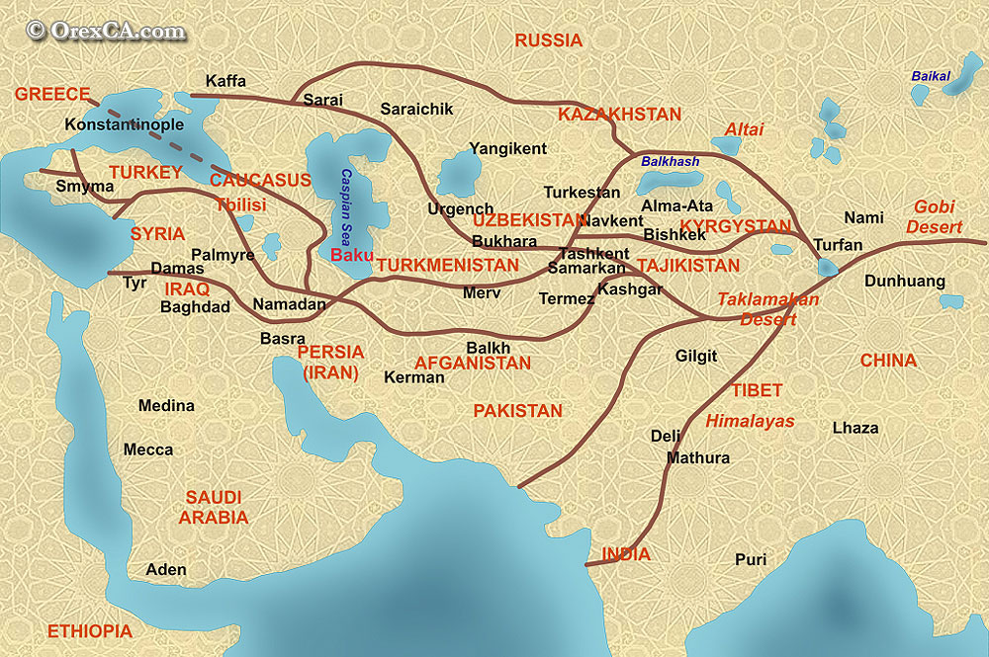 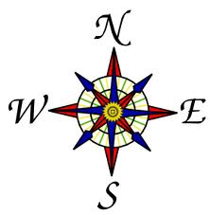

1. The exchange of silks and spices and the spread of Buddhism along the Silk Roads are examples of

(1) cultural diffusion

(2) self-sufficiency

(3) ethnocentrism

(4) desertification

1. One similarity between the ancient civilizations in Egypt and in China is that they developed

(1) nomadic lifestyles

(2) monotheistic belief systems

(3) democratic governments

(4) written forms of communication

1. In China, the development of civil service examinations and a belief in filial piety reflect the influence of

(1) Shinto

(2) Jainism

(3) Confucianism

(4) Buddhism

**WEEK 1-4:**

1. One effect of rugged, mountainous geography on the civilization of ancient Greece was the development of

(1) absolute monarchies

(2) separate, independent city-states

(3) extensive trade with the Persians

(4) belief in one God

1. Which statement most likely represents the view of a citizen of ancient Athens visiting Sparta?
2. “The government and society in Sparta are so strict. The people have little voice in government.”
3. “I feel as though I have never left home. Everything here is the same as it is in Athens.”
4. “This society allows for more freedom of expression than I have ever experienced in Athens.”
5. “I have never heard of a society like Sparta that believes in only one God.”

Base your answers to question 14 on the illustration & your knowledge of social studies.



Source: Guide to the Essentials of World History, Prentice Hall, 1999 (adapted)

1. Which concept is most closely related to the main idea of the illustration?

(1) isolation

(2) cultural diffusion

(3) armed conflict

(4) urbanization