Mesoamerica NOTES

- Where was Mesoamerica located?

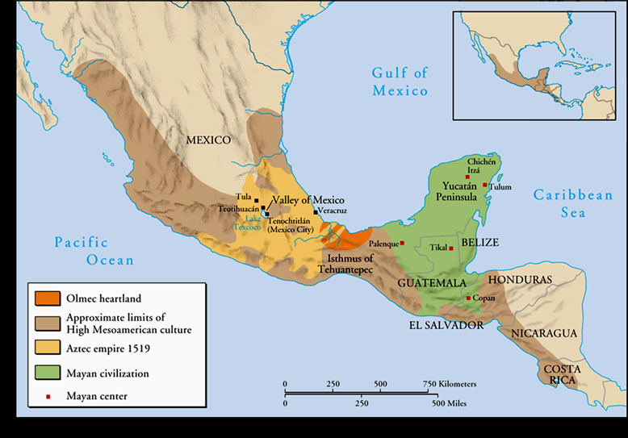
- List the 3 major cultures of Mesoamerica.

- ________________________________________
- ________________________________________
- ________________________________________

-- MAYA --
- The Maya civilization existed from _________________ CE - _______________CE on the Yucatan _______________________________________.

- How did geography affect life in Maya?
Geographic Feature | Effect on Lifestyle

- List 2 contributions of the Mayan civilization.

-- AZTEC --
- The Aztec civilization existed from _________________ CE - _______________CE in Southern _______________________________________. Their capital was Tenochtitlan.

- List 2 contributions of the Aztec civilization.

-- INCA --
- The Inca civilization existed in the _________________ CE on the Pacific Coast of ______________________________________________________. Their capital was Cuzco.

- How did geography affect life in Inca?
Geographic Feature | Effect on Lifestyle

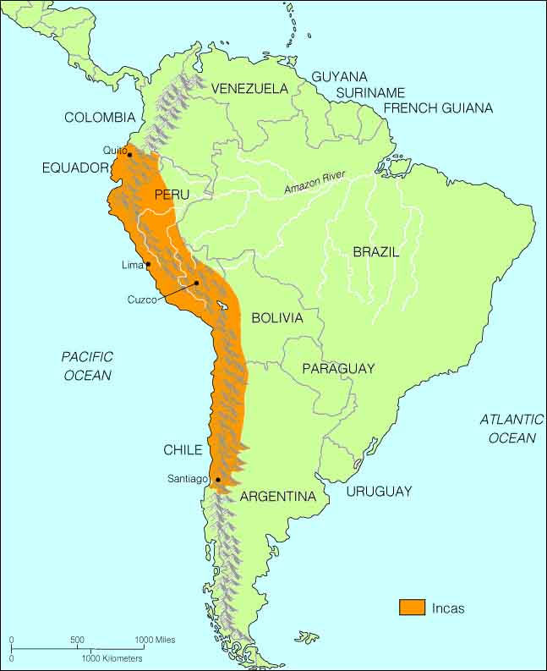
10) List 2 contributions of the Inca civilization.

