Regents Q’s: REVIEW –5

1. In the 1950s, what was the status of most countries in Eastern Europe?

(1) members of the Common Market

(2) participants in the Marshall Plan

(3) allies of the United States

(4) satellites of the Soviet Union

1. The imaginary line that divided the Western European countries from the Eastern European countries after World War II was known as the

(1) prime meridian

(2) line of demarcation

(3) Iron Curtain

(4) Berlin Wall

1. In the post–World War II time period, the purpose of both the North Atlantic Treaty Organization (NATO) and the Warsaw Pact was to

(1) discourage religious toleration

(2) establish a military alliance

(3) promote economic self-sufficiency

(4) eliminate political corruption

1. The Marshall Plan was designed to stop the spread of communism by providing

(1) government housing to refugees

(2) military assistance to Vietnam

(3) funds for economic recovery in war-torn European nations

(4) nuclear weapons to North Atlantic Treaty Organization (NATO) members

1. Which group of countries became Soviet satellites after World War II?

(1) France, Spain, Great Britain

(2) Poland, Czechoslovakia, Hungary

(3) Switzerland, Austria, Belgium

(4) Turkey, Greece, Italy

1. The purpose of both the Truman Doctrine and the Marshall Plan was to

(1) support the construction of the Iron Curtain

(2) increase membership in the United Nations

(3) prevent the spread of communism

(4) attempt to solve world hunger

1. Which title best completes the partial outline below?

|  |
| --- |
| I. __________________________________  A. Berlin blockade  B. Cuban missile crisis  C. Vietnam War |

(1) Path to World War I

(2) Victories for Democracy

(3) Cold War Confrontations

(4) Terrorism in the 20th Century

1. During the Cold War, nations that adopted a policy of nonalignment believed they should

(1) be exempt from United Nations decisions

(2) restrict trade with neighboring countries

(3) reject international environmental treaties

(4) follow a course independent of the superpowers

1. One way in which the Korean War and the Vietnam War are similar is that both

(1) resulted in unification of two formerly independent nations

(2) reflected the success of the Western policy of containment

(3) attempted to remove French imperialists from power

(4) developed from Cold War tensions

1. One similarity in the results of the revolutions led by Fidel Castro in Cuba and by the Sandinistas in Nicaragua is that both

(1) restored a monarchy

(2) destroyed a theocracy

(3) followed Marxist principles

(4) protected freedom of the press

1. One way in which Toussaint L’Ouverture, Kwame Nkrumah, and Ho Chi Minh are similar is that each leader

(1) opposed the role of the Roman Catholic Church in politics

(2) established the first democratic government in his country

(3) fought to free his country from European control

(4) embraced the principles of civil disobedience

1. What was a direct result of the Four Modernizations introduced in China by Deng Xiaoping?

(1) Freedom of speech was guaranteed.

(2) Goods and services were evenly distributed.

(3) Economic opportunities were expanded.

(4) Fewer consumer goods were produced.

1. The tools shown in this cartoon represent traditional symbols of

**“Filthy Imperialist!”**



(1) manorialism

(2) communism

(3) western capitalism

(4) national socialism

1. Which of these groups were the major supporters of 20th-century communist revolutions?

(1) priests and artisans

(2) bourgeoisie and nobility

(3) entrepreneurs and capitalists

(4) workers and peasants

1. One way in which Joseph Stalin’s five-year plans and Mao Zedong’s Great Leap Forward are similar is that both plans were

(1) efforts to reduce human rights violations

(2) policies to improve relations with the West

(3) methods used to control population growth

(4) attempts to increase agricultural and industrial production

1. The treatment of untouchables in India, the treatment of Jews during the Holocaust, and the treatment of Chinese student demonstrators in Tiananmen Square are all examples of

(1) fascist policies

(2) extraterritoriality

(3) excommunication

(4) human rights violations

1. Which Chinese leader is most closely associated with leading the Great Leap Forward and the Cultural Revolution?

(1) Sun Yixian (Sun Yat-sen)

(2) Jiang Jieshi (Chiang Kai-shek)

(3) Mao Zedong

(4) Deng Xiaoping

1. Which leader’s policies included *glasnost* and *perestroika*?

(1) Fidel Castro

(2) Nikita Khrushchev

(3) Mikhail Gorbachev

(4) Deng Xiaoping

1. One way in which Vladimir Lenin’s New Economic Policy and Mikhail Gorbachev’s policy of perestroika are similar is that both

(1) allowed elements of capitalism within a communist economic system

(2) strengthened their country’s military defenses

(3) supported censorship of news and of personal correspondence

(4) increased tensions during the Cold War

1. Mikhail Gorbachev’s reforms of perestroika and glasnost resulted in

(1) an era of world peace and Soviet prosperity

(2) conditions that helped lead to the breakup of the Soviet Union

(3) a successful transition to a command economy in Russia

(4) censorship of the news media in Russia

1. The main idea of this 1990s cartoon is that Russia is

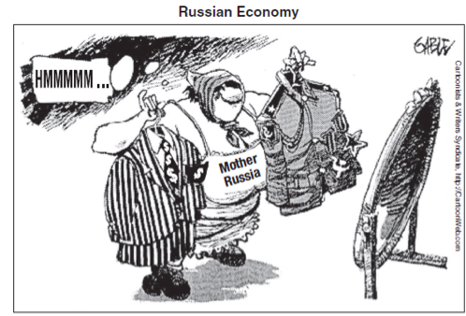

(1) deciding between a capitalism or communism

(2) attempting to restore military power

(3) expressing concern about how the rest of the world views its government

(4) maintaining a balance between a civilian and a military government

1. During the Cold War, which event occurred *last?*

(1) Cuban missile crisis

(2) destruction of the Berlin Wall

(3) Berlin airlift

(4) launch of *Sputnik* by the Soviet Union

1. What do the darkest areas of this map represent?

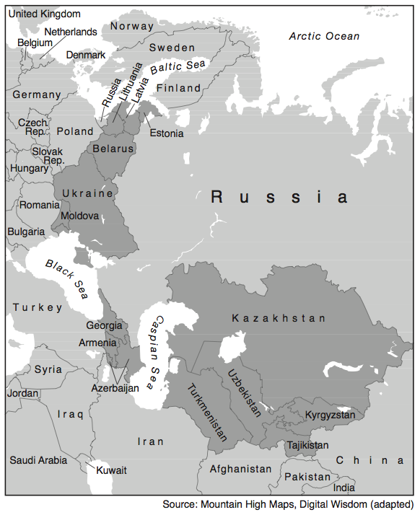

(1) former republics of the Soviet Union

(2) current members of the European Union

(3) original member countries of the Warsaw Pact

(4) recent additions to the Organization of Petroleum Exporting Countries (OPEC)

1. **“Contaminated Food from China Sold in the**

**United States”**

**“Computer Virus Shuts Down Hundreds of**

**Businesses Worldwide”**

**“Multinational Corporations Relocate**

**Factories”**

These headlines are directly related to

(1) world hunger

(2) overpopulation

(3) global warming

(4) economic interdependence

1. The “one child” policy in China, established during the late 1970s, was an attempt to

(1) gain the support of the upper classes

(2) increase tax revenue for government programs

(3) eliminate Western influence

(4) reduce the population growth rate

1. **“Reliance on Imported Oil Raises Concerns**

**in China, Europe, & the United States”**

**“Coca-Cola Accused of Wasting Precious Water in India”**

**“Competition for Control of Cobalt Mines Causes Violence in Congo”**

These headlines best illustrate the economic concept of

(1) inflation

(2) embargo

(3) boycott of goods

(4) scarcity of resources

1. Which statement best reflects this cartoonist’s point of view?

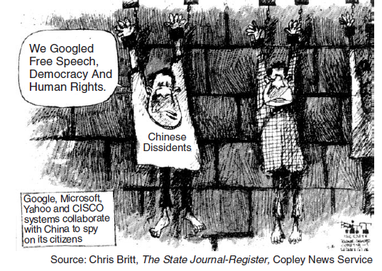

(1) The development of computer technology is prohibited in China.

(2) Chinese prisoners are denied access to computers.

(3) Foreign software developers have flooded the Chinese market.

(4) Some American firms have assisted the Chinese government in monitoring citizen computer usage.

1. The southern edge of the Sahara is expanding in a process called

(1) annexation

(2) conservation

(3) desertification

(4) desalination

1. The destruction of the rain forests in Latin America is primarily due to the

(1) diseases carried by insects

(2) wildfires occurring during dry seasons

(3) devastation caused by high winds during the tropical storm season

(4) demand for timber, farmland, and grazing land

1. What is the main idea of this 2002 cartoon?



(1) The United States refuses to become involved in another war.

(2) Nuclear proliferation continues to threaten world peace.

(3) The Cold War conflict continues today.

(4) Pakistan is the dominant nuclear force in this region.

1. What is the main idea of this cartoon?



(1) Petroleum is being overproduced.

(2) The demand for petroleum exceeds production.

(3) Fossil fuels are unevenly distributed.

(4) The demands of global environmental groups have increased.

1. The aftermath of which problem is being described in this passage?

*... For Ukraine, however, contamination via river water is still a major problem, since most of the rivers flow southwards. To slow the spread of radiation, protective dams were built along the Dnieper after the accident. “But of course not all riverbanks could be protected in this way,” as the Ukrainian government agency Chernobyl Interinform points out in its summary of the situation. “Particularly during flooding, radiation is still leached into rivers. This is a particular threat for the 30 million people who obtain their drinking water from the Dnieper basin.” ...*

* Chernobyl.info

(1) volcanic eruption

(2) nuclear disaster

(3) global warming

(4) deforestation