Regents Q’s: REVIEW – 4
1) Which statement describes one major aspect of a command economy?

- Supply and demand determines what will be produced.
- Most economic decisions are made by the government.
- The means of production are controlled by labor unions.
(4) The economy is mainly agricultural.

2) The Bolshevik Party in 1917 gained the support of the peasant class because they promised them

(1) “Peace, Land, and Bread”
(2) “Liberty, Equality, Fraternity”
(3) abolition of the secret police
(4) democratic reforms in all levels of
government

3) Joseph Stalin’s policies in Ukraine during the 1930s directly resulted in

(1) widespread starvation
(2) agricultural self-sufficiency
(3) the development of cottage industries
(4) the use of subsistence farming techniques

4) • Five-year plans
• Collectivization of agriculture
• Great Purge

Which individual is associated with all these policies?

(1) Adolf Hitler
(2) Joseph Stalin
(3) Deng Xiaoping
(4) Jawaharlal Nehru

5) Which aspect of the economy was emphasized in Joseph Stalin’s five-year plans?

(1) heavy industry
(2) consumer goods
(3) famine relief
(4) private landownership

6) Under communism in the former Soviet Union, people were required to

(1) reject modern technology
(2) limit the size of their families
(3) honor their ancestors and religious traditions
(4) put the interests of the state before individual
gain

7) Totalitarian countries are characterized by

(1) free and open discussions of ideas
(2) a multiparty system with several candidates
for each office
- government control of newspapers, radio,
and television
- government protection of people’s civil
liberties

- The Amritsar Massacre and the Salt March are both associated with the independence movement in

(1) Iraq
(2) India
(3) China
(4) Kenya

- Between 1923 and 1938, which leader instituted a modernization program in Turkey?

(1) Shah Reza Pahlavi
(2) Jawaharlal Nehru
(3) Kemal Atatürk
(4) Ho Chi Minh

- Mohandas Gandhi’s protests during India’s independence movement were often successful because of his application of

(1) an appeasement policy
(2) civil disobedience
(3) traditional caste beliefs
(4) divide-and-conquer principles

- Which leader is most closely associated with the rise of fascism in Italy prior to World War II?

(1) Ho Chi Minh
(2) Winston Churchill
(3) Mao Zedong
(4) Benito Mussolini

- Which statement about both the Bolshevik Revolution in Russia and the rise of fascism in Germany and Italy is accurate?

(1) Economic conditions led to political change.
(2) Industrialization hindered national
development.
(3) Goals were achieved by peaceful means.
(4) Communist ideals fueled both movements.

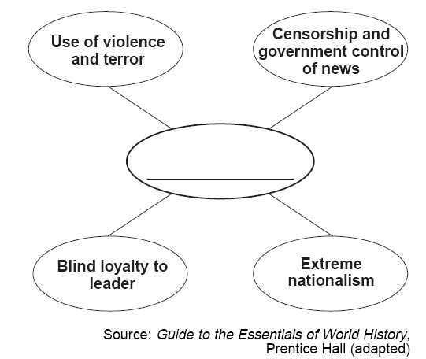
- Which ideology best completes this graphic organizer?

(1) socialism
(2) democracy
(3) capitalism
(4) fascism

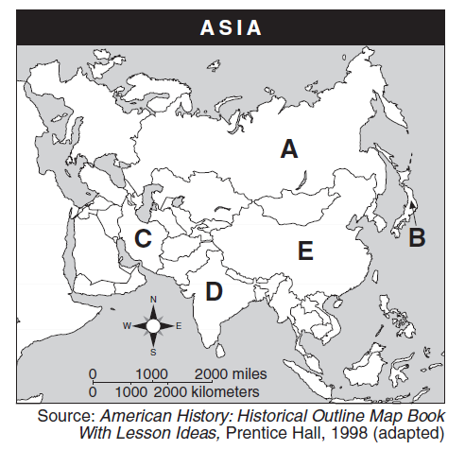
- Which letter identifies the nation most closely associated with Mohandas Gandhi?

(1) A
(2) B
(3) C
(4) D

- This cartoonist is referring to the way Germany was affected in 1919 by

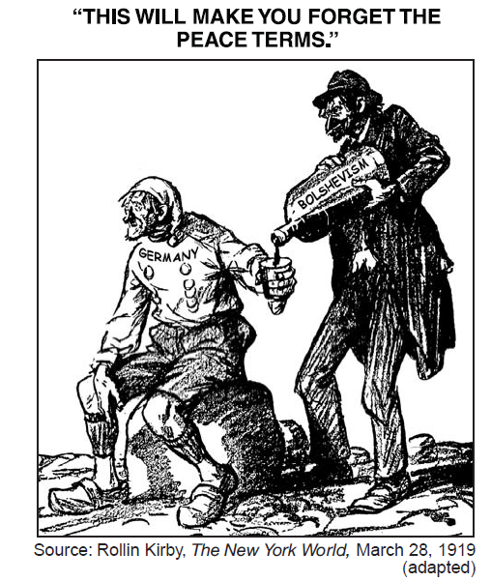
(1) the Congress of Vienna
(2) its defeat of Napoleon
(3) the Treaty of Versailles
(4) its defeat in World War II
- One reason the League of Nations failed as a world organization was that it

(1) supported the rise of fascist states
(2) lacked a military force to settle conflicts
(3) dealt with conflict by establishing naval
blockades
- encouraged the annexation of territory by force

- “You should take steps now to cease military resistance. Otherwise, we shall resolutely employ this bomb and all our other superior weapons to promptly and forcefully end the war.”

This paragraph from a 1945 Allied leaflet warned the

(1) Czechs of a German invasion
(2) Americans in Hawaii of a Japanese attack
(3) Koreans of a Russian invasion
(4) Japanese civilians of a United States attack

- The Nuremberg Trials are considered an important event in the 20th century because they

(1) brought an end to genocide
(2) condemned the use of nuclear weapons
(3) ruled on provisions for the postwar
occupation of Germany
(4) established principles of responsibility for
human rights violations

- The primary purpose of the United Nations is to

(1) control world grain prices
(2) promote democratic governments
(3) resolve conflicts between nations peacefully
(4) unite all nations militarily through alliances

- Japan’s invasion of Manchuria, Italy’s attack on Ethiopia, and Germany’s blitzkrieg in Poland are examples of

(1) military aggression
(2) appeasement
(3) containment
(4) the domino theory

- The term appeasement is best defined as

- an attempt to avoid conflict by meeting the
demands of an aggressor
- a period of peace and prosperity, resulting in
cultural achievement
(3) a declaration of war between two or more nations
(4) an agreement removing economic barriers
between nations
- “…Seventy thousand people were killed instantly, and many more would die — 60,000 by November and another 70,000 by 1950. Most of them would be victims of a new method of killing - radiation…”

The situation described in this passage was the direct result of which World War II event?

(1) blitz of London
(2) attack on Pearl Harbor
(3) D-Day invasion of Normandy
(4) bombing of Hiroshima

- Which characteristic is most closely associated with both Pol Pot’s government in Cambodia and Slobodan Milosevic’s government in Yugoslavia?

(1) use of terror to achieve political goals
(2) support for freedom of speech
(3) establishment of a theocratic system
(4) respect for ethnic minorities

- Which policy is most closely associated with the events on this time line?
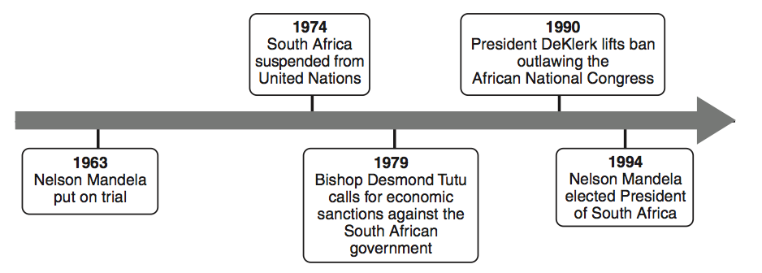
(1) nonalignment
(2) détente
(3) containment
(4) apartheid

- What is the main idea of this cartoon?
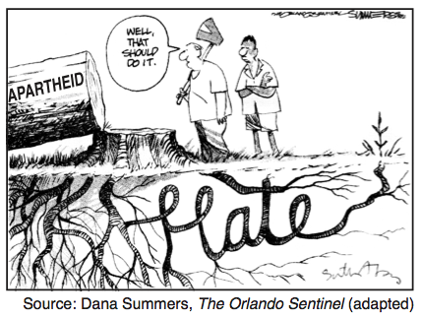

- The original causes of apartheid have not
been eliminated.
(2) Apartheid improved race relations in South Africa.
(3) Peace can be achieved by nonviolence.
(4) Hate is caused by poverty.
- What is the key idea of this cartoon?
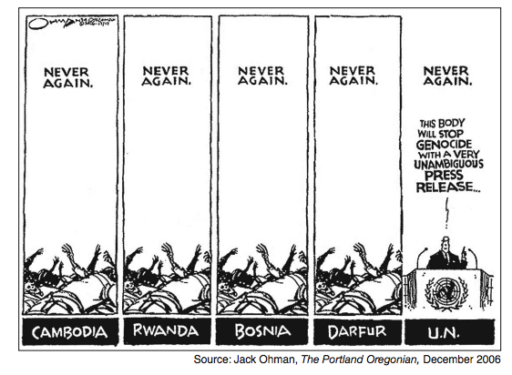
- Genocide in Cambodia, Rwanda, Bosnia, and
Darfur has been stopped.
- Human rights issues are best dealt with by
the United Nations.
- The United Nations has not been effective in
ending genocide.
- Fear of war crimes trials has brought peace to
troubled regions.

