Regents Q’s: REVIEW – 3

- One way in which Toussaint L’Ouverture, Simón Bolívar, and José de San Martín are similar is that they

(1) supported the Reconquista
(2) led independence movements
(3) fought for Native American suffrage
(4) defended the encomienda system

- What was one effect of the French Revolution?

- Differences between ethnic groups were
eliminated.
(2) Communism became popular.
(3) Militarism was discouraged.
(4) Nationalistic feelings were stimulated.

- One major effect of Napoleon’s rule of France was that it led to

- an increase in the power of the Roman
Catholic Church
(2) massive emigration to the Americas
(3) trade agreements with Great Britain
(4) a restoration of political stability

- “Angry Mob Destroys Bastille”
“Robespierre’s Execution Ends Reign of
Terror”
“Napoleon Seizes Power”

Which country’s revolution is referred to in
these headlines?

(1) Spain
(2) Austria
(3) France
(4) Russia

- Under the Old Regime in France, the burden of taxation fell mostly on the

(1) monarchy
(2) clergy
(3) nobles
(4) commoners

- Which geographic condition contributed to the defeat of Napoleon’s troops during the invasion of Russia?

(1) drought
(2) typhoons
(3) severe flooding
(4) harsh winter

- “The French Revolution is most important for having changed subjects to citizens.”

This statement emphasizes the shift from

(1) religious traditions to secular values
(2) divine right rule to people’s participation in
government
(3) rural lifestyles to urban lifestyles
(4) private property ownership to government
ownership

- Which event is most closely associated with the French Revolution?

(1) Council of Trent
(2) Thirty Years’ War
(3) Reign of Terror
(4) Paris Peace Conference

- The slogan “Blood and Iron” and a united Germany are most closely associated with

(1) Prince Metternich
(2) Simón Bolívar
(3) Camillo Cavour
(4) Otto von Bismarck

- One political objective of both Otto von Bismarck and Giuseppe Garibaldi was to

(1) overthrow divine right monarchies
(2) unify their nations
(3) establish communist systems
(4) form an alliance with Great Britain

- • Location — included lands surrounding the eastern Mediterranean Sea
• People — Turks, Arabs, Greeks, Muslims,
Christians, and Jews
• Nickname during the 19th and early 20th centuries — “Sick Man of Europe”

Which empire is described by these characteristics?

(1) Gupta
(2) Mongol
(3) Roman
(4) Ottoman

- Which area of Europe was known as the “Powder Keg” of Europe prior to the outbreak of World War I?

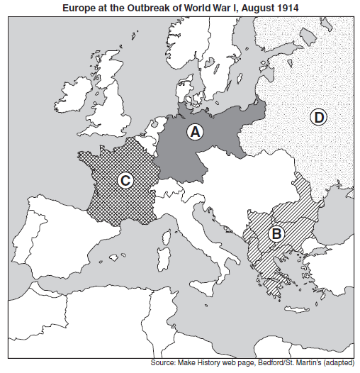
(1) A
(2) B
(3) C
(4) D

- • Irregular coastline
• Abundant mineral resources
• Large labor force
• Investment capital

Which country had these characteristics and used
them to industrialize in the 1700s?

(1) Germany
(2) Italy
(3) Great Britain
(4) Japan

- What was a result of the Industrial Revolution in Europe?

(1) the growth of the middle class
(2) an increase in nomadic herding
(3) a decline in urban population
(4) a decrease in international trade

- Urbanization in developing nations today is similar to urbanization in 19th-century England because in both cases

(1) many people moved to rural areas
(2) governments developed policies of forced
migration
(3) ties to extended families increased
(4) many farm workers went to cities to look for
jobs
- Which pair of natural resources were used to change transportation and manufacturing in Great Britain during the Industrial Revolution?

(1) gold and salt
(2) diamonds and petroleum
(3) copper and tin
(4) coal and iron ore

- Which statement represents a central idea of laissez-faire economics?

(1) Class struggles are based on inequities.
(2) Workers should form unions to better their
conditions.
(3) Prices are best determined by supply and
demand.
- The government should own all means of
production.

- Which idea is correctly paired with a document that supports it?

(1) colonialism — The Prince
(2) militarism — Sadler Report
(3) capitalism — Wealth of Nations
(4) monotheism — The Communist Manifesto

- Which of these groups were the major supporters of 20th-century communist revolutions?

(1) priests and artisans
(2) bourgeoisie and nobility
(3) entrepreneurs and capitalists
(4) workers and peasants

- Which written work criticized the capitalist system during the Industrial Revolution?

- Communist Manifesto by Karl Marx and
Friedrich Engels
(2) “White Man’s Burden” by Rudyard Kipling
(3) The Wealth of Nations by Adam Smith
(4) The Origin of Species by Charles Darwin

- Adam Smith would most likely agree with which statement?

- Revolution is the only solution to economic
problems.
- Five-year plans are necessary in order to
industrialize.
- All nations would benefit from an
agricultural economy.
- Government should follow a laissez-faire
policy.
- What was the main reason for the extensive Irish emigration to North America in the 1840s?

(1) mass starvation
(2) military draft
(3) civil war
(4) smallpox outbreak

- Which idea is most closely associated with laissez-faire economics?

(1) communes
(2) trade unionism
(3) subsistence agriculture
(4) free trade

- Which speaker best represents the views of Karl Marx?

Speaker A: If the rate of population growth continues to exceed the growth in the food supply, there will not be enough food for all of the people.

Speaker B: There are people who are wealthy and people who are poor. This is just how things are.

Speaker C: History is the story of class struggle. Eventually, the working class will rise up and revolt against the wealthy.

Speaker D: The government should do what is best for most of its people.

(1) A
(2) B
(3) C
(4) D

- One of the most important motives for the European “Scramble for Africa” in the late 1800s was that Africa provided a source of

- raw materials used in industry
(2) religious inspiration
(3) free labor for the Americas
(4) technologically innovative practices

- The theory of Social Darwinism was sometimes used to justify

  - (1) the establishment of communist
      - governments in Asia
  - (2) Latin American revolutions in the early
  - 19th century
  - (3) the independence movement in India
  - (4) European imperialism in the late 19th
  - century
- The message of this poem was used by many Europeans to justify

The White Man’s Burden
Take up the White Man’s burden–
Send forth the best ye breed–
Go bind your sons to exile
To serve your captives’ need;
To wait, in heavy harness
On fluttered folk and wild–
Your new-caught, sullen peoples,
Half-devil and half-child.
— Rudyard Kipling, 1899

(1) industrialism
(2) feudalism
(3) imperialism
(4) fascism

- One result of the Opium War was that China

(1) adopted democratic reforms
(2) gained control of Hong Kong
(3) regained control of Manchuria
(4) was divided into spheres of influence

- The Berlin Conference in 1884 was significant because it

(1) promoted Belgium as a world power
(2) established rules for the European division
of Africa
(3) called for a war against England
(4) ensured ethnic harmony in the Middle East

- A major goal of both the Sepoy Mutiny and the Boxer Rebellion was to

(1) remove foreign influences
(2) restore parliamentary government
(3) improve access to civil service
examinations
(4) outlaw caste systems

- In the late 19th and early 20th centuries, Japan rapidly industrialized. During which period did this change take place?

(1) Heian Court
(2) Song dynasty
(3) Yuan dynasty
(4) Meiji Restoration

- Which event is considered the immediate cause of World War I?

(1) signing of the Treaty of Versailles
(2) invasion of Poland by Germany
(3) assassination of Archduke Francis Ferdinand
(4) use of unrestricted submarine warfare by
Germany

- The term militarism can best be defined as

(1) loyalty to a nation or ethnic group
(2) buildup of armaments in preparation for war
(3) avoidance of military involvement in civil
wars
(4) control of territories for economic and
political gain

- Which region was described as “the powder keg of Europe” prior to World War I?

(1) Iberian Peninsula
(2) British Isles
(3) Balkan Peninsula
(4) Scandinavia

- What was a major cause of World War I?

(1) rebellions in colonial lands in Africa and Asia
(2) expansion of communism into western Europe
(3) militarism in the nations of Europe
(4) inability of the League of Nations to keep the
peace

