Regents Q’s: REVIEW – 2

- Constantinople became the center of the Byzantine Empire because

(1) the pope had made it the capital of the Christian world
(2) it was a religious center for Muslims
(3) its location made it the crossroads of Europe and
Asia
(4) it was geographically isolated from surrounding
Empires

- Which title best completes the partial outline below?

I. –––––––––––––––––––––––––––––––
A. Incorporation of European and Arabic ideas in architecture
B. Preservation of Greco-Roman ideas
C. Spread of Orthodox Christianity into Russia
D. Development of Justinian Code

(1) Age of Discovery
(2) Byzantine Empire
(3) Persian Empire
(4) Crusades

- Which development is most closely associated with the beginning of the Byzantine Empire?

(1) emergence of the Russian Orthodox Church
(2) division of the Roman Empire
(3) building of the Hagia Sophia
(4) fall of Constantinople

- Which situation was a result of Pax Mongolia?

(1) Trade increased between Europe and Asia.
(2) China became isolated from its neighbors.
(3) Warfare between Japan and Vietnam escalated.
(4) Europeans conquered the Aztecs and Incas.

- The leadership of Genghis Khan, the use of the stirrup, and excellent horsemanship skills all contributed directly to the

(1) collapse of Silk Road trade
(2) defeat of Tokugawa Japan
(3) beginning of European exploration
(4) rise of the Mongol Empire

- Which geographic feature had the greatest influence on the development of the Inca Empire?

(1) deserts
(2) irregular coastline
(3) river valleys
(4) mountains
- • Creation of the House of Wisdom in Baghdad
• Development of algebra
• Use of calligraphy as an art form

Which Golden Age is most closely associated with these achievements?

(1) Islamic
(2) Gupta
(3) Tang
(4) Songhai

- One way in which the ancient Inca Empire and the Roman Empire are similar is that both

(1) fought rivals for control of the sea
(2) adopted Christianity as the state religion
(3) traded with other civilizations along the Silk Road
(4) built a system of roadways throughout their
empires

- These photographs indicate the people of China and the people of ancient Peru modified their environment to
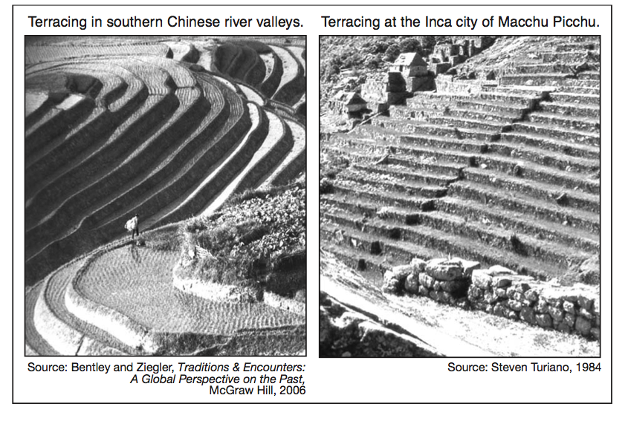
(1) create effective trade routes
(2) increase the amount of land available for
agriculture
(3) move large quantities of water into cities
(4) provide an effective defense

- Which statement is an opinion rather than a fact?

(1) Mansa Musa made a pilgrimage to Mecca.
(2) Mali would have flourished without Mansa
Musa’s influence.
(3) Mali’s economy was based on the gold and salt trade.
(4) Timbuktu became a center for Islamic learning.

- The trans-Saharan trade carried out by West African civilizations was primarily based on an exchange of

(1) gold and salt
(2) ivory and silk
(3) silver and tea
(4) hardwoods and animal skins
- In the late 1400s and early 1500s, what was a major reason for the European voyages of exploration?

(1) introduction of Enlightenment ideas
(2) desire to control Constantinople
(3) rapid industrialization
(4) need for alternate trade routes

- Which idea is most closely associated with the economic concept of mercantilism?

(1) Colonies exist to provide raw materials and markets for a colonial power.
(2) Wealth and power are based on land exchanged between nobles.
(3) Goods and services are traded without government interference.
(4) Property is owned collectively and administered by the state.

- The encomienda system in colonial Latin America led to the

(1) use of forced labor
(2) establishment of trade unions
(3) increase in landownership by Native Americans
(4) weakening of the power of peninsulares

- The use of the terms Encounter and Columbian exchange represents attempts to describe the

(1) nature of cultural interactions
(2) establishment of land grants
(3) results of scientific innovations
(4) origins of divine right theory

- In this passage about a conflict in Mexico, whose perspective is being expressed?

... In addition, after the last battle they were afraid of the horses and guns, of our swords and crossbows and our good fighting. Above all was the great mercy of God, Who gave us the strength to keep on....

(1) Aztec warrior
(2) Spanish conquistador
(3) Portuguese explorer
(4) Inca emperor

- According to the passage above, which factors were influencing the outcome of the conflict?

(1) efficiency and education
(2) climate and disease
(3) tribute and tradition
(4) technology and fear
- What is the best title for this chart?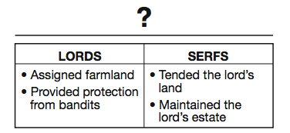
(1) Role of the Church
(2) Feudal Obligations
(3) Knights’ Code of Chivalry
(4) Rules for Guild Membership

- What is a primary characteristic of a feudal society?

(1) a representative government
(2) economic equality for all
(3) protection of individual rights
(4) an exchange of land for services

- In western Europe, feudalism developed after the

(1) Roman Empire collapsed
(2) Renaissance began
(3) city of Constantinople fell
(4) Mongols invaded

- Which heading best fits the partial outline below?
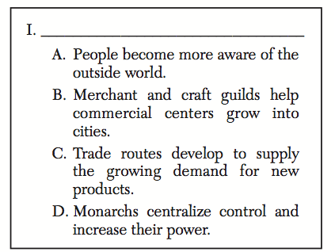

(1) Seljuk Turks Dominate Europe
(2) Democracy Ends in Eastern Europe
(3) Feudalism Declines in Western Europe
(4) Religion Becomes Powerful Force in Europe

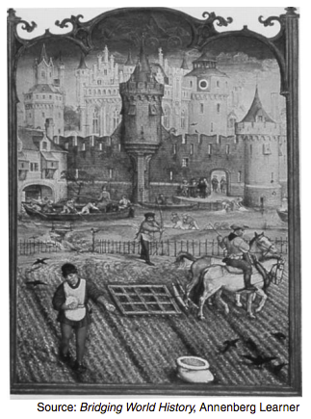
- Which economic system is most closely associated with the activities shown in this artwork?

(1) manorialism
(2) capitalism
(3) communism
(4) socialism

- Which speaker expresses a Muslim perspective during the Crusades?

Speaker A: We must fight to keep control of Jerusalem in the hands of those who believe in Allah.

Speaker B: Come and battle while there is still time to protect the Holy Land where Christ walked.

Speaker C: We must go forth to heal the split between the churches.

Speaker D: An investment in ships and knights will yield control of profitable trade routes.

(1) A
(2) B
(3) C
(4) D

- One long-term effect of the Crusades was the

(1) development of Pax Mongolia
(2) fall of the Ming dynasty
(3) control of Jerusalem by Europeans
(4) growth of trade and towns in western Europe

- Which institution served as the primary unifying force in medieval western Europe?

(1) legislature
(2) church
(3) monarchy
(4) military
- What was one of the primary reasons for the spread of the bubonic plague?

(1) increase in trade
(2) colonization of the Americas
(3) development of the manorial system
(4) economic decline

- One reason the Renaissance began in Italy was that Italian city-states

(1) defeated the Spanish Armada
(2) were unified as a nation under the Pope
(3) were unaffected by the Commercial Revolution
(4) dominated key Mediterranean trade routes

- What was a direct result of the Black Death in Europe?

  - (1) The rate of urbanization increased.
  - (2) A shortage of workers developed.
  - (3) Food crops had to be imported from the Americas.
  - (4) German states dominated trade in the eastern Mediterranean.

- • Leonardo DaVinci used movement and perspective in his work.
• Machiavelli’s The Prince advised rulers on how to gain and maintain power.
• Humanist scholars examined worldly subjects and classical culture.

Which period is associated with these statements?

(1) French Revolution
(2) Renaissance
(3) Early Middle Ages
(4) Enlightenment

- A direct impact that the printing press had on 16th-century Europe was that it encouraged the

(1) spread of ideas
(2) beginnings of communism
(3) establishment of democracy
(4) development of industrialization

- In The Prince, Niccolò Machiavelli was most concerned with

(1) the use of political power
(2) the expansion of church authority
(3) government regulation of the economy
(4) equality and justice for all
32) Humanism during the Italian Renaissance was focused on

(1) the affairs of the church
(2) self-sufficiency
(3) the importance of the individual
(4) political theories

- Which action could be considered an effect of the Protestant Reformation?

(1) posting of the Ninety-five Theses
(2) decline in the power of the Roman Catholic
Church
(3) sale of indulgences
(4) end of religious warfare

- • Pope Leo authorizes the sale of indulgences, 1515
• Martin Luther posts the Ninety-five Theses, 1517

These events are most closely associated with the

(1) Protestant Reformation
(2) Crusades
(3) Age of Reason
(4) Puritan Revolution

- Prior to the Protestant Reformation, the medieval church in western Europe was criticized for

(1) sponsoring explorations to the Middle East
(2) allowing the Bible to be printed and
distributed to the people
(3) being too concerned with worldly power and
riches
(4) refusing to sell indulgences to peasants

- Enlightenment thinkers encouraged the improvement of society through the

(1) teachings of the church
(2) use of reason
(3) development of absolutism
(4) establishment of a rigid social hierarchy

- Which pair of ideas were central to the Scientific Revolution?

(1) social stability and economic self-sufficiency
(2) observation and experimentation
(3) technology and military expansion
(4) scarcity and interdependence

- Which period is most closely associated with the major ideas of these philosophers?
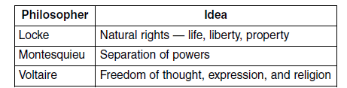
(1) Crusades
(2) Renaissance
(3) Reconquista
(4) Enlightenment

- According to John Locke, the purpose of government is to

(1) protect the natural rights of individuals
(2) serve the monarch
(3) create overseas settlements
(4) stimulate the economy

- Galileo Galilei and René Descartes faced challenges to their scientific theories because their ideas

(1) were based on the Bible
(2) contradicted traditional medieval European
beliefs
(3) relied only on teachings from non-Christian
cultures
(4) were not supported by scientific investigations

- One contribution that John Locke made to Enlightenment philosophy was the idea that

(1) absolute monarchies should continue
(2) the punishment should fit the crime
(3) individual rights should be denied
(4) governments should be based on the consent of
the people

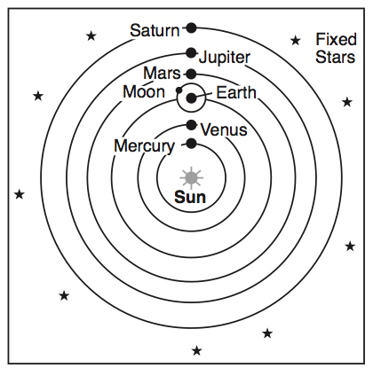
- Which individual supported the theory represented in this illustration?

(1) Socrates
(2) Ptolemy
(3) Dante
(4) Galileo

